**INFORMATION AGE**

Today we live in what is commonly called the *Information Age*. This is the age of computers, email, cellular phones, and satellite TV. As a result of these new technologies most of us are constantly being bombarded with information and advertising in huge quantities. The act of personally sorting out and processing this onslaught of information is daunting and disturbing. To solve the problem of information overload we must do what humans have done in the past when facing a new challenge. We need to change our lifestyle and mode of thinking.

For a quick historical perspective let’s look at some recent 'ages' that people had to go through. In the early 1800's most people were farmers and used livestock for their power and transportation. This pre-industrial age required its own set of know-how to maintain the animals and operate the farm. Today most of that knowledge is forgotten. During the late 1800's and early 1900's we entered the Industrial Age of automobiles and electricity.

In the Industrial Age people's lives were ruled by machines they built and had to maintain, so knowledge of machines was required. Beginning in the mid 1900's and early 2000's machines began to be built and run by computers so knowledge of machine operation was no longer needed. This is Computer Age or Information Age where we are now. Computers run most of the machines for us and even the farms are becoming almost totally automated. In this information age many people have been relegated to the job of *information processors*.

If we look at our information age objectively we see billions of people driving gas guzzling cars to work every day. They park their cars at office buildings in congested metropolitan areas. They enter these box-like buildings to do mostly just one thing, *process information*. After leaving 'work' they drive home again only to be deluged by more commercial information from their TV's and computers. In the information age, people are simply information processors and that's what they do almost all day long.

Now obviously this act of driving to and from work every day is a waste of time and energy. With all these computers and telecommunications around why do we still need to use humans as information processors? And why do we need to transport them to and from an office to do their information processing job?

The *new age* will no longer require office buildings and their associated travel to work. People will no longer need to be 'information processors' and instead become citizens of a global *true knowledge* network.

The transition beyond the information age will be easy for most but difficult for many. Old ways will need to be forgotten and new skills acquired. People will need to learn a lot more about how the human mind works including the real meaning of life.

The *main goal* should be to build a tool to free people from the job of information processing so we can *eliminate* *office buildings* and the associated wasteful to *drive to work*. These changes will save our planet and lead us *beyond the information age* to an *age of true knowledge and precise understanding.*

Adapted form <http://www.vias.org/beyinfoage/beyinfoage_03.html>

**1. Mark the following statements as True or False.**

1. Today the information overload prevents people from being relaxed. **False**
2. In the past different types of knowledge were required. **False**
3. In the information age people act as information processors who have to commute every day. **True**
4. Office buildings and travelling to work will still be necessary in the new age. **False**
5. The true knowledge network can be acquired only in the new age. **True**

**2. Match the terms in column A with the terms in column B.**

|  |  |
| --- | --- |
| A | B |
| precise | 1. knowledge of how to do something |
| cellular phone 5 | an electronic device designed to accept data, perform prescribed mathematical and logical operations at high speed, and display the results of these operations 4 |
| 1. know-how | remove or get rid of 2 |
| Eliminate 2 | wireless telephone that operates over a relatively large area 5 |
| Processor 4 | interrupt the quiet, rest, peace; to trouble 3 |
| Disturb 3 | clearly expressed; definite |

**3. Complete the table.**

|  |  |  |
| --- | --- | --- |
| **NOUN** | **VERB** | **ADJECTIVE** |
| knowledge | Know | Knowable |
| Precision |  | Precise |
| information | inform | informative |
|  | Be true | true |
| person | personalize | Personify |
| Though | think | Thoughtful |
| Electricity | Electricity | Electrical |
| Requirement | Require | Required |
| Congestion | Congested | congested |
| meaning | Mean | meaningful |
| simplicity | Simply | simplified |
| Maintained | maintain | maintenance |

**Complete the sentences by using some of the new words.**

1. The advantage of the idea was its **simplicity**…….……….. .

2. Who’s responsible for the **maintenance** ….. and care of the buildings?

3. He **knew**………..………. what I meant last night.

4. We are sure the applicant meets all our entrance **requirements**.. .

5. I liked the discussion as it was deep and **meaningful**………

**INTRODUCING, SPELLING, ABBREVIATIONS**

1. **INTRODUCING**
2. **What do YOU do at work?**

***Work with a partner.***

***Introduce yourself to him and then ask / answer questions about his / your job.***

What do you do? Do you travel a lot? Do you use a computer? Do you work long hours? Do you need to wear special clothing? Do you work outside? Do you meet a lot of different people? Do you need qualifications to do your job? Do you make a lot of money? Do you like your job?

1. **What does your friend / wife do?**
2. **Read about these jobs. Are any similar to yours?**

|  |  |
| --- | --- |
| SOFTWARE ENGINEER   * works for a bank * writes, tests, and debugs code * updates security features and troubleshoots * is responsible for a project team | QUALITY CONTROLLER   * works for a chemical company * collects and examines product samples * analyses data and writes reports * works night shifts |

**Glossary:**

**debug** (v.) – to detect, locate, and correct logical or syntactical errors in a program or malfunctions in hardware. In hardware contexts, the term troubleshoot is the term more often used, especially when the problem is a major one.

**debugger** (n.) - a program designed to aid in debugging another program by allowing the programmer to step through the program, examine the data, and monitor conditions such as the values of variables.

**bug** (n.) – **1.** an error in coding or logic that causes a program to malfunction or to produce incorrect results. Minor bugs, such as a cursor that does not behave as expected, can be inconvenient or frustrating, but do not damage information. More severe bugs can require the user to restart the program or the computer, losing whatever previous work had not been saved. Worse yet are bugs that damage saved data without alerting the user. All such errors must be found and corrected by the process known as debugging. Because of the potential risk to important data, commercial application programs are tested and debugged as completely as possible before release. After the program becomes available, further minor bugs are corrected in the next update. A more severe bug can sometimes be fixed with a piece of software called a patch, which circumvents the problem or in some other way alleviates its effects. **2.** a recurring physical problem that prevents a system or set of components from working together properly.

**update** (v.) – put in the latest information

**troubleshoot** (v.) – find and correct faults and problems

**sample** (n.) – specimen, small quantities of a product that show what the rest is like

**analyse** (v.) – examine sth carefully to understand and explain it

**shifts** (n.) – parts of the working day

**II. SPELLING THINGS OUT**

1. **Can you spell your name to your partner? Can you spell your email address?**
2. **Can you spell this email address aloud?**

[m\_barley@zqr.com](mailto:m_barley@zqr.com)

m underscore barley at zqr dot com

1. **Label the parts of the email and website addresses with words from the list:**

|  |
| --- |
| hyphen dot underscore colon at slash |

[john-22@guest.arnes.si](mailto:john-22@guest.arnes.si)

<http://www.tsckr.si/>

1. **Work with a partner and act out some calls.**

|  |  |
| --- | --- |
| A | B |
| You are trying to email a supplier’s sales office at: [sales\_11@telecom.net](mailto:sales_11@telecom.net). Your messages are being returned. Call the company and check you have the right email address. Make a note of any changes.  Changes (?): \_\_\_\_\_\_\_\_\_\_\_\_\_\_\_\_\_\_\_\_\_\_\_\_ | Here’s the email address of your sales office:  [sales-11@telecom.net](mailto:sales-11@telecom.net).  A customer calls you. |
| B | A |
| You tried to connect to your supplier’s website at: <http://www.chemical/290slo.net> but you got a message saying “The page you are looking for is currently unavailable.” Perhaps their server is down. Call, ask, and make notes.  Notes (?): \_\_\_\_\_\_\_\_\_\_\_\_\_\_\_\_\_\_\_\_\_\_\_\_\_\_ | Your computer server is working fine. You have a new online link to your products at: <http://www.chemistry-29/slo.net>.  A supplier calls you. |

## III. English alphabet

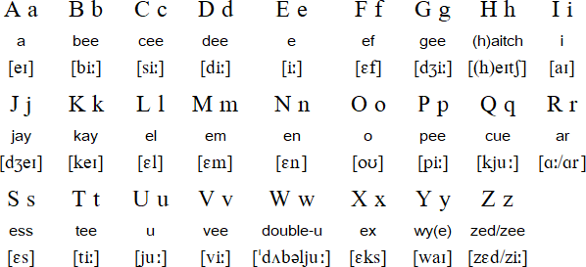

[**http://www.languageguide.org/im/alpha/eng/**](http://www.languageguide.org/im/alpha/eng/)

**COMPUTING**

Computing plays an important role in the information age. It will doubtlessly have the greatest impact as we approach the next century and the next phase of the information revolution. The applicability of computers to business is unique, as well as the potential of computers to enrich our life.

**Computing** is usually defined like the activity of using and developing [computer](http://en.wikipedia.org/wiki/Computer) technology, [computer hardware](http://en.wikipedia.org/wiki/Computer_hardware) and [software](http://en.wikipedia.org/wiki/Computer_software). It is the computer-specific part of [information technology](http://en.wikipedia.org/wiki/Information_technology). [Computer science](http://en.wikipedia.org/wiki/Computer_science) (or computing science) is the study and the science of the theoretical foundations of information and computation and their implementation and application in computer systems.

The **history of computer science** began long before the modern discipline of [computer science](http://en.wikipedia.org/wiki/Computer_science) that emerged in the twentieth century. Machines for calculating fixed numerical tasks, such as the [abacus](http://en.wikipedia.org/wiki/Abacus), have existed since antiquity. The progression, from mechanical inventions and mathematical theories towards the modern concepts and machines, formed a major academic field and the basis of a massive world-wide industry.

Before the 1920s, *computers* were human clerks that performed computations. They were usually under the lead of a physicist. Many thousands of computers were employed in commerce, government, and research establishments. Most of these computers were women, and they were known to have a degree in calculus. Some performed astronomical calculations for calendars.

After the 1920s, the expression *computing machine* referred to any machine that performed the work of a human computer

During the 1940s, as newer and more powerful computing machines were developed, the term *computer* came to refer to the machines rather than their human predecessors. As it became clear that computers could be used for more than just mathematical calculations, the field of computer science broadened to study [computation](http://en.wikipedia.org/wiki/Computation) in general. Computer science began to be established as a distinct academic discipline in the 1960s.

Time has seen significant improvements in the usability and effectiveness of **computer science technology**. Modern society has seen a significant shift from computers being used solely by experts or professionals to a more widespread user base. By the 1990s, computers became accepted as being the norm within everyday life.

Despite its relatively short history as a formal academic discipline, computer science has made a number of fundamental contributions to [science](http://en.wikipedia.org/wiki/Science) and [society](http://en.wikipedia.org/wiki/Society).

Adapted from <http://en.wikipedia.org/>

*1. Define computing.*

*2. When did computer science begin?*

*3. Who did the computing machines replace after the 1920s?*

*4. In what way has computing changed your life?*

*Useful links:*

<http://foldoc.org/>

FOLDOC - Free On-line Dictionary of Computing

<http://www.computing.net/>

Computing.Net is one of the biggest and oldest technical support web sites.

Go to [www.computerhistory.org/timeline](http://www.computerhistory.org/timeline/) and complete the table below.

|  |  |
| --- | --- |
| Hewlett-Packard was Founded. | ­­­\_1939\_\_ |
| FORTRAN, a general-purpose programming language, was developed by \_IBM\_ . | 1957 |
| \_\_BASIC\_\_\_\_\_\_\_\_\_\_\_\_, an easy-to-learn programming language, was created. | 1964 |
| The first electrically powered and computer-controlled \_\_robot\_\_\_\_\_\_\_\_\_\_ was created. | 1969 |
| The first advertisement for a microprocessor, the Intel 4004, appeared in Electronic News. | 1970  \_\_\_\_\_ |
| The Kenbak-1, the first personal ­­­­­­­\_\_\_computer\_\_\_\_\_\_\_\_\_\_\_, was advertised for $750 in Scientific American. | 1971 |
| The first ­­­­­­­­­­­­­­­­­­­­\_\_\_email\_\_\_\_\_\_\_\_ was sent. | 1971 |
| An IBM team, originally led by David Noble, invented the 8-inch floppy \_\_\_drive\_\_\_\_\_\_\_\_\_\_\_\_\_. | 1971 |
| Steve Wozniak designed the Apple I, a single-board computer. With specifications in hand and an order for 100 machines at $500 each from the Byte Shop, he and \_\_\_\_\_\_\_\_\_\_Steve Jobx\_\_\_\_\_\_\_\_\_ got their start in business. About 200 of the machines sold before the company announced the Apple II as a complete computer. | 1976 |
| USENET was invented as a means for providing mail and file transfers. It enabled its users to post messages and files that could be accessed and archived. | 1978  \_\_\_\_\_ |
| \_SONY\_\_\_\_\_\_\_\_\_ introduced and shipped the first 3 1/2" floppy drives and diskettes. | 1981 |
| Apple Computer launched the Macintosh, the first successful \_\_\_mouse\_\_\_\_\_\_\_\_\_\_\_\_\_\_\_\_\_\_\_ computer with a graphic user interface. | 1984 |
| The World Wide Web was born when Tim Berners-Lee developed **\_\_\_\_\_\_\_\_\_\_\_\_\_\_\_HTML\_\_\_\_\_\_\_\_\_\_\_\_\_** Language. | 1990 |
| Microsoft shipped (released) Windows 3.0. | \_\_1990\_\_\_ |
| The \_\_\_\_\_\_\_\_\_LINUX\_\_\_\_\_\_\_ operating system, is now one of several open source Unix-like operating systems, was introduced. | 1991 |
| The \_\_Intel Pentium\_\_\_\_\_\_\_\_\_\_\_\_\_\_\_\_ microprocessor was released. | 1993 |
| The Mosaic web browser, the first commercial software that allowed graphical access to content on the internet, was released. | \_\_\_\_\_ |
| \_\_\_\_\_\_\_\_Yahooi\_\_\_\_\_\_\_\_\_\_ , one of the Internet’s most popular search engines, was founded. | 1994 |

**Language is a Cycle**

When you open a traditional language course book it usually starts with lesson 1 and goes down to lesson 10 or whatever the final lesson in the book might ……………… . Naturally you follow this logical structure and when you …………………….completed the first lesson you move on to the next. At least that …………………… what the authors of the book recommend you to do. And it all makes perfect sense, …………………. it? A language course must …………………. a beginning and an end. Now, let's think about this again. ………………………. this really so? What happens if you skip the first five lessons and start with lesson No 6 and then you move on to lesson No 3 after which you jump to lesson No 8. ………………………. you tried this already? No? Then that suggests you like rules and structure.

However, in most real life situations you ………………….. find that they ………………….. have the same sequence as the course in your exercise book. Even the grammar rules …………………………. seem to appear in the same order as you ……………………. learned them. Language ……………………. not be pressed into the pages of a course book. Language ………………………… not be regarded as a course that starts at one point and goes on to another because language is a cycle that you ……………………….. complete as often as you want and on every round you …………………….discover something new. Traditional language teaching assumes that a person has to start at a certain level and then move on to the next stage. But when you learn a second language you already know all the grammatical concepts of your mother tongue. Take the Conditionals. In most language course books you …………………….. find them in the more advanced sections. Yet, when you use English to communicate with another person you ………………………. very well encounter a situation that requires one of the conditionals. In the world of conventional teaching there ………………… learners with various skill levels.

……………………… you speak your mother tongue fluently? Of course you …………………. so you ……………………… proved that you ……………………… learn any other language as well. Our psychology ………………………. programmed in such a way that we assume it …………………… be hard work to learn a second language, it must take a long time and a lot of self-discipline but that …………………….. not the case. ………………………… you know that a child aged 6 - 7 years already uses most of the grammatical constructions of their native language? (including any form of the conditional)

So, when you learn a second or third language you ……………………. have to start from scratch - you already know the concepts of the tenses, the passive and active voice, modal verbs and so on. All you really have to do ……………….. change your habits and get used to expressing the same concept with different constructions and phrases. That ……………. what it comes down to:

Changing your habits. If you grew up in an English speaking country you usually say «I …………………. cold.» when you feel cold. If your mother tongue …………………………. German you ………………………. likely to say: «Ich friere.» You see, in all three cases the concept ……………………. the same. What ……………………. different ……………………. the way to express this concept. The older you get the more you get used to your language but the more you ……………………. also aware that life ………………………. a series of changes you have to adapt to or even bring about yourself. So, when you want to learn a new language you …………………… have to start with «lesson 1» or even «lesson 0». You …………………… pick any point out of the cycle and start there because sooner or later you ………………………… come across the point that ………………………… marked «lesson 1» in your language course book.

This of course ……………………….. only one part of the aspects to learning languages and the more ideas and concepts you try out the sooner you …………………………. find what works best for you. If you …………………….. achieved the results you want to yet it ……………………….. not because you ……………………… not good at languages it …………………….. simply that you …………………….. found your own special way of dealing with them yet.

*Adapted from http://www.english-test.net/articles/3/index.html*

**THE MACHINE THAT CHANGED THE WORLD**

# *When was the first computer invented?*

Unfortunately this question has no easy answer because of all the different types of classifications and types of [computers](http://www.computerhope.com/jargon/c/computer.htm).

It is difficult to identify any one device as the earliest computer, partly because the term *computer* has been subject to varying interpretations over time. Originally, the term *computer* referred to a person who performed numerical calculations (a [human computer](http://en.wikipedia.org/wiki/Human_computer)), often with the aid of a [mechanical calculating device](http://en.wikipedia.org/wiki/Mechanical_calculating_device).

The first devices that resemble modern computers date to the mid-20th century (around 1940 – 1945. The Z1 is considered to be the first electrical binary programmable computer. The history of the modern computer begins with two separate technologies - that of automated calculation and that of programmability.

A computer is a programmable [machine](http://en.wikipedia.org/wiki/Machine) that manipulates [data](http://en.wikipedia.org/wiki/Data_%28computing%29) according to a list of [instructions](http://en.wikipedia.org/wiki/Code_%28computer_programming%29) known as a program. Early electronic computers were the size of a large room, modern computers, however, are based on tiny [integrated circuits](http://en.wikipedia.org/wiki/Integrated_circuit) and are millions to billions of times more capable while occupying a fraction of the space. [Personal computers](http://en.wikipedia.org/wiki/Personal_computer), in various forms (desktop, laptop, tablet), are icons of the [Information Age](http://en.wikipedia.org/wiki/Information_Age) and are what most people think of as "a computer"; however, the most common form of computer in use today is the [embedded computer](http://en.wikipedia.org/wiki/Embedded_computer). Embedded computers are small, simple devices that are used to control other devices — for example, they may be found in machines ranging from [fighter aircraft](http://en.wikipedia.org/wiki/Fighter_aircraft) to [industrial robots](http://en.wikipedia.org/wiki/Industrial_robot), [digital cameras](http://en.wikipedia.org/wiki/Digital_camera), and [children's toys](http://en.wikipedia.org/wiki/Toy).

Computer users and computer professionals should ensure that computers are used not only efficiently but in a socially responsible way.

**I. Computers can be generally classified by size and power. Match the terms in column A with the statements in column B.**

|  |  |
| --- | --- |
| A | B |
| **Minicomputer 7** | 7A small, single-[user](http://www.webopedia.com/TERM/C/user.html) computer based on a [microprocessor](http://www.webopedia.com/TERM/C/microprocessor.html). In addition to the microprocessor, a personal computer has a keyboard for entering data, a [monitor](http://www.webopedia.com/TERM/C/monitor.html) for displaying information, and a [storage device](http://www.webopedia.com/TERM/C/storage_device.html) for [saving](http://www.webopedia.com/TERM/C/save.html) data. |
| **personal computer** | 8 An extremely fast computer that can perform hundreds of millions of instructions per second. |
| **Mainframe 3** | 3 A [multi-user](http://www.webopedia.com/TERM/C/multi_user.html) computer capable of supporting from 10 to hundreds of users simultaneously. It is primarily used by large organizations for critical applications, bulk data processing, industry and consumer statistics, enterprise resource planning and transaction processing. It is often approximately measured in millions of instructions per second (MIPS). |
| **Supercomputer 8** | A powerful computer that is at the frontline of current processing capacity, particularly speed of calculation. It is used for scientific and engineering problems (high-performance computing) which are data crunching and number crunching. It is measured in floating point operations per second (FLOPS). |
| **Workstation 5** | 5A powerful, single-user computer. A workstation is like a personal computer, but it has a more powerful microprocessor and a higher-quality monitor. |

**II. Compare a PDA and a laptop in terms of:**

size, weight, portability, speed.

*- Read the articles on these websites and check your answers.*

* [www.opentopia.com/showart.php?source=go&artid=54259&catid=7](http://www.opentopia.com/showart.php?source=go&artid=54259&catid=7)
* [www.andybrain.com/archive/mb/comparing\_computers.htm](http://www.andybrain.com/archive/mb/comparing_computers.htm)

- *Would a PDA or a laptop be more suitable for this person?*

»I work as a businessman. I travel a lot. I have to send my headquarters my customers' orders in time. I also need a device to organize all my appointments. I don't want to carry much weight.«

**III. Answer.**

1. ***Do you have a computer at home?***
2. ***What do you use it for?***
3. ***Can you imagine your life without it?***
4. ***Do you consider yourself to be a computer addict?***
5. ***How do you think these professions might use computers? Compare your answers with your colleague.***

**musicians, interior designers, farmers, teachers, salespeople, rally drivers**

**IV. Work with your partner. Find out this information from him/her.**

***Example:***

**Send an email** (who to, when)

A: Have you ever sent an email?

*B: Yes, I have.*

A: Who did you send it to?

*B: I sent it to my friend.*

|  |  |
| --- | --- |
| watch satellite TV | which station |
| write a program | which language, when |
| replace a printer cartridge | when |
| fix a printer fault | what kind |
| download music | what site |
| make your own website | how |

**V. Describe how you use a computer in your free time and in your study.**

**COMPUTER**

­Wh­en you mention the word *technology*, most people think about **computers.** Computers are, in fact, all around us. Microprocessor chips are found in many electronic devices (in an iPod, in a DVD player, in a microwave, in a car, in a phone). These are special-purpose computers that run programs to control the equipment and optimize its performance. But the computer that everyone thinks of first is typically the **personal computer,** or **PC.**

A computer is an electronic [machine](http://en.wikipedia.org/wiki/Machine) that manipulates [data](http://en.wikipedia.org/wiki/Data_%28computing%29) according to a list of [instructions](http://en.wikipedia.org/wiki/Code_%28computer_programming%29). It accepts, processes, stores and outputs information. The ability to store and execute lists of instructions called [programs](http://en.wikipedia.org/wiki/Computer_program) makes computers extremely versatile and distinguishes them from [calculators](http://en.wikipedia.org/wiki/Calculator).

A typical computer consists of two parts: hardware and software. Hardware is any electronic or mechanical part of the computer system that you can see or touch. Software is a set of instructions, called a program, which tells a computer what to do.

There are three basic hardware sections.

1. The CPU is the heart of the computer, a microprocessor chip which processes data and coordinates the activities of all the other units.
2. The main memory holds the instructions and data which are being processed by the CPU. It has two main sections: RAM (random access memory) and ROM (read only memory).
3. Peripherals are the physical units attached to the computer. They include:

Input devices, which let us enter data and commands (e.g. the keyboard and the

mouse).

Output devices, which let us extract the results (e.g. the monitor and the printer).

Storage devices, which are used to store information permanently (e.g. hard disks and

DVD-RW drives). Disk drives are used to read and write data on disks.

At the back of a computer there are ports into which we can plug external devices (e.g. a scanner, a modem, etc.). They allow communication between the computer and the devices.

**1. Match the item in Column A with its function in Column B.**

A B

|  |  |
| --- | --- |
| modem | is a device used to produce voice output and play back music |
| mouse | is a mechanism that reads and/or writes to optical discs |
| monitor | controls all the operations in a computer |
| ROM | holds data read or written to it by the processor |
| keyboard | inputs data through keys like a typewriter |
| RAM | holds instructions which are needed to start up a computer |
| processor | displays the output from a computer on a screen |
| CD/DVD drive | controls the cursor |
| speaker | device that converts data so that it can travel over the Internet |

**2. Describe the functions of these items.**

1. printer
2. memory
3. hard disk drive
4. barcodes
5. scanner
6. swipe cards
7. port
8. cache

**3. Label this diagram with the correct terms.**

**4. Complete the diagram and sentences below.**

Functions of a computer

1. Computer ………………………….. is the visible or audible result of data processing –

information that can be read, printed or heard by the user.

2. The CPU will process data as instructed by the programs you’re running. …………………

includes functions like calculating, sorting, editing, drawing and searching.

3. DVDs are expected to replace CDs as …………………… devices.

4. As a scanner, the Stigma-100 can be used to ………………………. photographs as well as

documents into the computer.

**6. Complete each sentence using the correct preposition.**

1. The CPU is a large chip ………………. the computer.
2. Data always flows ………………… the CPU ……………….. the address bus.
3. The CPU can be divided ……………………. three parts.
4. Data flows …………………. the CPU and memory.
5. Peripherals are devices ……………… the computer but linked …………………. it.
6. The signal moves ………………… the VDU screen ……..………….. one side ……………….. the other.
7. The CPU puts the address ……………………. the address bus.
8. The CPU can fetch data …………………. memory ………………… the data bus.

**7. Translate into Slovene.**

|  |  |
| --- | --- |
| cache -  memory bus - | address bus –  bus speed – |

**8. Find the words in the matrix, then read the leftover letters to find a secret message**

**about computers.**

**Computer Wordsearch Puzzle**

|  |  |  |  |  |  |  |  |  |  |
| --- | --- | --- | --- | --- | --- | --- | --- | --- | --- |
| C | O | M | N | E | E | R | C | S | P |
| C | R | A | S | H | B | Y | T | E | U |
| A | T | E | R | Y | R | O | M | E | M |
| P | A | S | S | W | O | R | D | S | S |
| P | A | E | U | E | W | R | E | U | E |
| L | H | N | R | B | S | U | S | O | C |
| I | C | T | F | S | E | R | A | M | A |
| C | R | E | V | I | R | U | S | E | P |
| A | A | R | O | T | I | N | O | M | S |
| T | E | N | R | E | T | N | I | F | R |
| I | S | K | N | I | L | I | A | M | E |
| O | K | E | Y | B | O | A | R | D | B |
| N | U | K | C | I | L | C | O | P | Y |
| S | L | R | E | T | U | P | M | O | C |

|  |  |  |
| --- | --- | --- |
| **applications**  **browser**  **byte**  **click**  **computer**  **copy**  **crash**  **cyberspace** | **email**  **enter**  **internet**  **keyboard**  **links**  **memory**  **monitor**  **mouse** | **password**  **RAM**  **ROM**  **screen**  **search**  **surf**  **virus**  **website** |

***Secret message:***

Computers are useful

http://www.enchantedlearning.co

**TYPES OF COMPUTER SYSTEMS**

There are different types of computer varying in size and power. The first computers took up a whole room, but by the 1960s, electronic components had become much smaller and computers began to shrink in size. The home computer became possible through the invention of the microchip which contains tens of thousands of electronic components within a space no larger than a fingernail.

**Brief history of miniaturization**

|  |  |
| --- | --- |
| In 1834, Charles Babbage designed the first mechanical computer, but he never saw it built.  <http://www.sciencemuseum.org.uk/images/object_images/535x535/10297676.jpg> |  |
| In the 1960s, computers used transistors and stored data on tape. They could fill a whole room.  <http://www.digibarn.com/stories/trepanier/reac.jpg> |  |
| The 1981 Sinclair ZX81 was one of the first home computers to be launched on the world market.  <http://workbench.cadenhead.org/media/timex-sinclair-zx81.jpg> |  |
| Portable laptop computers, small enough to fit inside a briefcase, became available in 1980s.  <http://www.computermuseum.li/Testpage/Toshiba1.htm> |  |
| The process of miniaturization created electronic diaries called personal organizers.  <http://ecx.images-amazon.com/images/I/61wF8qppG1L._SL500_AA280_.jpg> |  |
| **Your example(s)?** |  |

**1. Match the computer types in column A with the definitions in column B.**

|  |  |
| --- | --- |
| **A** | **B** |
| Tablet PC | A tiny, hand-held computer which can be used as personal organizer, a telephone and a web explorer |
| Laptop / notebook | A computer which has its own CPU, monitor and keyboard; it is designed to be placed on a desk and is popular for home use and found in many businesses |
| Wearable computer | The most powerful type of computer which is capable of processing and storing large amounts of data and is usually linked to many terminals |
| Mainframe | A small computer that is worn on the user’s body and runs on batteries. |
| Desktop PC | A lightweight, portable computer that can be as powerful as a desktop PC |
| PDA /personal digital assistant | A full-function PC which looks like a book. You can write on the LCD screen by using a special digital pen and your handwriting can be converted into editable text. Its screen can be folded and rotated 180 degrees. |

**2. Label the pictures with words from exercise 2.**

|  |  |  |  |
| --- | --- | --- | --- |
| … .………………....... | …………………… | …………………… | ……………………. |

**3. Mobile devices (tablets, cell phones) in the classroom – a distraction or a useful learning tool? Discuss with a partner.**

For more opinions go to >>

<http://campustechnology.com/articles/2014/02/20/from-distraction-to-learning-tool-mobile-devices-in-the-classroom.aspx>

<http://blogs.kqed.org/mindshift/2012/05/how-teachers-make-cell-phones-work-in-the-classroom/>

<http://www.scholastic.com/browse/article.jsp?id=3754742>

<http://www.nbcnews.com/id/26510338/ns/technology_and_science-back_to_school/t/cell-phones-welcome-some-classrooms/#.VDGLVRZiKmp>

Why not use the **mobile app Socrative** for revising and testing knowledge in the classroom?

Go to <http://www.socrative.com/>

**MOBILE COMPUTER DEVICES**

A mobile computer device is a type of computer that can be easily transported and uses batteries to operate, so the device can be used from anywhere. A mobile computer device allows a user to work from any location and access the Internet through a wireless network or at a Wi-Fi hotspot. Mobile devices are smaller and more lightweight than traditional computers while still carrying the same functionality.

1. **Name at least five types of mobile devices.**
2. **Discuss with a partner and write at least 3 advantages and 3 disadvantages of mobile computer devices.**

|  |  |
| --- | --- |
| ADVANTAGES | DISADVANTAGES |
|  |  |
|  |  |
|  |  |
|  |  |

These sites might help you:

<http://www.ehow.com/list_6187068_advantages-mobile-computer.html>, <http://www.ehow.com/list_6137468_disadvantages-mobile-computers.html>,

1. **Complete the text.**

**Laptop Computers**

A laptop computer is the most common type of a mobile computer....................... . A laptop computer is a one-piece device (meaning the..................., screen and computer are all attached) that is small enough to fit into a person’s.......................... Modern laptops range in price, size, and .......................... although most laptops come equipped with DVD-ROM drives, wireless cards, and several gigabytes of RAM. Laptops are capable of handling any task normally carried about by a desktop computer, such as checking email, creating .............................., or playing games.

**Notebook Computers**

Notebook computers function much like laptops. However, notebook computers do not come equipped with DVD-ROM .........................., and have .....................memory and a smaller hard drive.

**Tablet PC**

A Tablet PC is ............................... to a laptop computer in that a Tablet PC often carries a wireless network card, and an adequate hard drive and memory. Unlike the laptop computer, the Tablet PC does not fold open to reveal a separate keyboard and screen. Instead, the Tablet PC is a single screen and the consumer uses a ..................................to write on the tablet instead of the traditional keyboard.

**Personal Digital Assistant**

A Personal Digital Assistant (PDA) functions much like a laptop computer or Tablet PC but is a smaller, .................................. device. Original PDA devices were designed as an electronic address and date book holding contact information, calendars, and to-do lists. Modern PDA devices have expanded to include Wi-Fi, GPS, and the ability to .................................. a variety of applications.

**Smartphone**

A smartphone is a combination of a cellular phone and a PDA. Smartphones are small, handheld devices that more resemble a PDA than a cellular phone. A smartphone .............................. standard phone features, such as making and receiving phone calls, with computer functionality. Smartphones incorporate Wi-Fi access, email, calendars and GPS. Typical modern smartphones also ......................... the user to download additional applications and personalize the device, similar to a computer.

Source: <http://www.ehow.com/list_5951440_types-mobile-computer-devices.html>

**INPUT DEVICES**

An input device is a piece of hardware that is used to enter data into a computer. There are many different kinds of input devices, manual and automatic.

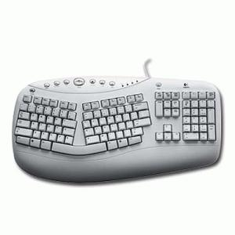The most common input devices are: a keyboard, a mouse, a touchpad, a joystick, a touch screen, a scanner, a digital camera, a graphics tablet, a microphone, a lightpen, a webcam, a barcode reader.

The **keyboard** is the most common and widely used input device. It is made up of buttons called 'keys'. The keys are arranged into sections:

* alphabet keys
* Function or F keys (F1, F2, F3)
* Numeric keys (one set above the alphabet keys and a numeric keypad on the right)
* Arrow keys
* Command keys (insert, delete, home, end, page up/down)

Most keyboards are called 'QWERTY' keyboards. This name comes from the first six letters on the top row of the alphabet keys. Using a keyboard for too long can lead to health problems such as repetitive strain injury (RSI). To try to overcome this, different styles of keyboard have been developed, for example, the ergonomic keyboard. They are supposed to put your hands into a much more natural position than a traditional keyboard.

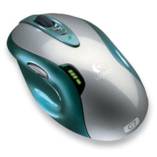Along with the keyboard, a **computer mouse** is one of the most common input devices. A mouse is also called a 'pointing device' because it enables you to control what happens on the screen by moving the mouse on your desk and pointing, clicking and selecting items on the screen.

A mouse usually has two buttons, a right and left one and also a central wheel which allows you to scroll up and down the page (some mice have three or four buttons). The left and right buttons have different functions. Left clicking usually lets you put your cursor at a certain point on the page or lets you choose a menu item. Right clicking brings you up a list of relevant menu items from which you can select a task.

Many of the older styles of mice used a ball which moved against two internal rollers to record the direction that the mouse was being moved in. Recent versions of mice use 'optical' or 'wireless' technology to track mouse movement.

1. **Write the “mouse actions”.**

To press and release the left button = to ……………..

To press and release the left button twice = to …………….

To hold down the button, move the pointer to a new place and then release the button = to ………….

To press and release the right button = to …………..

1. **Complete the sentences using the expressions from exercise 1.**
2. If you want to select a menu option, you just ……………………… on the left button.
3. If you want to start a program or open a document you ……………….. on its icon – that is you rapidly press and release the mouse button twice.
4. If you want to find the commands for a particular text, image, you have to …………………….. on it.
5. If you want to move an object, press the button and …………………… the object to the desired location.
6. **What am I?**

I store photos as digital data, usually on a tiny storage device known as a flash memory card.

…………………………….

|  |  |
| --- | --- |
| I read images and convert them into electronic codes which can be understood by a computer. |  |
| I let you send and receive live video pictures through the internet. |  |
| I am used for reading barcode labels printed on products. |  |
| I have no cable. I send data via infrared signals or radio waves. |  |
| I remove the character to the left of the cursor or any selected text. |  |
| I’m used to confirm commands. In a word processor, I create a new paragraph. |  |
| I work in combination with other keys, e.g. by pressing me and V to paste the selected text. |  |
| I produce upper-case letters. |  |

1. **Which input device would you use for the following tasks?**

|  |  |
| --- | --- |
| to read price labels in a shop |  |
| to copy images from a book into a computer |  |
| to play computer games |  |
| to select text and click on links on web pages |  |
| to enter drawings and sketches into a computer |  |

1. **Voice input**

Today you can also interact with your computer by voice with a **voice-recognition system** that converts voice into text, so you can dictate text directly onto your word processor or email program. You can also control your PC with voice commands; this means you can start programs, open, save or print files. Some systems let you search the Web or chat using your voice instead of the keyboard.

- Who do you think can find voice-recognition system extremely useful?

- Do you think that in the future people will be able to interact with their computers naturally,

like a friend?

**OUTPUT DEVICES**

A **monitor** (or screen) is the most commonly used output device. They come in many different shapes, sizes and forms. The picture on a monitor is made up of thousands of tiny coloured dots called pixels. The quality and detail of the picture depends on the number of pixels that the monitor can display. The higher the number of pixels, the better quality the output.

Larger monitors make working at the computer much easier on the eyes, but the larger the monitor, the more money it costs! Typical monitor sizes are 24 inches.

The two types of monitor that you need to know about are Cathode Ray Tube monitors (CRT) and Thin Film Transistor monitors (TFTs).

**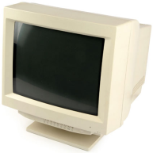CRT monitors** are becoming outdated, although you will probably remember using them at school not very long ago.

They are large and bulky and have a glass screen which makes them fairly robust and difficult to damage. They produce quite a lot of heat so when you have an office with lots of them it could get quite warm. They are also fairly noisy compared to newer TFT monitors.

**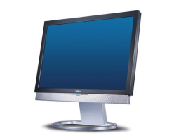TFT monitors** used to be very expensive but now the price has come down they are beginning to replace all of the old CRT monitors. Not only do they look much nicer they take up a lot less space. They are quieter than CRT monitors and also create less heat.

On the down side they are easier to damage than CRT screens. A few sharp pokes at the screen with a pencil can cause lasting damage. Another disadvantage is that unless you have a very high quality TFT monitor, the colours and contrast are not so good as a CRT monitor and so the picture can look a bit dull.

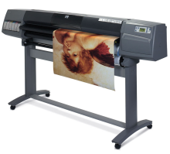

**Printers** are another common output device. A printer prints you texts or graphics on paper. There are different types of printers: a dot-matrix printer, an ink-jet printer, a laser printer, a multi-function printer, a plotter.

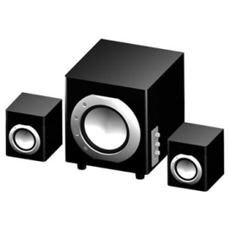

Most computers are fitted with a small internal **speaker** which can produce beeping sounds to alert you if you make an error. Computers can also be fitted with a sound card (or chip) which will enable sound to be output through external speakers. These usually produce a much higher quality sound than the internal speaker.

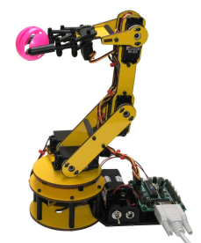**Other output devices**

* Output can also be in the form of instructions to a device such as a **robot arm**.
* **LCD projectors**

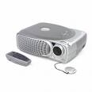An *LCD projector* is a type of [video projector](http://en.wikipedia.org/wiki/Video_projector) for displaying video, images or computer data on a screen or other flat surface. It is a modern analogue of the [slide projector](http://en.wikipedia.org/wiki/Slide_projector) or [overhead projector](http://en.wikipedia.org/wiki/Overhead_projector). To display images, LCD ([liquid crystal display](http://en.wikipedia.org/wiki/Liquid_crystal_display)) projectors typically send light from a [metal halide lamp](http://en.wikipedia.org/wiki/Metal_halide_lamp) - **High-intensity discharge** (HID) lamp. These lamps are used because they output an ideal colour temperature and a broad spectrum of colour. They also have the ability to produce an extremely large amount of light within a small area. The primary drawback to LCD projectors is the cost of bulb replacement, often running several hundred dollars each.

1. **Write terms which correspond to these definitions.**

|  |  |
| --- | --- |
| A device that uses a laser beam to fix the ink to the paper |  |
| A container that holds the ink in an ink-jet printer |  |
| A device that uses a group, or matrix, of pins to create precise dots. |  |
| A peripheral which combines a printer, a fax machine and photocopying and scanning capability into one device |  |
| A flat-panel display which works by emitting light through a special liquid 8liquid crystal solution) |  |
| The smallest element in a displayed image |  |
| Visual display unit (VDU) |  |
| A special type of printer which uses ink and fine pens held in a carriage to draw detailed designs on paper. It is able to draw high quality images on very large pieces of paper and used by engineers (computer-aided designs), architects and map-makers to draw plans of buildings, diagrams of machines or large scale maps. |  |
| An output device which can give you a warning that you have made a mistake or error |  |

1. **Choose the most appropriate type of printer for these situations.**

|  |  |
| --- | --- |
| Which printer is also known as an 'impact' printer? |  |
| A friend wants you to recommend the best printer for them to use at home for printing a few colour posters |  |
| Which printer should a company choose for printing large quantities of mail-merged letters? |  |
| A firm wants the quietest type of printer. Which one should they buy? |  |
| Your friend wants to know which printer uses cartridges |  |
| Which output device would be used for printing onto pieces of paper 3 feet wide? |  |
| Which type of office printer would produce the best quality printouts? |  |
| Which type of printer can use continuous paper with perforated edges? |  |
| Which type of printer produces the cheapest cost per page print outs? |  |

**III. Complete the following sentences by filling in the missing words from the list given.**

***dot matrix, ink jet, page printer, pins, pixels, speakers, pens, plotter, visual display unit,******characters per second, pages per minute, liquid crystal display, PDL***

1. Lasers use a page description language or ­­­­­­­­­­­­­\_\_\_\_\_\_\_\_\_\_\_\_whichdescribes how to print the text and draw the images on the page.
2. A laptop computer uses a LCD output device which stands for \_\_\_\_\_\_\_\_\_
3. A laser printer can print 200 monochrome \_\_\_\_\_\_\_\_
4. CPS stands for \_\_\_\_\_\_\_\_\_\_\_
5. Most PCs use a colour monitor as an output device and this is also called a VDU or \_\_\_\_\_\_\_\_\_\_\_
6. With a \_\_\_\_\_\_\_\_\_\_\_\_\_ a page is held fixed and a pen draws on it. Different coloured \_\_\_\_\_\_\_\_ can also be used with this output device.
7. A video conferencing system uses \_\_\_\_\_\_\_\_\_\_\_\_\_\_ as an output device so that a person can hear over the Internet.
8. The resolution of a monitor depends on the number of \_\_\_\_\_\_\_\_\_ going across and down the screen.
9. With a dot matrix printer each character is made up from a series of \_\_\_\_\_\_\_\_ which are hammered against a printer ribbon.
10. A laser printer is an example of a \_\_\_\_\_\_\_\_\_
11. I would use an \_\_\_\_\_\_\_\_\_\_\_\_\_\_ printer to print photographs that have been taken with a digital camera.
12. A garage would use a \_\_\_\_\_\_\_\_\_\_\_\_ printer to produce carbon copies of bills to customers.

**STORAGE DEVICES**

Unless you want to lose all of the work you have done on your computer, you need to have a way to store it safely. Computer data storage, often called storage or memory, refers to [computer](http://en.wikipedia.org/wiki/Computer) components, devices, and [recording media](http://en.wikipedia.org/wiki/Recording_medium) that retain digital [data](http://en.wikipedia.org/wiki/Data_%28computing%29) used for computing for some interval of time. Computer data storage provides one of the core functions of the modern computer, that of information retention. Data can be stored either in the 'internal memory' or on a 'storage device'. Historically, *memory* and *storage* were called *primary storage* and *secondary storage*. In contemporary usage, *memory* usually refers to a form of [semiconductor](http://en.wikipedia.org/wiki/Semiconductor) storage known as [random access memory](http://en.wikipedia.org/wiki/Random_access_memory) (RAM) and sometimes other forms of fast but temporary storage. Similarly, *storage* today more commonly refers to [mass storage](http://en.wikipedia.org/wiki/Mass_storage) - [optical discs](http://en.wikipedia.org/wiki/Optical_disc), forms of [magnetic storage](http://en.wikipedia.org/wiki/Magnetic_storage) like [hard disks](http://en.wikipedia.org/wiki/Hard_disk).

The amount of data and instructions that can be stored is measured in 'bytes'.

One byte contains 8 bits (short for Binary Digit). This is the smallest unit of data that can be stored. Each 'bit' is represented as a binary number, either 1 or 0.

A single keyboard character such as the letter A or T takes one byte of storage.

We normally refer to the capacity of a storage device in terms of Kilobytes (KB), Megabytes (MB),

one

bit

Gigabytes (GB) - or even Terabytes!

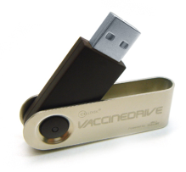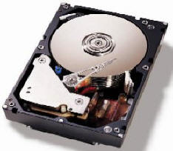

|  |  |  |  |  |  |  |  |
| --- | --- | --- | --- | --- | --- | --- | --- |
| 0 | **0** | 1 | 1 | 0 | 1 | 0 | 1 |

one byte = 8 bits

  Magnetic storage Optical storage Flash memory

**There are different storage sizes.**

|  |  |
| --- | --- |
| **Bit** - Smallest unit of data, either a 0 or 1 | **Megabyte (Mb)** - 1,000 kilobytes (1,024 Kb) |
| **Byte** - 8 bits | **Gigabyte (Gb)** - 1,000 megabytes (1,024 Mb) |
| **Kilobyte (Kb)** - Assumed to be 1,000 bytes. In reality, it is really 1,024 bytes. | **Terabyte** **(TB)** - 1012 bytes (1,000 Gb) |

### There are various types of storage devices, different devices are suitable for different tasks: ROM, RAM, hard disk, external hard disk, floppy disk, CD, DVD, flash memory.

|  |  |
| --- | --- |
| **USB flash drive**  ***Flash memory*** is [non-volatile](http://en.wikipedia.org/wiki/Non-volatile_memory) (no power is needed to maintain the information stored in the chip) [computer memory](http://en.wikipedia.org/wiki/Computer_storage) that can be electrically erased and reprogrammed. It is a technology that is primarily used in [memory cards](http://en.wikipedia.org/wiki/Memory_card) and [USB flash drives](http://en.wikipedia.org/wiki/USB_flash_drive) for general storage and transfer of data between computers and other digital products.  A ***USB flash drive*** consists of a [NAND](http://en.wikipedia.org/wiki/Flash_memory#NAND_memories)-type [flash memory](http://en.wikipedia.org/wiki/Flash_memory) [data storage device](http://en.wikipedia.org/wiki/Data_storage_device) integrated with a [USB](http://en.wikipedia.org/wiki/USB) (universal serial bus) interface. USB flash drives are typically removable and rewritable. It consists of a small [printed circuit board](http://en.wikipedia.org/wiki/Printed_circuit_board) protected inside a plastic, metal, or rubberised case, robust enough for carrying with no additional protection. The most common use of flash drives is to transport and store personal files such as documents, pictures and videos. The storage capacity is steadily being improved. [**http://en.wikipedia.org/wiki/USB\_flash\_drive**](http://en.wikipedia.org/wiki/USB_flash_drive) |  |

**I. Complete the blanks using words from the list. You should use each word only once.**

*backup, tape, erased, read, backing, media, WORM, compact, hard, read/write, cartridges, serial*

1. **\_\_\_\_\_\_\_\_\_** storage is used to store programs and data when they are not being used or when a computer is switched off.
2. Magnetic \_\_\_\_\_\_\_\_\_\_, floppy disks, and \_\_\_\_\_\_\_\_\_\_ disks are all types of backing storage \_\_\_\_\_\_\_\_\_\_.
3. Magnetic tape comes in reels or \_\_\_\_\_\_\_\_\_\_\_\_\_\_. It is used to make \_\_\_\_\_\_\_\_\_\_\_\_\_ copies of programs and data. Magnetic tapes allow only \_\_\_\_\_\_\_\_\_\_\_\_\_ access to data.
4. CD-ROMstands for \_\_\_\_\_\_\_\_\_\_\_\_\_ disk \_\_\_\_\_\_\_\_\_\_ only memory. A CD-ROM can store approximately four hundred times more data than an ordinary 3½ inch floppy disk. Data stored on a CD-ROM cannot be changed or \_\_\_\_\_\_\_\_\_\_\_\_\_.

\_\_\_\_\_\_\_\_\_\_\_\_\_ disks are a special type of compact disk that are supplied blank and can

have data written or ‘burned’ onto them using special \_\_\_\_\_\_\_\_\_\_\_\_\_\_\_\_ CD drives.

**II. Match the sentence beginnings with the correct endings.**

|  |  |
| --- | --- |
| RAM (Random Access Memory) is temporary or volatile which means that | is permanent and contains instructions needed by the CPU. |
| Optical drives use | is the brain of your computer. It processes data and coordinates the other parts of the computer. |
| ROM (Read Only Memory) | it holds data while your PC is working on it, but loses it when the power is switched off. |
| The processor, also called the CPU or central processing unit | which can hold several gigabytes of data and is used to keep the operating system, the programs and the user’s files easily available for use. |
| A floppy disk drive is a magnetic device using 3.5 inch diskettes | a laser to read and write data. |
| Flash memory is solid-state and | optical storage devices. Data is burned onto the surface of the disk using a laser beam which is also used to read the data stored on the disk. |
| A hard disk is a magnetic device | which can only hold 1.44 MB of data. |
| CDs (compact disks) and DVDs (digital versatile disks) are known as | rewritable memory which is retaining data when the power is turned off. |
| Flash memory cards | a USB port of the computer. They let you save and transfer data easily. |
| Flash drives are connected to | typically small, lightweight, removable and rewritable. They consist of a small printed circuit board which is encased in plastic or metal casing. |
| Flash memory storage devices are | such as CompactFlash are found in cameras, PDAs and music players. |

**III. Explain how a hard disk works.**

**IV. Outline 2 advantages and 2 disadvantages of using a hard disk to back up your data.**

**V. Compare and contrast a hard disk with RAM.**

**VI. WHAT AM I?**

I'm a magnetic storage device. I used to be very popular but now people do not want to use me any longer. I can only store files that are 1.44 Mb or less. I get damaged easily.

I'm a solid state storage device. I'm light, portable and reliable. I can store more than 8Gb of data. I can be plugged into a USB port in your computer.

I'm a magnetic storage device. I have a large storage capacity so I can permanently store all of your applications and files. I'm not easy to access and you cannot carry me around.

I'm an optical storage device. I can store about 650 Mb of data. You can use me to store music or to back up your files and data. You have to be careful with me as I can snap or get scratched.

\_\_\_\_\_\_\_\_\_\_ \_\_\_\_\_\_\_\_\_\_

………………………………………………………………………………………………..

**Glossary:**

***Non-volatile memory***, **nonvolatile memory**, **NVM** or **non-volatile storage**, is [computer memory](http://en.wikipedia.org/wiki/Computer_memory) that can retain the stored information even when not powered. Examples of non-volatile memory include [read-only memory](http://en.wikipedia.org/wiki/Read-only_memory), [flash memory](http://en.wikipedia.org/wiki/Flash_memory), most types of magnetic [computer storage](http://en.wikipedia.org/wiki/Computer_storage) devices (e.g. [hard disks](http://en.wikipedia.org/wiki/Hard_disk), [floppy disks](http://en.wikipedia.org/wiki/Floppy_disk), and [magnetic tape](http://en.wikipedia.org/wiki/Magnetic_tape)), [optical discs](http://en.wikipedia.org/wiki/Optical_disc), etc. <http://en.wikipedia.org/wiki/Non-volatile_memory>

***NAND*** flash architecture was introduced by [Toshiba](http://en.wikipedia.org/wiki/Toshiba) in 1989. These memories are accessed much like [block devices](http://en.wikipedia.org/wiki/Block_size_%28data_storage_and_transmission%29) such as [hard disks](http://en.wikipedia.org/wiki/Hard_disk) or [memory cards](http://en.wikipedia.org/wiki/Memory_card). <http://en.wikipedia.org/wiki/Flash_memory#NAND_memories>

***Block (data storage)*** - In [computing](http://en.wikipedia.org/wiki/Computing) (specifically data transmission and [data storage](http://en.wikipedia.org/wiki/Computer_storage)), a block is a sequence of [bytes](http://en.wikipedia.org/wiki/Byte) or [bits](http://en.wikipedia.org/wiki/Bit), having a nominal length (a *block size*). <http://en.wikipedia.org/wiki/Block_size_(data_storage_and_transmission)>

**NUMBERS**

**1. Say these numbers.**

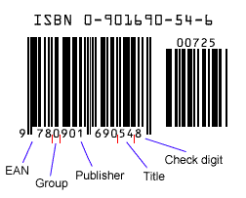

100 – one hundred

200 - two hundred

221 – two hundred **and** twenty-one (AmE – **and** can be omitted)

**2. Say these decimal numbers.**

4.56 7.304

0.9 12.12

1.08 0.602

**Write decimal points as a point (.), not a comma (,).** 5.7 ~~5,7~~

**After the point say numbers separately.** 3.25 three point two five

**Before the point say numbers together.** 25.25 twenty-five point two five

**Before the point 0 is *zero* or *nought* (not *oh*).** 0.4 zero point four

or nought point four

**After the point, 0 is zero or oh.** 0.05 zero point zero five

or zero point oh three

|  |  |
| --- | --- |
| **TODAY'S EXCHANGE RATE**  Base currency: €  € - Euros  £ - British Pounds  ¥ - Japanese yen  $ - American dollars | ***Ask your partner about the missing rates.***  A: I need some… What's the exchange rate  today?  B: It's…  A: OK. That's fine, thanks. |

**3. What parts does your telephone number have?**

+386 4 2804000 ext 43

country area number extension

code code

**4. Saying statistics and fractions.**

**3*% three per cent***

*Say these statistics:* 23% 69% 1.5%

22.33% twenty-two point three three recurring

**1/2 (a) half**

*Say these fractions:*

1/3 ……………. 2/3 ………………

1/4 …………… 3/4 ………………

1/5 …………….. 3/10 ……………..

1/10 …………….. 3/8 ………………

*Say these percentages as fractions:*

**25% is a quarter**

50% 75% 20% 10% 90%

*Complete the text with the following numbers: 1.3, 2, 21, 79, 70. Use each number once.*

**…………….per cent of the earth is covered by water. The air on the planet is ………….. per cent nitrogen and ………………. per cent oxygen, and carbon levels are increasing. Cities cover ……………. per cent of the world's land surface and the world's population is growing by …………….. per cent a year.**

*Complete the text by writing the fractions: 2/3, 1/4, 3/4, 1/2.*

**………………. of world’s population lives in cities. People in cities use ………………. of the worlds’s energy. ………………. of the world’s energy is used for transport, and cars use half of that. …………………. of the world’s cars are in Western Europe and North America.**

*The pie chart below represents the sales of an international newspaper. Use the information from the chart to complete these sentences:*

1. The majority of sales are in ………………………. .
2. Almost a quarter of sales are in ……………………… .
3. Almost three-quarters of sales are in ……………………. .
4. Two very small areas for sales are in …………………….. and …………………. .
5. …………………….. represent a fairly small percentage of sales.

**5. Calculations.**

*Write the symbols.*

multiplied by □ equals □ minus □ plus □ divided by □

*Complete and say the equations.*

8 □ 4 = 2 Eight divided by four equals two.

6 □ 12 = 18 15 □ 3 = 12 8 □ 2 = 4

*Work with a partner.*

A – dictate a sum. B – write it down and say the answer.

Example

A: Nine multiplied by three, minus six, plus four equals…

B: It equals twenty-five.

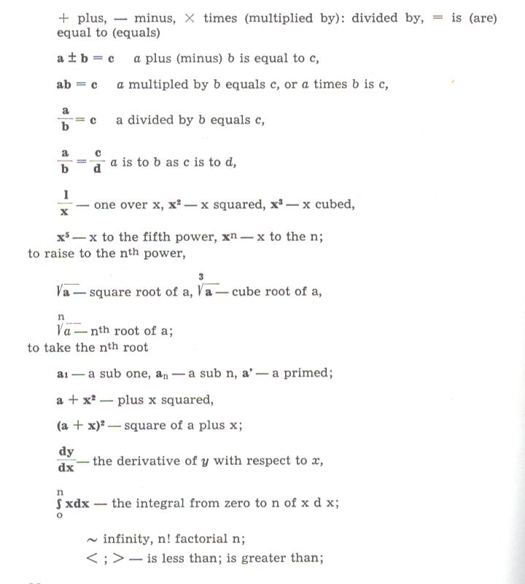**6. Dimensions**

height → How ……...high…….. is it? 5 in

length → How ………...………. is it? 6 in

width → How …………………..is it? 9 in

weight → How …………………..is it? 12 g

depth → How ……………...…...is it? 20 m

*Look at the specifications and complete the text about the Robosaurus.*

**SPECIFICATIONS**

|  |  |
| --- | --- |
| Height (standing) – 12m | Length of teeth – 30 cm |
| Height (folded up) – 4 m | Jaw pressure – 140 kg/cm2 |
| Length (folded up) – 14 ½ m | Weight – 26 tonnes |
| Width (folded up) - 2 ½ m |  |

**The Robosaurus is a 12 ………………………. entertainment robot. It's designed to lift, crush and burn cars. It …………………… 26 tonnes and it's controlled by a human pilot who sits inside its head. 60 m flames come out of his nose, and its mouth opens and closes with a pressure of ………………….. . It can lift cars 15 m in the air and bite them in half with its ………………….. teeth. After shows, the robot becomes a trailer and it can travel by road to the next city. It can fold up to just …………………… long, 4 metres…………………., and 2 ½ metres ………………………. .**

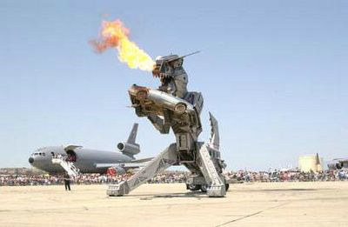

**SHAPES**

1. **Complete the sentences using the words from the list.**

|  |  |  |  |
| --- | --- | --- | --- |
| THE SHAPE |  | THE DESCRIPTION |  |
|  | It's a circle. |  | It's circular /round. |
|  | It's a triangle. |  | It's ……………. . |
|  | It's a square. |  | It's ……………. . |
|  | It's a ………. . |  | It's semi-circular. |
|  | It's a rectangle. |  | It's ……………. . |
|  | It's an ………. . |  | It's oval. |
|  | It's a ………... . |  | It's spherical. |
|  | It's a ………... . |  | They’re cubic. |
|  | It's a cylinder. |  | It's ……………. . |
|  | It's a cone. |  | It's ……………. . |

1. **Work with a partner. Ask and answer questions about these things.**

What shape is a watch / a traffic cone / a stamp / a floppy disc / a traffic sign / a CD / a dice / a can / a half-moon / a table-tennis ball / an egg / one side of a pyramid / a protractor / a marble?

**Note:** We can also add *–shaped* to the word.

a heart-shaped box, a star-shaped cookie cutter

1. ***RAISE – RISE***

*Raise* and *rise* describe upward movement, but they mean different things.

**When you pull down on the ring, it RAISES the load. (lifts it up)**

**The load RISES. (moves up)**

***Complete the sentences with raise or rise.***

1. The sun ………………in the east.
2. The switch ………………the pressure.
3. The thermostat …………….the temperature if it gets too cold.
4. Hot air ………………. .
5. The wheel turns and it ……………… the rod.
6. The temperature ………………. in the summer.

**CHARTS AND GRAPHS**

* 1. ***Presenting visual information.***

It is easy to produce tables, graphs, charts and diagrams to illustrate number-based information, thanks to word processing software and desktop publishing packages.

**Examples:**

* A **Pareto chart** is a type of bar chart typically used to improve quality, process capability, or to conserve materials and energy.
* A **bar graph** uses either horizontal or vertical bars to show comparisons among categories.
* A **pie chart** helps you to visualize the relative importance of several categories of a variable but it does not show movement.
* A **flow chart** is used to illustrate the stages in a process.
* A **table** gives very precise information, but its visual impact is rather poor.
* A **graph** is good for showing movements and how one thing varies against another.
* A **diagram** is an illustration designed to show how a machine or system functions.

***2. Label the following visuals with these words:***

bar chart, curve, diagram, dotted line, flow chart, graph, horizontal axis, pie chart, table, vertical axis

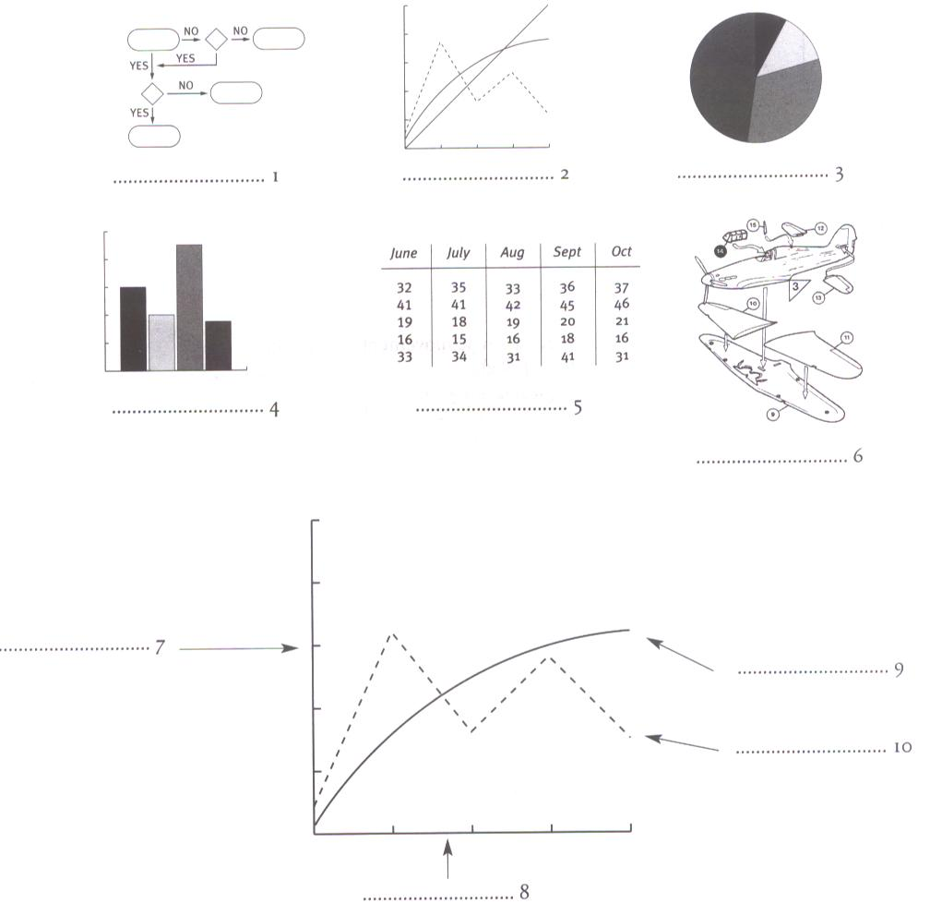

***3.Understanding and describing graphs.***

***Look at the graphs. Complete by using* BY *or* TO*.***

*Note:*To describe a point something reaches, use……… .

To describe the difference between two points, use ……... .

Energy bills fell ………..…€600,00 in the second quarter.

Energy bills fell …………. €200,00in the second quarter.

Unemployment fell ………… 10%.

Pollution increased ………… 4%.

***4. Look at the two charts below.***

1. How many people work for Telecom?
2. What percentage of them work in Germany?
3. What proportion of the staff:
   * work in factories?
   * design new products?
   * work with customers?
   * manage company business from offices?

**HUMAN RESOURCES**

**(by function)**

**HUMAN RESOURCES -**

**TOTAL: 40,000**

**(by geographic area)**

***5. Look at the graph about a German company. Are the statements below true or false? Correct the false one.***

1. Telecom earned more in 1985 than in 1984.
2. 1982 was a better year than 1981.
3. The company earned more than €12,000 billion in 1984.
4. The earnings for 1981 were higher than for 1983.

***6. Complete these sentences with the correct year.***

1. Telecom's earnings fell by 12% in …….. .
2. The company's earnings rose by 6 % in …….. .
3. The company's earnings rose to €11.600 billion in ……. .
4. The company's earnings improved between …………. and 1984.

**PROCESSING**

**The processor**, also called the central processing unit or CPU, is the brain of a computer. It is a central computer unit that controls the activities of other units connected to it. In PCs it is built into a single chip – a small piece of silicon with a complex electrical circuit, called an integrated circuit – that executes instructions and coordinates the activities of all the other units.

Three typical parts of a CPU are: the control unit, the arithmetic and logic unit (ALU) and the registers. The main circuit board is known as the motherboard. The speed of a processor is measured in gigahertz (GHz).

**RAM** is a form of computer data storage. It takes the form of integrated circuits that allow the stored data to be accessed in any order (i.e., at random).

When you run a program, the CPU looks for it on the hard disk and transfers a copy into the RAM. The amount of RAM determines the number of programs you can run simultaneously and how fast they operate. It can be expanded by adding extra RAM chips.

**ROM** contains instructions needed by the CPU. It tells the computer how to load the operating system.

1. **Complete the puzzle with the missing words in the sentences.**
2. A sequence of instructions that a computer can interpret and execute is called a …………
3. The processor is measured in …………
4. A device attached to a computer that enables the transfer of data to or from a computer through telephone lines is called a …………
5. The brain of a computer is a …………
6. A complex set of electronic components imprinted on a chip is called ………… circuit.
7. Eight bits together are called a …………

***DOWN:*** *Capacity for storing information*

|  |  |  |  |  |  |  |  |  |  |  |  |  |
| --- | --- | --- | --- | --- | --- | --- | --- | --- | --- | --- | --- | --- |
| 1 |  |  |  |  |  |  |  |  |  |  |  |  |
|  | 2 |  |  |  |  |  |  |  |  |  |  |  |
|  |  | 3 |  |  |  |  |  |  |  |  |  |  |
|  |  |  |  | 4 |  |  |  |  |  |  |  |  |
|  | 5 |  |  |  |  |  |  |  |  |  |  |  |
|  |  |  |  |  | 6 |  |  |  |  |  |  |  |

1. **Match the sentence beginnings with the correct endings.**

|  |  |
| --- | --- |
| 1. The CPU processes data and | a. areas within the CPU. |
| 2. The control unit is the part of the CPU that | b. you can't make changes to it. |
| 3. The arithmetic and logic unit is able to make | c. controls the way instructions are executed. |
| 4. The registers are high-speed storage | d. the computer is turned off. |
| 5. Data contained in RAM is lost when | e. coordinates the other parts of the computer. |
| 6. ROM memory can only be read: | f. calculations: add, subtract, multiply and divide. |

***CPU Quiz***

<http://computer.howstuffworks.com/cpu-quiz.htm>

1. **Complete the text about the motherboard with the words from the box.**

|  |  |
| --- | --- |
| modem cards paths  memory mobo mainboard |  |

A motherboard is the central printed circuit board in PCs. The motherboard is sometimes alternatively known as the 1 ………………………. , system board, or, on Apple computers the logic board. It is sometimes shortened to 2 …………………………... .

The motherboard contains the CPU, the 3 ……………………. chips, expansion slots and controllers for peripherals, connected by internal buses, or 4 ………………… …., that carry electronic signals. Expansion slots allow you to install expansion 5 ………………….. which provide extra functions, e.g. a video card, a sound card, a network card, a TV tuner card or a

6 ……………………………….. .

1. **Fill in the blanks with the correct unit of memory.**

|  |  |
| --- | --- |
| **C** o m p u t e r | 1. One ………………represents one character. |
|  | 2. One ……………… represents 1,024 characters (about a small page of text). |
|  | 3. One ……………… represents about one million characters (about the text of a small book). |
|  | 4. One ……………… represents about 1,000,000,000 characters (about 1,000 books). |
|  | 5. One ………………. represents 1,000,000,000,000 characters (about one million books in a bid library). |

**OPERATING SYSTEMS**

|  |  |
| --- | --- |
| An operating system the software controlling a computer. OS controls the execution of computer programs and may provide various services.  Operating systems handle input/output operations, run programs, organize files on disks, give access to networks, and allow multitasking (a user can run several programs and do various tasks at a time).  In fact, it is a set of programs that control the hardware and allow people and applications to communicate with the hardware. | A layer structure showing where the Operating System is located on generally used software systems on desktops. |

**Examples of OS are:** the Windows family, Mac OS, Unix, Linux, Palm OS, Symbian OS, RIM etc.

**I. Match the OS with the definitions.**

|  |  |
| --- | --- |
| The Windows family | Found on mainframes and workstations in corporate installations, as it supports multi-users |
| Mac OS | used on Palm hand-held devices |
| Unix | Designed by Microsoft and used on most PCs |
| Linux | Designed for mobile devices |
| Palm OS | Created by Apple and used on Macintosh computers |
| Symbian OS | OS which is a popular Linux distribution |
| Ubuntu | Used on Blackberry communication devices, developed by the Canadian company Research In Motion |
| RIM | Developed under the GNU General Public Licence; anyone can copy its source code, modify and redistribute it. It is used on PCs and in appliances and small devices. |
| Windows Mobile | Used on most PDAs and smart phones |



**Tux** is the ………………………… mascot.**II. Complete the text about the Ubuntu OS with the words from the box.**

**technical - talents - free and open - usability - updates - Zulu - sponsored - profit - versions - improve**

**Ubuntu** is a computer operating system based on Debian GNU/Linux, a popular Linux distribution. Its name comes from the 1…………………….. (language spoken in South Africa). The word »ubuntu« is translated as humanity and describes the ubuntu philosophy: "I am who I am because of those around me." Ubuntu's goals include providing an up-to-date, stable operating system for the average user, with a strong focus on 2…………………… and ease of installation.

Ubuntu is a 3………………………. source software which means that users are free to run, copy, distribute, study, change and 4…………………..the software under the terms of the GNU GPL licence. Ubuntu is 5…………………………... by the UK based company Canonical Ltd, owned by South African entrepreneur Mark Shuttleworth. Instead of selling Ubuntu for 6……………………., Canonical creates revenue by selling 7…………………………… support. By keeping Ubuntu free and open source, Canonical is able to take advantage of the 8……………………….. of outside developers in Ubuntu's constituent components without developing the entire operating system itself. Canonical releases new 9…………………………….. of Ubuntu every six months and supports Ubuntu for eighteen months by submitting security fixes, patches to critical bugs and including minor 10……………………………. to programs. *Adapted from: http://en.wikipedia.org*

***Watch this…***

******How to pronounce Linux

<http://www.youtube.com/watch?v=5IfHm6R5le0>

# The Origins of Linux - Linus Torvalds

# <http://www.youtube.com/watch?v=WVTWCPoUt8w&feature=related>

# Linux Ubuntu vs. MS Vista

<http://www.youtube.com/watch?v=fdxGf4Xvgc0&NR=1>

Ubuntu Linux

<http://www.youtube.com/watch?v=mrLFFGWKqG8&feature=related>

**THE GRAPHICAL USER INTERFACE**

**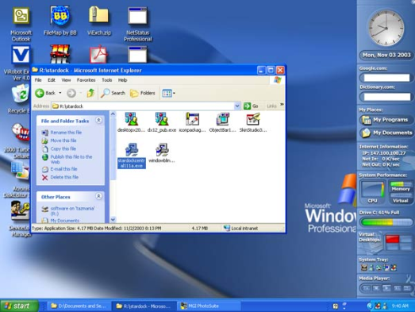**

A GUI makes use of a WIMP environment: **W**indows, **I**cons, **M**enus and **P**ointer. It is a user interface based on graphics (icons and pictures and menus) instead of text. The system functions are accessed by selecting self-explanatory icons (pictures representing programs or documents) and items from menus. A drop-down menu, or pull-down menu, is a list of options that appear below a menu bar when you click on an item. The pointer is the arrow, controlled by the mouse, which lets you choose options from menus. The background screen is called the desktop. Double-clicking a folder icon opens a window which shows the programs, documents etc.

1. *What is the meaning of WIMP in a graphical user interface?*
2. *Which expression is used to describe a system that is easy to use?*
3. *What does the desktop display?*
4. *Why do you think Windows is so popular?*

**PROGRAMMING**

Programming is a process of writing a program using a computer language. A program is a set of instructions which a computer uses to do a specific task.

The only language a PC can directly execute is **machine cod**e, which consists of 1s and 0s. As this language is difficult to write we use symbolic languages (**assembly languages**) that are easier to understand. Machine code and assembly languages are called ***low-level languages*** because they are closer to the hardware.

***High-level languages*** are closer to human languages which makes programming easier. Some examples are:

|  |  |
| --- | --- |
| **FORTRAN** | used for scientific and mathematical applications |
| **COBOL** | popular for business applications |
| **BASIC** | used as a teaching language |
| **C** | used to write system software, graphics and commercial programs |
| **Java** | designed to run on the Web |

The languages used to create Web documents are called ***markup languages***. They use instructions (markups) to format and link text files. Examples are:

**HTML** – the code used to create Web pages

**VoiceXML** – it makes Internet content accessible via speech recognition and phone. Instead of using a web browser on a PC, you use a telephone to access voice-equipped websites. You just dial the phone number of a website and then give spoken instructions, commands, and get the required information.

**1. Match the terms in column A with the terms in column B.**

|  |  |
| --- | --- |
| 1 High-level language | Programming language such as C, Java or Visual Basic |
| 2 Programming | Basic language which consists of binary codes |
| 3 Machine code | Writing computer programs |
| 4 Assembly language | Low-level language translated into machine code by an assembler |
| 5 Java applet | Language used to create and format documents for the Web |
| 6 Compiler | Software which converts a program into machine code |
| 7 Mark-up language | Small self-contained program written in Java |

**2. Go to the Webopedia website at** [**www.webopedia.com**](http://www.webopedia.com/)**. Webopedia is an online dictionary and search engine for computer and Internet technology definitions. Look up the computer languages in the table below and then complete the table.**

|  |  |  |
| --- | --- | --- |
| **Computer language** | **Meaning** | **Use** |
| Fortran / FORTRAN | Formula translator |  |
| COBOL |  |  |
| Pascal | Named in honour of the scientist Blaise Pascal |  |
| BASIC |  |  |
| C++ | Adds object-oriented features to its predecessor, C |  |
| Prolog |  |  |
| Ada | Named after Augusta Ada Byron; considered to be the world's first programmer |  |
| LISP |  |  |

**3. Put these programming steps into the correct order.**

|  |  |
| --- | --- |
| Document and maintain the program  Test the program and detect bugs  Make flowchart | Write code and compile  Analyze the problem  Debug and correct if necessary |

Does it work?

**4. Complete the text about the VoiceXML application language with the words from the box.**

HTML dial VoiceXML commands speech recognition

**Internet: Voice recognition takes off**

You don’t need a sophisticated cell phone to surf the Internet when you’re on the road – just your own voice. That’s the idea behind a new breed of voice that is popping up all over the place. Subscribers 1…………………………… a toll-free phone number and use spoken 2…………………………………. to listen to anything from weather conditions to stock quotes, or flight information to news stories. Half a dozen of these services – such as Audiopoint, BeVocal, TellMe and TelSurf Networks – have already gone live or are testing their systems.

These launches are all happening because two crucial technologies have come of age. 3…………………………………. Software from companies such as Lucent, Nuance and Speechworks can now understand a wide range of accents and diction without having to be trained to a specific voice. And computer languages such as VoiceXML make it as easy to write voice services as 4…………………………….. has made it to write web pages. With 5…………………………………., the human voice becomes a substitute for a computer mouse and the spoken command for a click. It doesn’t, however, call up conventional web pages, but content which is specially composed for a telephone: sound clips, numbers, music, spoken texts. *The Economist*

***Java Quiz***

<http://computer.howstuffworks.com/java-quiz.htm>

****



<https://www.coursera.org/course/pythonlearn>

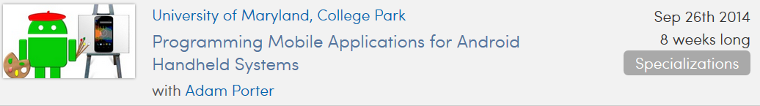

<https://www.coursera.org/course/android>

<https://www.coursera.org/course/interactivepython>

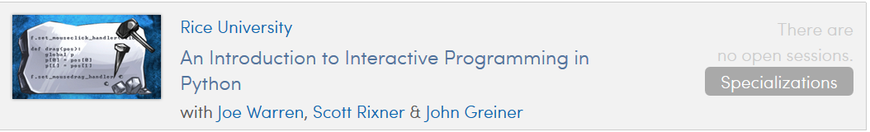<https://www.coursera.org/course/cplusplus4c>

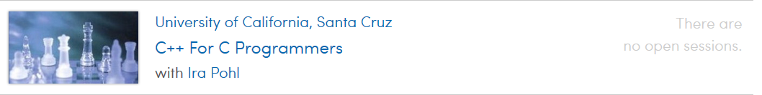

**INFORMATION TECHNOLOGY 1**

Information systems **collect, organize, store, process, retrieve** and **display** information in different formats (text, video, and voice). Information technology allows very fast, automated manipulation of **digital** data and their transformation from and to **analogue**.

Two basic technologies have been responsible for the development of the necessary **hardware**: **integrated circuits** and **digital communications**. Parallel advances have been made in **software**, particularly easy-to-use software products to **create, maintain, manipulate**, and **query files** and **records**. Many of these **software programs** are designed for use both by computer professionals and enthusiastic amateurs. Another important factor is the development of **computer networks**. (→ IT 2)

As technology develops, new models and types of computer appear. At the heart of all computers is the **hardware**. However, without software, computers are just dumb boxes, unable to perform any calculations or operations.

**Models and types of computer**

desktop • laptop • mainframe • notebook • server • terminal • workstation

**Computer hardware**

CPU (central processing unit) • dot matrix printer • expansion card • inkjet printer • keyboard • laser printer • monitor • mouse • RAM (random access memory) • scanner • screen • storage devices

**Computer software**

applet • application software • browser • database software • email software • graphics software • operating system • search engine • spreadsheet • word processing

**Many words in the field of IT come from American English. So you may see the following spellings:**

*British English American English*

programme program

analogue analog

The area of IT is developing very quickly; and the language to describe hardware, software and applications is also evolving at a high speed.

As a result new **noun + noun combinations** often change to **single nouns**

*noun + noun →→ single noun*

lap top laptop

note book notebook

work station workstation

desk top desktop

**1. Combine one word from A and one word from B and match it with the appropriate definition in C.**

**A B C**

create products a monitor will do this on a computer screen

central information this describes the format of 0 and 1 in which information is stored

software processing unit these enable a computer to perform word

processing, to create databases, and to manipulate numerical data

display card when two or more components are combined and

then incorporated into a single package

digital files to make new programs, utilities or documents

expansion network a group of electronic machines connected by cables

or other means which can exchange information and

share equipment (such as printers and disk drives)

integrated data the principal microchip that the computer is built around

computer circuits you plug this into a slot to add features such as video, sound, modem

and networking

**2. Complete each gap in the following text with a phrase from the table above.**

1 The computer monitor will \_\_\_\_\_\_\_\_\_\_\_\_\_\_\_ \_\_\_\_\_\_\_\_\_\_\_\_\_ so you can see it on screen.

2 Information is stored on a computer as \_\_\_\_\_\_\_\_\_\_\_\_\_\_\_\_\_\_\_ \_\_\_\_\_\_\_\_\_\_\_\_\_\_\_\_\_\_\_\_\_ .

3 Spreadsheet and graphic software are examples of \_\_\_\_\_\_\_\_\_\_\_\_\_\_\_ \_\_\_\_\_\_\_\_\_\_\_\_\_\_\_\_ .

4 Digital communications and \_\_\_\_\_\_\_\_\_\_\_\_\_ \_\_\_\_\_\_\_\_\_\_\_\_ have allowed developments

in hardware to be made.

5 In order to organise data you should \_\_\_\_\_\_\_\_\_\_\_\_\_\_\_\_\_ \_\_\_\_\_\_\_\_\_\_\_\_\_\_\_\_ where you

can store data.

6 When several computers are linked together you have a \_\_\_\_\_\_\_\_\_\_\_\_ \_\_\_\_\_\_\_\_\_\_\_\_\_\_ .

7 The part of the computer which interprets and carries out instructions is the

\_\_\_\_\_\_\_\_\_\_\_\_\_\_\_ \_\_\_\_\_\_\_\_\_\_\_\_\_\_\_\_ .

8 An \_\_\_\_\_\_\_\_\_\_\_\_\_\_\_ \_\_\_\_\_\_\_\_\_\_\_\_\_\_ can be inserted in your computer to give your

computer extra capabilities.

**INFORMATION TECHNOLOGY 2**

**A network includes:**

- techniques

- physical connections

- computer programs

**used to link two or more computers.**

**Network users can:**

- share files, printers and other resources

- send electronic messages

- run programs on other computers.

Each network operates according to a set of computer programs called network **protocols** for computers to talk to one another. Computer networks can now be **interconnected** efficiently through **gateways**. The biggest network is the **World Wide Web**. It consists of a large number of smaller interconnected networks called **internets**. These internets may **connect** tens, hundreds, or thousands of computers. They can share information with each other, such as **databases** of information. The Internet allows people all over the world to **communicate** with each other effectively and inexpensively.

Before a network can operate, it needs physical connections so that signals can be transmitted. After the network has been connected, it is ready for operation.

**Network connections**

bandwidth • baud • bits per second (bps) • optical fibre • packet receive • signal • transmit • transmission speed • twisted pair

**Network operation**

configure • download • hack • hub • install • Internet service provider (ISP) • local area network (LAN) • switch • transmit • upload • web page • website • wide area network (WAN) • wireless

A **prefix** comes at the beginning of a word and usually has a specific meaning, for example inter = between.

Look at the following prefixes and their use in the above IT words/phrases:

**prefix meaning of prefix example of use**

inter- between Internet, interconnect, interactive, international

intra- within intranet, e.g. company intranet

trans- across transmit, transfer, transaction

co-/com-/con- with combine, compatible, connect, configure

up- up (to Internet) upload

down- down (from Internet) download, downtime, i.e. when the network is down (not working)

**1. Choose the correct word in each of the following.**

1 The speed with which a modem can process data is measured in ………………...

a) bandwidth b) bits per second (bps) c) signal

2 Cables consisting of several copper wires each with a shield are known as ………… cables.

a) twisted pair b) optical fibre c) power cables

3 Computers that are connected together within one building form a …………………

a) WAN b) ISP c) LAN

4 If you transfer a file from a remote computer to your computer, you ………………….

a) download b) upload c) run

5 To send out information is to ……………………

a) signal b) packet c) transmit

6 A document containing information and graphics that can be accessed on the Internet is …………………

a) a website b) a web page c) the World Wide Web

**2. Complete the words in the following sentences by adding the prefix *inter-, intra-, trans-, com-, con-, up- or down-.***

1 Last month computer \_\_\_\_\_\_\_time cost the company over €10,000 in lost production.

2 The computers in the production department have now been successfully \_\_\_\_\_\_\_connected

with those in the planning department.

3 Once you have completed payment details the data will be \_\_\_\_\_\_\_mitted via a secure link.

4 We cannot network these computers because the systems are not \_\_\_\_\_\_\_patible.

5 Many companies distribute internal documents on their own \_\_\_\_\_\_\_net.

6 Once the home page has been completed, we'll be ready to \_\_\_\_\_\_\_load the site.

7 Cables are being laid throughout the building as the network requires physical \_\_\_\_\_\_\_nections.

8 Using the network he was able to \_\_\_\_\_\_\_bine the data from different reports.

**3. Here is a list of instructions for someone wanting to set up a small network. Put the instructions in the correct order.**

**a** Make wiring and layout plans for your network.

**b** Hook up the network cables by connecting everything to the hub.

**c** Check that each computer has an IP address and give it a name.

**d** If you're installing a small network, twisted pair will be adequate. However, in order to span greater distances and to minimize magnetic and electrical interference use fibre optic cable.

**e** Decide on the type of network you want to install. To enable you to transfer large amounts of data, choose Fast Ethernet (100BaseT).

**f** Install network adapters in the computers.

**g** Add an Internet gateway to your network to set up a shared internet connection.

**h** Install driver software for the adapter driver and install client software to share printers and files.

**i** Check which protocols are installed and add any other protocols you require.

**j** Get the hardware you need: an Ethernet adapter card for each computer that doesn't have an Ethernet port, a hub if you've got more than two computers, cables and wall jacks.

***Home Networking Quiz***

<http://computer.howstuffworks.com/home-networking-quiz.htm>

****

[**https://www.coursera.org/course/comnetworks**](https://www.coursera.org/course/comnetworks)

**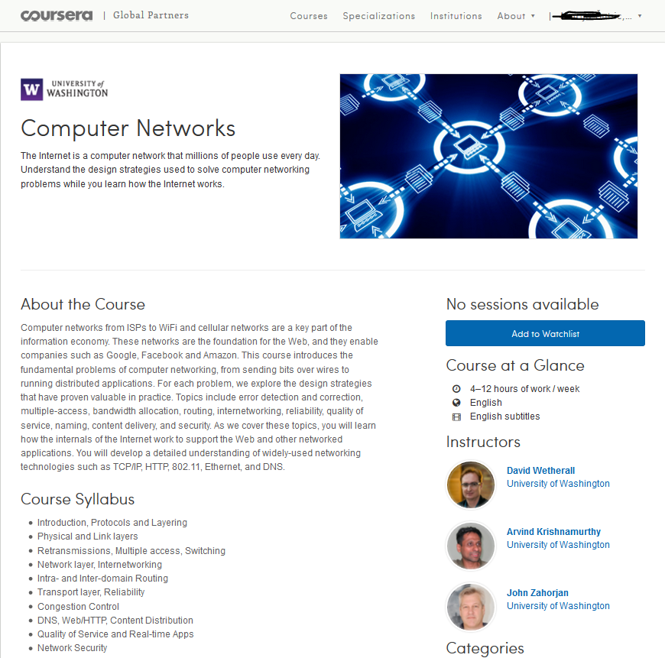**

**INTERNET**

The Internet has revolutionized the computer and communications world like nothing before. The invention of the telegraph, telephone, radio, and computer set the stage for this unprecedented integration of capabilities. The Internet is a world-wide broadcasting capability, a mechanism for information dissemination, and a medium for collaboration and interaction between individuals and their computers without regard for geographic location.

Beginning with the early research in packet switching, the government, industry and academia have been partners in evolving and deploying this exciting new technology.

The Internet is an International computer Network made up of thousands of networks linked together. All these computers communicate with one another. They share data, resources, transfer information, etc. To do it they need to use the same language or protocol: TCP / IP (Transmission Control Protocol / Internet Protocol) and every computer is given the address or IP number. This number is a way to identify the computer on the Internet.

The basic connection components which enable you to use the internet are: a computer, the right connection software and a modem.

The modem (modulator-demodulator) is used to connect your computer to a telephone line and then access your ISP (Internet Service Provider). It converts digital signals stored in the computer into analogue signals that can be transmitted over telephone lines. There are two basic types: external with a cable that is plugged into the computer via a USB port, and internal, an expansion card inside the computer. A PC card modem is a different, more versatile option for laptops and mobile phones.

At first computers used a dial-up telephone connection that worked through the standard telephone line. Now a broadband connection, a high data transmission rate Internet connection has become more popular: either ADSL (Asymmetric Digital Subscriber Line), which allows you to use the same telephone line for voice and fast access to the Internet, or cable, offered by most TV cable providers.

The basic equipment has changed drastically in the last few years. You no longer need a computer to use the Internet. Web TV provides email and access to the Web via a normal TV set plus a high-speed modem. More recently, 3Generation mobile phones and PDAs, personal digital assistants, also allow you to go online with wireless connections, without cables.

Telephone lines are not essential either. Satellites orbiting the earth enable your computer to send and receive Internet files. Finally, the power-line Internet, still under development, provides access via a power plug.

The Internet consists of many systems that offer different facilities to users.

The most popular system is the World Wide Web. Many people use the terms ***Internet*** and ***World Wide Web* (*the Web*)** interchangeably, but in fact the two terms are **not synonymous**. The Internet and the Web are two separate but related things.

The ***Internet*** is a massive network of networks, a networking infrastructure. It connects millions of computers together globally, forming a network in which any computer can communicate with any other computer as long as they are both connected to the Internet. Information that travels over the Internet does so via a variety of languages known as [protocols](http://www.webopedia.com/DidYouKnow/Internet/2002/protocol.html).

The ***World Wide Web***, or simply *Web*, is a way of accessing information over the medium of the Internet. It is an information-sharing model that is built on top of the Internet. The Web uses the HTTP protocol, only one of the languages spoken over the Internet, to transmit data. Web services, which use HTTP to allow applications to communicate in order to exchange business logic, use the Web to share information. The Web also utilizes [browsers](http://www.webopedia.com/DidYouKnow/Internet/2002/browser.html), such as [Internet Explorer](http://www.webopedia.com/DidYouKnow/Internet/2002/Internet_Explorer.html) or [Netscape](http://www.webopedia.com/DidYouKnow/Internet/2002/Netscape.html), to access Web documents called **Web pages** that are linked to each other via [hyperlinks](http://www.webopedia.com/DidYouKnow/Internet/2002/hyperlink.html). Web documents also contain graphics, sounds, text and video.

**The Web** is just one of the ways that **information can be disseminated over the Internet**. The **Internet,** not the Web, is also used for [**e-mail**](http://www.webopedia.com/DidYouKnow/Internet/2002/e_mail.html), which relies on SMTP (***S****imple* ***M****ail* ***T****ransfer* ***P****rotocol,* a [protocol](http://www.webopedia.com/TERM/S/protocol.html) for sending [e-mail](http://www.webopedia.com/TERM/S/e_mail.html) messages between [servers](http://www.webopedia.com/TERM/S/server.html)), [**Usenet**](http://www.webopedia.com/DidYouKnow/Internet/2002/Usenet.html) news groups (forums), [instant messaging](http://www.webopedia.com/DidYouKnow/Internet/2002/instant_messaging.html) ([text](http://www.webopedia.com/TERM/I/text.html)-based [communication](http://www.webopedia.com/TERM/I/instant_messaging.html) in [real time](http://www.webopedia.com/TERM/I/real_time.html) over the [Internet](http://www.webopedia.com/TERM/I/Internet.html) – chat rooms) and[**FTP**](http://www.webopedia.com/DidYouKnow/Internet/2002/FTP.html) (***F****ile* ***T****ransfer* ***P****rotocol,* the [protocol](http://www.webopedia.com/TERM/F/protocol.html) for exchanging [files](http://www.webopedia.com/TERM/F/file.html) over the [Internet](http://www.webopedia.com/TERM/F/internet.html)). **So the Web is just a large portion of the Internet, but the two terms are not synonymous and should not be confused.**

**1. Match the components of the Internet with their definitions.**

|  |  |
| --- | --- |
| Email or electronic mail | A system that allows the transmission of video and audio signals |
| WWW | Used to transfer files between computers |
| Mailing lists (listservs) | Used for real-time conversations (you type your messages on the keyboard) |
| Chat & instant messaging | Where people send, read and respond to public bulletin board messages stored on a central computer |
| Internet telephone | Based on programs that send messages on a certain topic to all the computers whose users have subscribed to the list |
| Video conference | A system that enables people to make voice calls via the Internet |
| File Transfer Protocol (FTP) | A program that enables a computer to function as a terminal working from a remote computer and so use online databases or library catalogues |
| Newsgroups | A collection of files or pages containing links to other documents on the Net |
| TELNET | Exchanging of messages and attached files |

**2. Look at this list of things you can do on the Internet.**

* Join special interest chat groups
* Play games
* Speak to people over a video phone

*Add other activities to the list. …………………………………………………………………*

*Which of the items on your list interest you most? Why? Which have you done? Do you enjoy using the Internet? Do you find it useful?*

**3. Look at these verbs. They are all common computer commands. Match each word with an icon below.**

connect open help print save undo cut copy paste search view

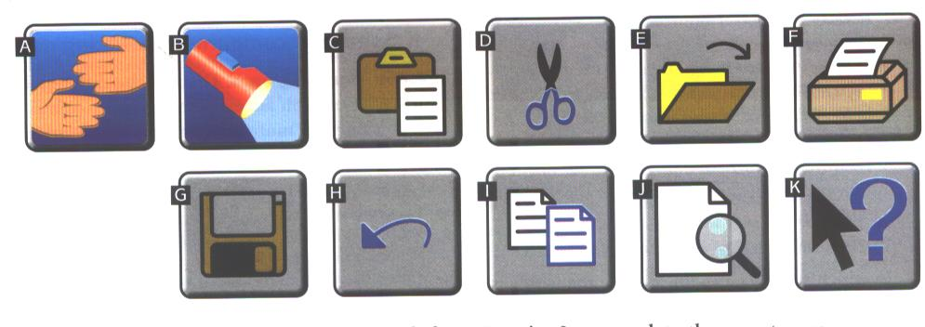

***Now use words from Exercise 3 to complete the sentences.***

1. You…………..a computer to the Internet by a normal telephone line.
2. You can get advice by selecting »………«.
3. If you give a command by mistake you can …………… it.
4. The ……………..command allows you to see the text as it will be printed.
5. To move text from one place to another, you use the ……….. command. Then you go to the place where you want the text to be and………… it there.

**3. READ THE TEXT about a company and then EXPLAIN in not more than 20 words what *Intra* does.**

**INTRA** is a Swedish market communications agency, with 27 employees and offices in Uppsala and Stockholm. It works with companies that want to promote themselves or their products and is involved at every stage of a project: establishing a campaign's aims, making suggestions for its content, producing and distributing materials, and evaluating its success.

Intra works with traditional media to sell a client's products or create an image, although it is better known for its use of interactive media. These allow two-way communication between the client and customers. While the choice of media depends on a company's aims, budget and target group, Leit Nordlund, Managing Director of Intra, believes that at least one medium should be interactive.

There are many advantages to Web sites from a company's point of view, so creating them is an important part of Intra's work. Despite being in the far north of Europe, Swedish companies can reach a global audience, particularly if their sites are in English. They know how many people visit their sites, and information can be updated quickly and cheaply.

Of course, companies do need to advertise their Internet address in more traditional ways; the Swedish dairy company Arla, for example, advertised its new site on its milk cartons. The Arla Web site is one that Intra helped to create. The site is extremely popular and includes activities and educational material for children, recipes and the sale of cookery books, as well as campaigns. Arla's breakfast campaign for instance, reminded people that breakfast is a healthy meal, and a good time for the family to talk to each other.

Intra forms relationships not only with clients but also with suppliers. Some of these suppliers may become partners in a project, with their own project managers - when market research is needed, for example, or highly technical assistance like connecting a Web site to a customer database.

***a. What are the purposes of:***

- a Web site

- a database

- an Internet address

***b. Which of these are traditional marketing media? Which are interactive? Which can be both? Can you add to the list?***

\* magazines and newspapers \* television \* the World Wide Web

\* direct marketing by mail \* radio \* the telephone (telemarketing)

***c. How can traditional media include interactive features, do you think?***



***Internet Quiz***

<http://computer.howstuffworks.com/internet-quiz.htm>

***Visual dictionary online***

<http://visual.merriam-webster.com/communications/office-automation/internet_1.php>

The history of the internet goes back to the 1950s and 60s.

**A brief timeline highlighting some of the major occurences over the past 48 years:**

|  |  |
| --- | --- |
| **1958** | President Eisenhower requests funds to create [ARPA](http://webopedia.internet.com/TERM/A/ARPANET.html). Approved as a line item in Air Force appropriations bill. |
| **1962** | •J.C.R. Licklider & W. Clark write first paper on Internet Concept, "On-Line Man Computer Communications." |
| **March 1972** | First basic [e-mail](http://webopedia.internet.com/TERM/e/e_mail.html) programs written by Ray Tomlinson at BBN for ARPANET: SNDMSG and READMAIL. "@" sign chosen for its "at" meaning. |
| **1980** | Tim Berners-Lee writes program called "Enquire Within," predecessor to the [World Wide Web](http://webopedia.internet.com/TERM/W/World_Wide_Web.html). |
| **1981** | IBM announces its first Personal Computer. [Microsoft](http://webopedia.internet.com/TERM/M/Microsoft.html) creates [DOS](http://webopedia.internet.com/TERM/D/DOS.html). |
| **Nov. 1983** | [Domain Name System](http://webopedia.internet.com/TERM/D/DNS.html) (DNS) designed by Jon Postel, Paul Mockapetris, and Craig Partridge. .edu, .gov, .com, .mil, .org, .net, and .int created. |
| **1984** | •William Gibson writes "Neuromancer." Coins the term "[cyberspace](http://webopedia.internet.com/TERM/c/cyberspace.html)". |
| **March 15, 1985** | Symbolic.com becomes the first registered domain. |
| **1986** | 5000 [hosts](http://webopedia.internet.com/TERM/h/host.html) on ARPAnet/[Internet](http://webopedia.internet.com/TERM/I/Internet.html). |
| **1987** | • 10,000 hosts on the Internet. • 25 million PCs sold in US. |
| **1989** | • 100,000 hosts on Internet. • anti-virus software available for free. |
| **1990** | ARPAnet ends. [Tim Berners-Lee](http://groups.google.com/groups?selm=6487%40cernvax.cern.ch) creates the World Wide Web. |
| **1992** | "Surfing the Internet" is coined by Jean Armour Polly. |
| **April 1994** | •[Netscape Communications](http://webopedia.internet.com/TERM/N/Netscape.html) founded. •[Java](http://webopedia.internet.com/TERM/J/Java.html)'s first public demonstration. |
| **Dec. 1994** | Microsoft licenses technology from Spyglass to create Web browser for [Windows 95](http://webopedia.internet.com/TERM/W/Windows_95.html). |
| **Jan. 2009** | **Total World Users – Dec. 2013 - 2,802,478,934 (EU - millions of users: 566,3)** |

<http://www.internetworldstats.com/stats.htm>

***Internet history*** <http://www.livinginternet.com/>





<https://www.coursera.org/course/insidetheinternet>



**WWW**

The World Wide Web, Web or WWW is a set of electronic documents stored on computers that are connected over the Internet and are made available by the protocol known as HTTP. It is a network of documents that works in a hypertext environment, i. e. using text that contains links, hyperlinks to other documents. The World Wide Web makes up a large part of the Internet.

The files, web pages, are stored in computers, which act as servers. Your computer, the client, uses a web browser, a special program to download them. The web pages are organised in websites, groups of pages on the Web, maintained by a webmaster, the manager of a website. If you want to surf or navigate the Web you must type the website address or URL (Uniform Resource Locator). Websites usually have a beginning page or home page. From this starting point you can navigate by clicking your mouse on hyperlinks in texts or images.

* **The main parts of the URL**

[**http://**www.**visual.merriam-webster.com/**communications /**internet\_1.php**](http://www.visual.merriam-webster.com/communications%20/internet_1.php)

1…… 2…… 3…… 4…… 5……

* **Complete the sentences with the words in the box.**

blogger hyperlink home weblog index

1. A link to the webpage is called a ………………..
2. A person who keeps a blog is a ………………….
3. The first page of a website is a …………………. Page.
4. ………………… is another word for directory.
5. A ……………….. is an electronic journal.
   * **Complete the instructions about how to navigate the Web with the words in the box.**

surf client web page search engine web server website web browser URL

1. Start up your computer and connect to the Internet.
2. Open your ……………………..
3. Type the …………………… to access to a website.
4. Your web browser sends the request to the correct ………………………..
5. The server looks for the document and sends it to the ……………………. Computer.
6. Your web browser displays the selected ………………… on the screen.
7. From the home page of the ……………………., you can …………………… to other pages by clicking on hyperlinks.
8. If you want to find more websites, use a …………………………

* **Fill in the gaps with words from the box.**

template multimedia formats link table white HTML

**WEB PAGES**

Web pages are created with a special language ……………………… (Hyper Text Markup Language), which is interpreted by a web browser to produce hypertext, a blend of text, graphics and links.

A well-designed website should be neat and organised. Words should be surrounded by sufficient …………………. space. Use dark text on a light background, preferably white. You can divide the page into columns with a ………………….. or use CSS - Cascading Style Sheets (to separate style from content) to create your page layout. Usually the navigation bar appears on the left side of the page. You can display it on all the pages of your website by using a frame. It is a good idea to put a ……………………. to the top of the page at the bottom of a long text.

The graphic element of a web page is crucial. Graphics load slowly, so use them sparingly and for good reason. There are two common picture……………………. : JPEG, for pictures with lots of colours and GIF, which is ideal for buttons and banners.

Web pages can also include…………………… files: animations, audio and video files. Sounds are recorded with different audio formats. MIDI, WAV, MP3 and AU are some of the most common audio formats.

If you do not know how to write HTML tags (the coded instructions that form the web pages), you can use a web ………………………. provided by a web-based site builder, where you just fill in the information you want on the page.

* **What can you do on the Web?**

(E-learning…. E-commerce or cybershopping….)

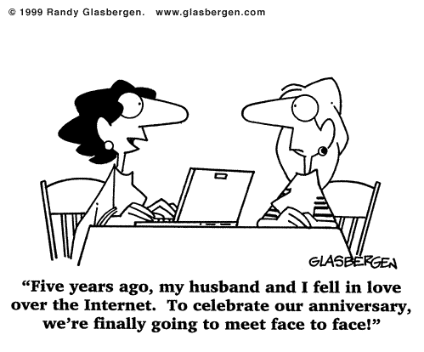

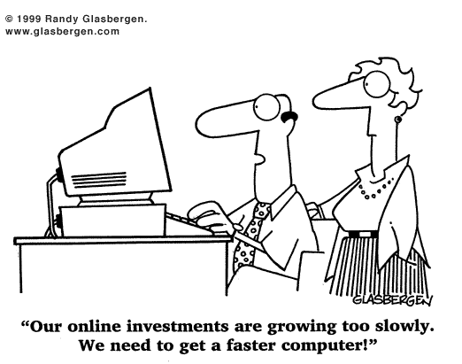

<http://www.glasbergen.com/>



***Web Page Quiz***

<http://computer.howstuffworks.com/web-page-quiz.htm>

[](http://logodatabases.com/joomla-logo.html/joomla)

1. *Watch, listen and discuss.*

**Video:** [What is Joomla?](http://www.youtube.com/watch?v=Qjnc0H8utks)

1. **What is Joomla?**

**Joomla** is an award-winning content management system (CMS), which enables you to build Web sites and powerful online applications. Many aspects, including its ease-of-use and extensibility, have made Joomla the most popular Web site software available. Best of all, Joomla is an open source solution that is freely available to everyone.

**What's a content management system (CMS)?**

A content management system is software that keeps track of every piece of content on your Web site, much like your local public library keeps track of books and stores them. Content can be simple text, photos, music, video, documents, or just about anything you can think of. A major advantage of using a CMS is that it requires almost no technical skill or knowledge to manage. Since the CMS manages all your content, you don't have to.

Source: <http://www.joomla.org/about-joomla.html>

1. ***Click on these links (***[***link1***](http://www.joomla.org/about-joomla.html) ***&*** [***link2***](http://www.joomla.org)***) to find out extra facts on this topic.***
2. ***After you have read the text above and browsed the Joomla web site, decide whether the statements below are TRUE or FALSE.***

|  |  |  |
| --- | --- | --- |
|  | **T** | **F** |
| 1. Joomla has never won an award. |  |  |
| 1. Joomla’s usability has made it very popular. |  |  |
| 1. Joomla is server software that is free. |  |  |
| 1. Only computer experts can use the Joomla CMS. |  |  |
| 1. Joomla can be used for small business web sites only. |  |  |
| 1. eBay, IKEA and ŠC Kranj are using Joomla. |  |  |
| 1. [Harvard University](http://gsas.harvard.edu/) uses Joomla as well. |  |  |
| 1. More examples of companies using Joomla can be found on a special [showcase site](http://community.joomla.org/showcase/) called the Joomla Community Site Showcase. |  |  |
| 1. Joomla is easy install, set up and use. However, if you need specialized functionality, it is highly extensible. |  |  |
| 1. Joomla is free, open and available to anyone under the GNU [General Public License.](http://www.gnu.org/licenses/old-licenses/gpl-2.0.html) |  |  |

**Sources:**

<http://logodatabases.com/joomla-logo.html/joomla>

<http://www.gnu.org/licenses/old-licenses/gpl-2.0.html>

<http://en.wikipedia.org/wiki/GNU_General_Public_License>

<http://www.youtube.com/watch?v=Qjnc0H8utks>

**UNDERSTANDING AND WRITING EMAILS**

An email is an electronic message sent from one computer to another that can also include attachments: documents, pictures, sounds and even computer programs. It is much faster and easier than the post (snail mail). You send an email to a mail server where it is stored in a mailbox, which holds incoming mail until the recipient downloads it. Users are given an email address and a password by an ISP (Internet Service Provider).

**Match the words in A with the definitions in B.**

|  |  |
| --- | --- |
| **A** | **B** |
| Spam or junk mail | Stands for blank/blind carbon copy |
| Username | The name given to the unwanted messages |
| CC | The message itself |
| The body of email | The part of the email address that identifies the user of the service |
| Email | Stands for carbon copy sent to another addressee |
| BCC | The part of the email address that identifies the server where the account is located |
| Domaine name | A file that has been included as part of an email message |
| Attachment | Facility that allows users to send and receive messages via the Internet |
| Mailing list | A collection of names and addresses used by an individual or an organization to send material to multiple recipients |

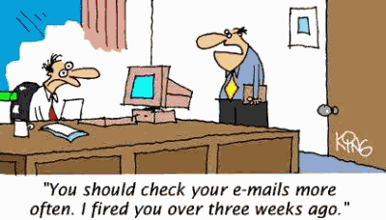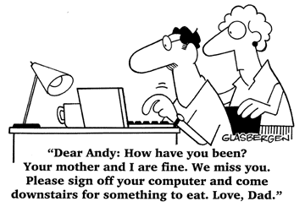

<http://www.geocities.com/rainforestwind/ninarchives_emailhumor.gif>

******

***E-mail Quiz***

<http://computer.howstuffworks.com/email-quiz.htm>

1. **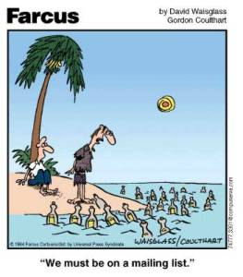WHO………….WITH?** (in/formal)

**WHAT…………ABOUT?**

**Do you deal with any English emails?**

**Who do you communicate with?**

**What are the emails about?**

***Practising commonly used expressions for***

* explaining problems
* asking for and offering help
* requesting a reply
* attaching documents
* thanking
* referring to future contact
* urgent emails

1. **Complete these emails using the phrases in the list.**

|  |  |
| --- | --- |
| email8 |  |

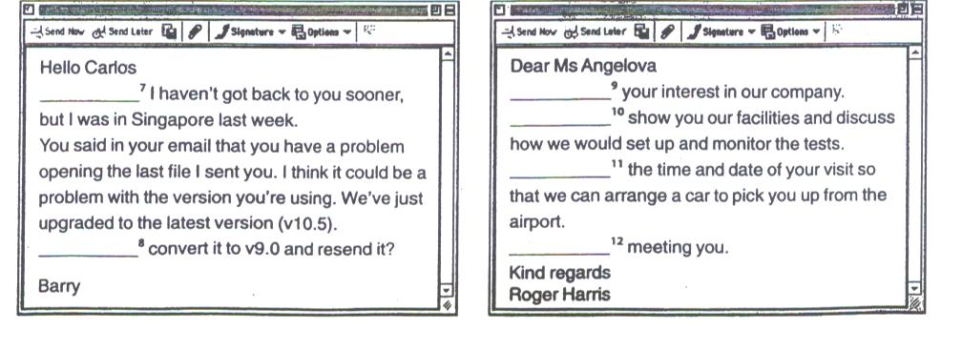

1. **Look at the list of the phrases that are often used in emails and say whether they:**

|  |  |
| --- | --- |
| **a offer help**  **b ask people to do things**  **c introduce good or bad news**  **d thank people**  **e refer to future contact**  **f refer to an attachment** | **1 I'm sorry, (but**) we can't .... .. ...  **2 Looking forward to** meet**ing** you. .......  **3 (Please) Could you** let me know as soon as possible? .......  **4 Tnx** a lot. .......  **5 I'm pleased to tell you** that we can give you a 3% discount. ........  **6 We would be pleased to** produce these parts for you. .......  **7 I'd appreciate it if you could** send ... .......  **8 Thanks for** getting back to me so quickly. .......  **9 I am attaching** the figures you asked for. .......  **10 I'm afraid (that)** we don't have any ... .......  **11 We would be happy to** send you a sample. .......  **12 We look forward to** work**ing** together with you. .......  **13 Can you** sign the contract and send it back to me? .......  **14 Thank you for** letting us know about ... ....... |

1. **Use some phrases in 2 to complete these emails.**

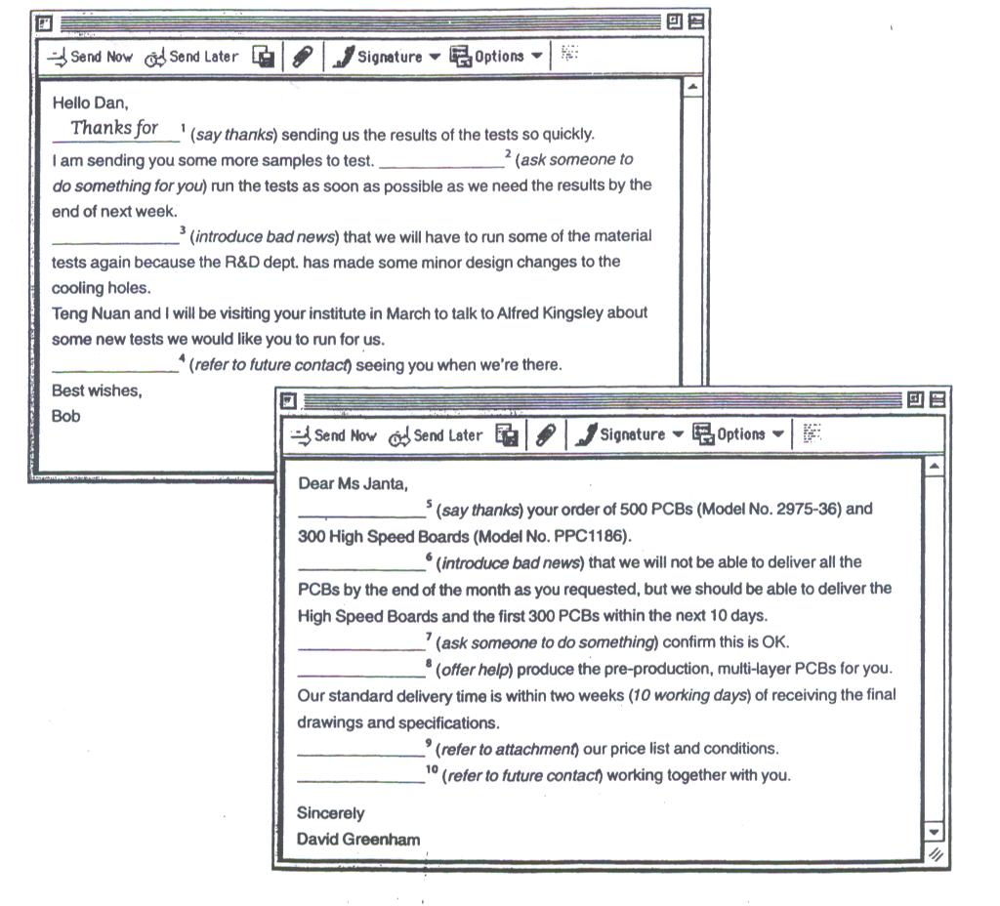

|  |  |
| --- | --- |
| **4. Five people need help. Who do you think they are writing to – a colleague, a customer, a supplier, etc? Which emails are urgent?**  **email2 001** | **5. Match these replies to the correct email in 4.**  **email3 001** |

******

***What happens when e-mail doesn't work?***

If you don't know, go to <http://www.youtube.com/watch?v=Ewme9untsDk>.

**INTERNET SECURITY**

Computers can make life easier, but they also can put your private information at risk. When a computer connects to a network and begins communicating with others, it is taking a risk. The Internet provides a wide variety of opportunities for communication and development, but not all that glitters is gold.

The most common types of Internet crime are:

**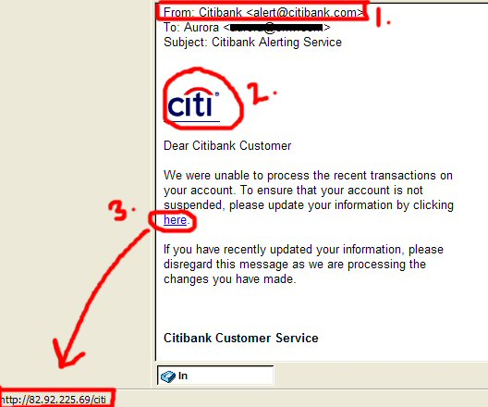Crackers** – computer criminals who use technology (gain unauthorized access to computers) to perform a variety of crimes – virus propagation, fraud, etc. Crackers are often mistakenly called hackers (= a computer enthusiast).

Internet-based crimes include **scam**, email fraud to obtain money, and **phishing**, bank fraud, to get banking information such as passwords of Internet bank accounts or credit card details. **Piracy**, the illegal copying and distribution of copyright software, documents, music and video files, is widespread. But by far the most common type of crime involves malware (malicious software): **viruses, worms, trojans and spyware**. This is the software created to damage or alter the computer data or its operations. <http://www.webopedia.com/DidYouKnow/Internet/2005/phishing.asp>

**1. WHAT AM I?**

**2. Fill in the gaps in these security tips with words from the box.**

Programs that spread by attaching themselves to executable files or documents. They may be designed to work at a particular time or on a specific date.

Self-copying programs that have the capacity to move from one computer to another without human help. They are self-contained and don’t need to be attached to a document or program the way viruses do.

Malicious programs disguised as innocent-looking files or embedded within legitimate software. They don’t copy themselves or reproduce by infecting other files.

Software designed to collect information from computers for commercial or criminal purposes. It usually comes hidden in fake freeware or shareware applications downloadable from the Internet.

antivirus backup website attachments digital certificate firewall personal

1. Don’t open email …………………. from unknown people. Always take note of the file extension.
2. Run and update …………………………….. programs.
3. Install a ………………………, a program designed to prevent spyware from gaining access to the internal network.
4. Make ………………….. copies of your files regularly.
5. Use a ……………………………., an electronic way of proving your identity, when you are doing business on the Internet.
6. Don’t give …………………….. information to people you contact in chat rooms.
7. Be careful about which …………………….. you visit.

**3. E-COMMERCE and ONLINE BANKING**

**E-commerce** or **online shopping** is the process of buying and selling products and services using the Internet.

A **dot-com company**, or simply a **dot-com** (alternatively rendered **dot.com** or **dot com**), is a company that does most of its business on the [Internet](http://en.wikipedia.org/wiki/Internet), usually through a [website](http://en.wikipedia.org/wiki/Website) that uses the popular [top-level domain](http://en.wikipedia.org/wiki/Generic_top-level_domain), "[.com](http://en.wikipedia.org/wiki/.com)".

**Online banking** or **Internet banking** is the process of performing banking transactions through electronic communications, mainly the Internet. Customers can also log in with a mobile phone or a PDA. The use of wireless networks to access financial institutions is known as **wireless banking**. Banks that offer physical locations and online services are called **brick-and-click** banks.

Both, the commerce and the banking, transacted electronically, over the Internet, may have some drawbacks and some advantages.

* **Make a list of the advantages and disadvantages online online shopping and online banking may have.**

***Tips:*** a great variety of products and prices, saving time, fraud, risks, no waste of paper,

in/secure connections, human contact, pay bills, transfer the funds, check the

account balances, schedule the payments, trade stocks online…

|  |  |
| --- | --- |
| **Advantages** | **Disadvantages** |
|  |  |

***Computer Security Quiz***

******<http://computer.howstuffworks.com/computer-security-quiz.htm>

***Internet Cookie Quiz***

<http://www.howstuffworks.com/internet-cookie-quiz.htm>

**4. COMPLETE THE TEXT ABOUT FUTURE TRENDS WITH THE WORDS FROM THE BOX.**

**Web emails interactive online data high-speed virtual electronic Internet**

***Fast connections***

Connecting to the 1…………………… using DSL lines, cable TV and satellite increases bandwidth dramatically, making the Web more useful. Increased speed has ignited an explosion of 2…………………………commerce, video on demand, telecommuting, collaborative scientific projects, video conferencing and 3…………………………. environments.

***Internet2, shaping the future***

Internet2 is not a single network, but a consortium of hundreds of 4………………………….networks linked by fibre-optic backbones that span the United States and link to the other countries. The network transmits 5………………………….. at speeds up to 2.4 gigabits per second – 45,000 times faster than a 56 Kbps modem – allowing scientists to test their laboratory discoveries in the real world.

The next-generation network went 6…………………………………… in February 1999, linking a number of universities around the world. When it is in commercial use, services will be available like 7…………………………. Television, virtual 3-D videoconferencing, and much more.

***A new kind of Web***

While PCs were once the primary means of accessing the Internet, we’re now seeing Internet-enabled devices such as PDAs and cell phones that send and receive 8……………………….

And access the 9………………………….. . Soon, everything from your car to your refrigerator will be connected to the global network, all communicating with each other wirelessly.  *Adapted from www.learnthenet.com*

**5. Fill in each gap with only one word.**

# The Greenhouse Effect

# Gases pollute the atmosphere because they are produced 1) ......... quickly to be cleared away naturally 2) ......... rain, winds or plant life. These poisonous gases 3) ............ from sev­eral sources such as oil producers, industries which burn fuel, and motor vehicles. When the gases are released, they have two harmful effects. 4) ........... , some of the gases are caught by rain clouds and fall as acid rain, 5) ........... damages the environment. Secondly, increasing amounts of carbon dioxide forms a cover over the earth, keeping the heat of the sun close 6) ......... the earth's surface just 7) ......... a greenhouse keeps heat in. The increase in carbon dioxide is 8) ........ worse by the cutting down 9) ....... forests. Trees use carbon dioxide, and the fewer trees 10) .... are, the more of this gas remains 11) ..... the air. The USA is now leading an international effort to limit defor­estation. In 1996, Washington set goals for industry, and sever­al international agreements12) ............. already been effective in reducing the production 13) ........... harmful gases. Only international cooperation can 14) .............. this problem which, if 15) ............. controlled, may threaten all life on earth.

**ICT CAREERS AND SKILLS**

With businesses growing ever more dependent on information systems and Web technology, IT managers are in high demand. Most ICT- related jobs have developed to meet the need to analyse, design, develop, manage or support computer hardware, software or networks. There are thousands of IT job possibilities there, but the most popular career paths are undoubtedly the following: manager, analyst, designer, engineer, administrator, operator, specialist, technician. All the people involved in the different stages of development of a computer project, i.e. analysts, programmers, support specialists, etc. are controlled by a project manager.

* **Draw lines between column B and column C.**

|  |  |  |
| --- | --- | --- |
| **A** | **B** | **C** |
| **ANALYZE** | **Database analyst** | Studies the network requirements and recommends the most suitable type of network |
|  | **Network analyst** | Is in charge of the research and development of databases |
|  | **System analyst** | Decides what ICT system will cater for the requirements of a specific institution |
| **DESIGN & DEVELOP** | **Web designer/**  **webmaster** | Designs applications against viruses |
|  | **Software engineer**  **(application/systems programmer)** | Plans, designs and tests computer programs |
|  | **Hardware engineer** | Designs and develops ICT devices |
|  | **Security specialist** | Plans and keeps websites updated |
| **MANAGE** | **Network/computer systems administrator** | Installs and maintains networks |
|  | **Database administrator** | Manages the accuracy and efficiency of databases |
| **SUPPORT** | **Computer operator** | Writes documentation of a program or device |
|  | **Help desk technician** | Teaches people how to use hardware and software |
|  | **Computer training instructor/trainer** | Is in charge of troubleshooting, the solution of technical problems |
|  | **Technical writer** | Controls computer data processing |

*A* ***project manager*** *controls all the operations and people in a project.*

* **With the development of ICT, there has been a change in the way lots of jobs are done.**

***Read the text about TELECOMMUTING and then make a list of advantages and disadvantages that telecommuting might have for you.***

**Telecommuting**, **e-commuting**, **e-work**, **telewo**rk, **teleworking,** w**orking at home (WAH)**, or **working from home (WFH)** is a [work](http://en.wikipedia.org/wiki/Employment) arrangement in which employees enjoy [flexibility](http://en.wikipedia.org/wiki/Labour_market_flexibility) in working location and hours. In other words, the daily [commute](http://en.wikipedia.org/wiki/Commuting) to a central place of work is replaced by [telecommunication](http://en.wikipedia.org/wiki/Telecommunication) links. Many work from home, while others, occasionally also referred to as **nomad workers** or **web commuters** utilize mobile telecommunications technology to work from other locations. Long distance telework is facilitated by such tools as [virtual private networks](http://en.wikipedia.org/wiki/Virtual_private_networks), [videoconferencing](http://en.wikipedia.org/wiki/Videoconferencing), and [Voice over IP](http://en.wikipedia.org/wiki/Voice_over_IP). It can be efficient and useful for companies as it allows staff and workers to communicate over a large distance, saving significant amounts of travel time and cost.

*Adapted from* <http://en.wikipedia.org/wiki/Telecommuting>

**HEALTH HAZARDS AND COMPUTING**

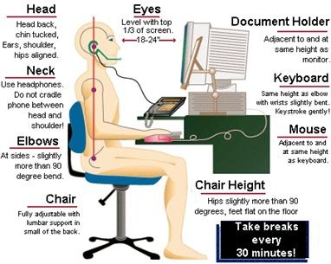

Working with a computer can be productive, rewarding and a lot of fun. Unfortunately, continuous use of computers may result in a number of health and safety problems. A little knowledge of the principles of ergonomics, how people interact safely and efficiently with machines and their work environment, can save a lot of discomfort and maximize both productivity and enjoyment.

* **COMPUTER ERGONOMICS**

<http://www.cpaadvisor.us/sub/2_ergonomics_files/image002.jpg>

**Complete the sentences with the words from the box.**

document adjustable eye breaks keyboard monitor elbows feet

1. Use an …………………chair so you can change its height and angle.
2. Make sure your …………………… rest firmly on the ground.
3. Put the monitor at …………………… level.
4. Use the ……………………… holder in line with the screen to reduce awkward neck.
5. Use an ergonomic ………………………… which helps you type in a more natural and relaxed position and avoid RSI (repetitive strain injury). Try to keep the wrists straight and flat when typing.
6. Position the keyboard at the same height as your ……………………… .
7. Sit at arms' length from the ………………………..
8. e-waste-logoTake regular ……………………….from the computer and look away from the screen at regular intervals.
   * **E-WASTE**

Severe public health and environmental problems can by caused by irresponsible disposal of electronic rubbish. E-waste (old computers, mobile phones, hi-fi and video systems, etc.) should be reduced, reused and recycled. <http://www.recycledgoods.org/about_us.htm>

Some companies have begun to test ways to recycle and dispose of e-waste. Epson Portland, for example, sponsors an electronics collection day on Earth day.

***How green are YOU?***

* **E-ADDICTION**

**- Mobile phones**

There is ongoing research into whether radiation emitted while using mobile phones causes health problems. Talking on a mobile when driving is dangerous and therefore it is illegal in most countries. There a serious risk of distracting a driver and causing accidents while using mobile phones cars. ***Do you ever use your mobile while driving?***

**- Computer and Internet**

When a person is spending too much time in front of the computer (e. g. obsessive game playing) or on the Internet so that his life is affected negatively, he is suffering from computer or internet addiction. ***If YOU are an internet addict, you should ask for help from specialists***

**NANOTECHNOLOGY**

**nano-** (prefix) - meaning **10–9** (one billionth).

* **Definition**

**Nanotechnology** is any technology which exploits phenomena and structures that can only occur at the nanometer scale, which is the scale of single atoms and small molecules.

The term was coined by Norio Taniguchi in 1974 and refers to the field of material processing and fabrication at dimensions below 200 nm. This field is in fact an extension of the more conventional microelectronics world.

**Nanomachines** are devices that range in size from the smallest of MEMS devices down to assembled from individual molecules. One fundamental characteristic of nanotechnology is that nanodevices self-assemble. That is, they build themselves from the bottom up.

* **Use of Nanotechnology**

Nanotechnology cuts across traditional boundaries in **materials science and engineering**. It is giving rise to a spectrum of activities whose commonalities lie in nanoscale dimensions.

***Examples:***

* It enables surface polishing to finishes better than 10 nm; ductile single-point machining of brittle ceramics and crystals by controlling the depth of cut to less than 100 nm; and surface control to atomic dimensions.
* Nanotechnology enables very precise material removal and deposition methods (e.g. optical and beam-based methods of material deposition). New micromachinig options and nanomaterials have already emerged by the use of excimer lasers.
* New tools create new technologies, which then create the next generation of tools. *Examples:*
* **excimer laser**, invented in 1971,whose features are high-power, short-pulse, short-wavelength photon beams. It is a form of [ultraviolet](http://en.wikipedia.org/wiki/Ultraviolet) [chemical](http://en.wikipedia.org/wiki/Chemical) [laser](http://en.wikipedia.org/wiki/Laser) which is commonly used in [eye surgery](http://en.wikipedia.org/wiki/Eye_surgery) and [semiconductor](http://en.wikipedia.org/wiki/Semiconductor) manufacturing.
* **scanning tunnelling microscope** (STM), invented in 1981, and the **atomic force microscope** (AFM) have already enabled the mapping of surface with single-atom resolution, in both conducting (STM) and insulating (AFM) surfaces. STM manipulation and placement of single atoms begin to realize nanotechnology’s ultimate goal.

Nanotechnology is the science of creating and using **devices at molecular and atomic sizes**. These devices will fall in the range of 1 nanometre (one billionth of a metre) to 100 nm. The molecular devices include **nanobots** and **nanocomputers** (DNA computer, quantum computer).

**1. Match the technical term with its meaning.**

|  |  |
| --- | --- |
| **TECHNICAL TERM** | **DEFINITION** |
| depth of cut | the process of putting a layer of a substance on the surface of the workpiece |
| mapping | the process of taking away a layer of material from the workpiece |
| material removal | a transformation taking the points of one space into the points of the same or another space |
| material deposition | the depth reached in material cutting (machining) |

**2. WHAT AM I?**

I have the potential to create and use the materials and devices at molecular and atomic sizes.

I am a molecular computer that works biochemically.

I am a molecule-sized computer.

I am a computer in which data is processed on the basis of quantum physics. I am millions of times faster than current computers.

I am a molecule-sized robotic device, used in medicine, for example.

## Visit the Nanotechnology Homepage of the European Commission which provides an overview of nanotechnology related activities at the European Commission.

## <http://cordis.europa.eu/nanotechnology/>

## On this site you can also find another definition!

"Nanotechnology is an area which has highly promising prospects for turning fundamental research into successful innovations. Not only to boost the competitiveness of our industry but also to create new products that will make positive changes in the lives of our citizens, be it in medicine, environment, electronics or any other field."

## *(European Commissioner for Science & Research, Janez Potočnik )*

## Publications and events

## <http://cordis.europa.eu/nanotechnology/src/publication_events.htm>

## Films, leaflet, brochures (available ad PDF, in Slovenian as well)

## <http://cordis.europa.eu/nanotechnology/src/pe_leaflets_brochures.htm>

## http://upload.wikimedia.org/wikipedia/commons/e/e5/Coursera_logo.PNG

## 

## <https://www.coursera.org/course/nanotech>

## 

**MY LIFE CAREER**

A career means more than just an occupation. One should be thinking of a life career - a term which includes every part of students' development and growth from childhood, through to teenage years and into adult life. A career is made up of all the things students do and the roles students fulfil. They combine to make the student a special and unique person, a person with a personal life style, unlike anyone else's.

***Discuss the factors that influence our career decisions with a partner and then complete the diagram.***

***Steve Jobs' speech***

<http://www.eslvideo.com/quiz_new.php?id=352&pagenum=18>

**MOOCs – Massive Open Online Courses**

****

[**https://www.coursera.org**](https://www.coursera.org)

****

[**https://www.edx.org**](https://www.edx.org)

****

[**https://www.udacity.com**](https://www.udacity.com)

****

[**https://iversity.org/**](https://iversity.org/)

****

[**https://www.open2study.com/**](https://www.open2study.com/)

****

**https://www.mooc-list.com/**

**PREPARING A COMPANY DESCRIPTION**

A well-written company profile is an effective way to introduce the business to the potential customers. A company profile is a professional introduction of the business and aims to inform the audience about its products and services.

To create business or company profiles, one needs to carefully develop a strategy and map out the characteristics to be highlighted and how to assimilate the unique offerings of the business in a concise and attractive manner.

1. **What should a company description include? Discuss with a partner.**
2. **The written company description of the business plan should answer the following questions:**

- What is the name of the company?

- What product or service are you offering?

- Where is it located?

- Is this a start up or an existing business?

- How will it be organized?

- Will it be a sole proprietorship, partnership, or corporation?

- Is the company a manufacturer, retailer, or service business?

- What customers is it attempting to serve?

- What are your business objectives?

**It is very important to state your business objective clearly. Don’t be too general. Always be clear and organized.**

1. **Complete the table about the most important elements included in your company description.**

|  |  |
| --- | --- |
| Company …………………............ | …. as registered in the state where you do business. |
| ................................................... | Information about the key people behind the company. |
| ..................................................... | Where is the company headquartered? |
| Company ..................................... | When was the business started, what inspired you to start the business, what need does your company fulfil? |
| ................................... statement | A clear statement that represents the purpose of your company. |
| **....................................................** | A brief overview of what you plan to sell and to whom. |
| **....................................................** | An outline of what you want to accomplish in the immediate future based on the data in the rest of the business plan as well future growth goals. |
| ....................................... statement | A statement about how you envision the future of the company. |

1. **Write a short business description. These sites may help you.**

<https://www.udemy.com/blog/company-profile-examples/>

<http://www.creditsunrise.com/bus_desc.htm>

<http://www.sampleplan.com/articles/how-to-write-a-business-description-for-a-business-plan.html>

<https://www.enloop.com/>

Sources:

<http://www.entrepreneur.com/article/25752>

<http://sbinformation.about.com/od/businessplans/a/How-To-Write-A-Company-Description.htm>

<http://rhodyag.com/developing-a-business-plan/86-business-plan/82-business-description>

<http://www.sampleplan.com/articles/how-to-write-a-business-description-for-a-business-plan.html>

**JOBS AND CAREERS**

1. **THE IDEAL JOB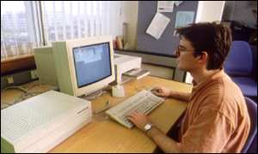**

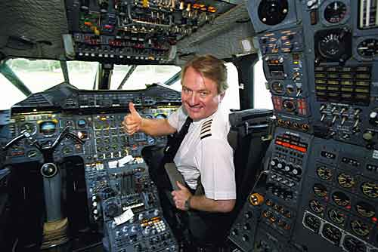

**Work in pairs. Look at the photos and discuss these questions:**

1. What would you enjoy about each of the jobs?
2. What would you dislike about each job? Why?
3. What are the most important things for you in your work? Arrange these aspects in order of importance and add some more things you think are important:

*earning enough money job satisfaction low commute cost*

*meeting people kind boss security*

*having pleasant co-workers/colleagues earning plenty of money*

1. Out of all the people you know, who has the job you'd most like to have? Why?
2. If you could choose any job in the world to do, what would it be? Why?
3. **COMPLETE THE JOB INTERVIEW.**

|  |  |
| --- | --- |
| A | Good morning, take ………………………….. . |
| *B* | *Good morning, thank you.* |
| A | My name is James Brown. I'm the personnel manager for …………………………………. Ltd.  And you are Tom Bennett? |
| *B* | *That's ………………………………..* |
| A | I see you graduated from …………………………………………….. six months ago. |
| *B* | *Yes, I ………………………………………….. information technology.* |
| A | So why do you want to work with us? |
| *B* | *Well, your company has a good ………………………………….. Besides I enjoy working with …………………………………. and I'd like to get some more work ………………………………...* |
| A | What experience do you have? |
| *B* | *I ……………………………………………………………………………………………………………. ..*  *I've ……………………………………………………………………………………………………..…….* |
| A | Mmm, what qualities do you think are important for the job? |
| *B* | *I’m sorry, what do you mean exactly?* |
| A | I mean, the qualities you need to work with …………………………………………………….. |
| *B* | *Well, you certainly must have …………………………………………….. . And another important thing is………………………. You've got to show ……………………………. that you enjoy things.* |
| A | OK, are there any questions you would like to ask me? |
| *B* | *Er, yes, just one thing. Could you tell me if there are any possibilities that this temporary job is changed into ………………………………………..?* |
| A | Yes, of course. |
| *B* | *Oh, I’m glad to hear that.* |
| A | Well, thank you Tom. I’ll be getting in touch with people next week. |
| *B* | *Thank you very much. Goodbye.* |

## Employability Skills

### Initiative

* Adapting to new situations
* Developing a strategic long-term vision
* Being creative
* Thinking critically and acting logically to evaluate situations, solve problems and make decisions

### Communication

* Listening and understanding
* Speaking clearly and directly
* Negotiating responsively
* Persuading effectively
* Speaking and writing in foreign languages

### Teamwork

* Working with people of different ages, gender, race, religion or political persuasion
* Working as an individual and as a member of a team

**Adaptability**

* Having a positive attitude toward change

### Technology

* Having a range of basic IT skills
* Being willing to learn new IT skills

### Problem Solving

* Developing creative, innovative solutions
* Developing practical solutions
* Showing independence and initiative in identifying problems and solving them
* Solving problems in teams

### Self-Management

* Having a personal vision and goals
* Taking responsibility.

### Planning

* Managing time and priorities – setting timelines, coordinating tasks for self and others
* Taking initiative and making decisions
* Collecting, analysing, and organising information

### Learning

* Managing own learning
* Contributing to the learning community at the workplace
* Using a range of mediums to learn – mentoring, peer support, networking, IT, courses

### Personal qualities that a candidate needs for a job

### *He/she should be:*

enthusiastic independent cooperative generous

sensitive motivated creative kind

lively honest patient sociable

hard-working energetic well-organised open-minded

efficient punctual

***Watch this...***   
A brief history of e-commerce <http://www.learnthenet.com/english/section/dobusi.html>

eok_flagOpening doors to learning and working in Europe

## What is Europass

Whether you are planning to enrol in an education or training programme, looking for a job, or getting experience abroad, it is important to be able to make your skills and competences clearly understood.

## Europass is a new way of helping people to:

* make their skills and qualifications clearly and easily understood in Europe (European Union, EFTA/EEA and candidate coutries);
* move anywhere in Europe.

## Europass consists of five documents:

* two documents ([Europass curriculum vitae (CV)](http://europass.cedefop.europa.eu/europass/home/vernav/Europasss+Documents/Europass+CV.csp) and [Europass Language Passport](http://europass.cedefop.europa.eu/europass/home/vernav/Europasss+Documents/Europass+Language+Passport.csp)) you can fill in yourself; and
* three other documents ([Europass Certificate Supplement](http://europass.cedefop.europa.eu/europass/home/vernav/InformationOn/EuropassCertificateSupplement.csp), [Europass Diploma Supplement](http://europass.cedefop.europa.eu/europass/home/vernav/InformationOn/EuropassDiplomaSupplement.csp) and [Europass Mobility](http://europass.cedefop.europa.eu/europass/home/vernav/InformationOn/EuropassMobility.csp)) filled in and issued by competent organisations.

**GO TO** [http://europass.cedefop.europa.eu/europass/home/hornav/Introduction.csp;jsessionid=94BF8F6BACB0A27BC119AA4D2F4CF14D.worker\_portal\_cms#](http://europass.cedefop.europa.eu/europass/home/hornav/Introduction.csp;jsessionid=94BF8F6BACB0A27BC119AA4D2F4CF14D.worker_portal_cms)

# The Europass Curriculum Vitae (CV)

## What is it?

Anyone who wants to use Europass can start by completing the Europass CV. The Europass CV enables you to make your skills and qualifications visible, and other Europass documents can be attached to the CV. The Europass CV replaces the European CV, launched in 2002.

**GO TO** <http://europass.cedefop.europa.eu/europass/home/vernav/Europasss+Documents/Europass+CV.csp?loc=en_GB>

### On the site above you can

### [Create your Europass CV online now](javascript:openInstrument('/europass/home/vernav/Europasss+Documents/Europass+CV/CVOnLine.csp','cvwin'))

following the online instructions and examples. You will then receive the completed CV electronically (download or e-mail).

### [Download the Europass CV documents](http://europass.cedefop.europa.eu/europass/home/hornav/Downloads.csp)

(blank template, instructions, examples and Europass cover page). You will then use this information to generate your CV on your computer.

### [Update your Europass CV (XML or PDF+XML)](javascript:openInstrument('/europass/home/vernav/Europasss+Documents/Europass+CV/CVUpdate.csp','cvwin'))

If you already have a Europass CV in XML or PDF+XML format, you can upload it and update your data. Your personal data will be automatically inserted in the system.

* Before creating your own Europass CV you can also

[**View examples of the Europass CV**](http://europass.cedefop.europa.eu/europass/home/hornav/Downloads/EuropassCV/CVExamples.csp)

*Source:* [*http://europass.cedefop.europa.eu/*](http://europass.cedefop.europa.eu/)

**WRITING FORMAL LETTERS**

|  |  |  |
| --- | --- | --- |
| **Dear Mrs White,**  **………..**  **Yours sincerely,**  **Adam Hill** | **Dear Sir or Madam,**  **………..**  **Yours faithfully,**  **Mark Adams** | PARAGRAPH PLAN FOR LETTERS **greeting**  🡻  **Introduction:** **Paragraph 1** reasons for writing  🡻  **Main body:**  **Paragraphs 2, 3** development of the subject  🡻  **Conclusion:** **Final paragraph** closing remarks  🡻  **full name** |

1. APPLICATION LETTER

COMPLETE TOM'S LETTER OF APPLICATION BY PUTTING ONE WORD INTO EACH GAP.

17 Hillside Rd

Chesswood

17 January 1998

David Benton

Worldwatch

13 Ferry Rd

Basingstoke

Dear Mr Benton,

I saw your ……………………………. for a business journalist in today's Guardian newspaper. I am very ……………………… in the job and I think that I have many of the necessary ………………………….. .

I ………………………… politics and modern languages at Oxford University. I am ………………….. in French, German and Spanish. I have ……………..……. widely in Europe and South America, and I …………………… worked as a business journalist for the BBC …………………………. the last five years.

I enclose a copy of my curriculum vitae. I look forward ………………………. hearing from you soon. Please let me know if you need more information.

Yours sincerely,

Tom Mann

Tom Mann

**b. LETTER OF COMPLAINT**

* ***READ THE LETTER AND FILL IN THE GAPS WITH WORDS / PHRASES FROM THE LIST.***

**but also, furthermore, not only, however, in addition to, firstly,**

**to make matters worse**

|  |  |
| --- | --- |
| **Dear Sir/Madam,**  **I am writing to express my strong dissatisfaction at the disgraceful treatment I received at the Walford branch of Stimpson's Electronics yesterday afternoon.**  **(1) ………….……, the product I was given was not the model I had asked for. The new X-401 calculator was demonstrated to me by the sales assistant, and I agreed to buy it. (2)……………….., on unpacking my purchase, I saw that I had been given the smaller X-201 model instead.**    **(3) ……………….., this calculator was much cheaper than the model I requested and paid for. It didn't have many of the features I**  **needed and was much more basic than the one I was shown to begin with.**  **(4) …………………….., I was deeply offended by the behaviour of the sales assistant when I went back to the shop to complain. He was (5) …………………. impolite, (6) ……………….. unhelpful. He refused to contact the manager when I asked to speak to him about the incident.**  **As you can imagine, I am extremely upset. I must insist on a full refund, (7) ………………….. a written apology from the local manager, or else I shall be forced to take further action. I expect to hear from you as soon as possible.**  **Yours faithfully,**  **Charles Adams**  **Charles Adams** | **Para 1**  *opening*  *remarks*  **Para 2**  *………….*  *…………*  **Para 3**  *……………*  *…………..*  **Para 4**  *……………*  *…………..*  **Para 5**  *……………* |

* ***READ THE LETTER AGAIN AND LABEL THE PARAGRAPHS WITH THESE HEADINGS.***
* closing remarks - 2nd complaint & examples / reasons
* opening remarks / reasons for writing - 3rd complaint & examples / reasons
* 1st complaint & examples / reasons

**COMPLETE THE LETTER.**

|  |  |
| --- | --- |
|  | Sony Robots  22Manchester Rd   London DW 34 MN [sony@entertainment.co.uk](mailto:sony@entertainment.co.uk) January 12, 2009 |

Mr Novak   
Slovenska cesta 11

1000 Ljubljana

Slovenia

(1)....................................,

Thank you for your interest in Sony entertainment robots.

We are sorry to inform you that the AIBO pet dog was discontinued in 2006. (2)......................................... some descriptive leaflets with the technical details of another entertainment robot QRIO ("Quest for cuRIOsity") which follows up on the success of our previous models. I would like to draw your attention to the fact that QRIO was credited in Guinness World Records (2005 edition).

The prices shown in our leaflets are net, but we offer discounts by negotiation. Sony Warranty provides 2-year coverage.

(3)............................................ deliver one of our robots on approval, for your inspection.

Please do not hesitate to contact us (4)......................................... .

I look forward to hearing from you again soon.

(5).................................... ,

James Green

James Green  
Sales Office Manager





<https://www.coursera.org/course/career>

**GRAMMAR**

**(REVISION)**

**VERBS IN ENGLISH**

1. AUXILIARY VERBS: do, be, have
2. MODAL AUXILIARY VERBS: must, can, may, should, might, will, would…
3. FULL VERBS: - play, go…

- be (I am tired.), do (I never do my homework.), have (I have a dog.)

**AUXILIARY VERBS**

|  |  |  |
| --- | --- | --- |
| **AUXILIARY VERB** | **to FORM** | **EXAMPLE** |
| **DO / DOES** | the question and the negative in the **Present Simple** | **Do** you like apples?  She **doesn't** live in Ljubljana. |
| **DID** | the question and the negative in the **Past Simple** | Why **did** you buy it yesterday?  They **didn’t** invite me last night. |
| **BE** | **continuous** forms **(BE +-ing)** | She **is sitting** in the garden now. **↔ NOT** |
|  | the **Passive** **(BE + -ed/3.)** | My bag **was stolen** yesterday. **↔ NOT** |
| **HAVE** | **perfect** tenses **(HAVE + -ed/3.)** | She **has** never **been** to Australia. **↔ NOT**  After I **had written** my homework, I went out. |

|  |  |
| --- | --- |
| **DO / DOES & DID** | **PRESENT & PAST SIMPLE ( ?, - )** |
| **BE (am/is/are, was/were, have been/has been, will be…)** | **CONTINUOUS TENSES & PASSIVE** |
| **HAVE (have/ has/ had)** | **PERFECT TENSES** |

|  |  |
| --- | --- |
| **She’s got a cat.**  **Has she got a cat?**  **She hasn’t got a cat.** | **She has a cat.**  **Does she have a cat?**  **She doesn’t have a cat.** |

**COMPLETE THE FOLLOWING SENTENCES WITH AUXILIARY VERBS:**

1. I ………have……………..known her for several years.
2. Jane ………had………….won a lot of money so next week she ……………is………..travelling to America to visit her relatives.
3. It was not long before she moved to Paris that she ………………… got a job in an agency.
4. ………Does………………… she happen to know me?
5. …………Didn’t……………… you write a letter to her a few minutes ago?
6. How many letters …………have………… you written so far?
7. The shopping centre …………is……... located near the village. I go there every morning.
8. I was surprised because she ………………had…….. never talked about moving abroad.
9. My parents are happy because I ………have…………… passed all the tests.
10. ……………Did……………. you phone me last night?
11. How often ……does……………… your mother cook fish?
12. Where ………did……………you buy all your clothes?
13. How much money …………has………… your sister spent in holiday in Greece?
14. How many times …………did………….Columbus travel to the new found land?
15. How many times …………have………….you crossed the Atlantic?
16. Tina was upset. She ……………had………... lost all of her documents.
17. We are excited. We ……………have………… never travelled by plane.
18. Paper …………is……………made from wood.
19. They…………have been…………. working all day yesterday.
20. …………Did…………….. she got any children?
21. ………………Do………. you do your homework every afternoon?
22. ……………Does………….. Tom have a lot of money?

**PRESENT SIMPLE TENSE…....&…....PRESENT CONTINUOUS TENSE**

|  |  |  |
| --- | --- | --- |
| **AUXILIARY** | **VERBS** | |
| PRESENT SIMPLE | PRESENT CONTINUOUS | |
| DO / DOES ( ?, - ) | AM , IS, ARE **↔ NOT** | |
|  | |
| ▼ ▼ ▼ ▼ ▼ ▼ | |

|  |  |
| --- | --- |
| **PRESENT SIMPLE** | **PRESENT CONTINUOUS** |
| HABITUAL ACTIONS (often, usually, rarely…)  He usually gets up at 6.30.  I wash my hair twice a week. | ACTIONS HAPPENING AT / AROUND THE MOMENT OF SPEAKING (now)  You can’t speak to her. She is having a bath. |
| PERMANENT SITUATIONS / STATES  She works as a nurse.  They own a house. | TEMPORARY SITUATIONS  This week he is going to work by bus as his car is broken. |
| PERMANENT TRUTHS / LAWS OF NATURE  Money doesn’t buy happiness.  Water freezes at 0oC. | REPEATED ACTIONS WITH »always« (ANNOYANCE, CRITICISM)  He’s always smoking in the dining room! |
| TIMETABLES / PROGRAMMES (future meaning)  The plane leaves at 10.05.  The match finishes at 6 p.m. | FIXED ARRANGEMENTS IN THE FUTURE  We are leaving tomorrow.  They’re getting married next month. |
| REVIEWS / SPORTS COMMENTARIES  Hopkins acts brilliantly in this film.  Cantona passes to Hughes … and Hughes scores! | CHANGING / DEVELOPING SITUATIONS  His French is getting better. |

**E X E R C I S E S**

**I. FILL IN WITH PRESENT SIMPLE OR PRESENT CONTINUOUS.**

1. Milk ………contains…………..(contain) a lot of vitamins.
2. John ………………flies……(fly) to Paris tonight.
3. How many brothers ……do………you………have……..(have)?
4. ………Does……….the film ……start…………(start) at 6 o’clock?
5. Light ………travels……………(travel) faster than sound.
6. My mother …does not cook……………..(not cook) dinner now.
7. They …………are staying………….(stay) at the Park Hotel at present.
8. He………………does not have……(not have) breakfast at the moment.
9. ………Does………..he ………have………..(have) a pet dog?
10. What time ……does………..your train………arrive…………(arrive) in London?
11. Hello June. Where ……are………..you………calling……….(call) from?
12. She …………is……always………interupting…………(interrupt) me!
13. The Browns ………are visiting……….(visit) us tonight.
14. Her grandmother ………does not live…………..(not live) in Ljubljana.
15. ………Do………they………have………..(have) a party at the moment?
16. He ………gets…………(get) stronger.
17. Who …………owes…….(owe) you the money?
18. If you heat ice it …melts………………(melt).
19. She ………drinks………..(drink) three cups of coffee every morning.
20. I …………think………(think) he’s tired.
21. I…………am thinking……….(think) about your plan.
22. The milk ………tastes………..(taste) awful.
23. I ………don’t taste………….(taste) the sauce; it might need some salt.
24. I ……………see……(see) you’re in trouble.
25. I…………am seeing……..(see) my lawyer tonight.

**II. COMPLETE THE SENTENCES ABOUT THE LAWS OF NATURE. USE WORDS FROM THE LIST.**

|  |  |  |  |
| --- | --- | --- | --- |
| ~~evaporate~~  ~~stretch~~  ~~crash~~  sink  ~~contract~~ | ~~burst~~  ~~rust~~  ~~condense~~  ~~freeze~~  ~~fade~~ | float  ~~soften~~  ~~bounce~~  ~~harden~~  ~~ignite~~ | ~~expand~~  ~~shrink~~  ~~burn~~  ~~boil~~  ~~dissolve~~ |

1 When you heat a metal bar, it **expands** and when you cool it, it … **contract** ……….

2 If you leave an iron bar in water, it …**rusts**………

3 If you wash jeans in very hot water, the fabric ......**shrinks**........ , and if you wash them repeatedly, the colour …..**fades**……….

4 Water …**freezes**…….. at 0 °C. It …**boils**…….. at 100 °C.

5 Steam .....**condenses**........ when it comes into contact with cold glass.

6 If you leave a bowl of water in the hot sun, the water ……**evaporates**………

7 Take ice cream out of the freezer five minutes before you want to eat it, so it ……**softens**……… . If you don't eat it all, put it back in the freezer and it ......**hardens**....... again.

8 A spark from an engine .......**ignites**...... the fuel.

9 If you put salt in water and stir, the salt …**dissolves**………

10 If you pull elastic, it ……**stretches**………

11 If you drop a rubber ball, it ……**bounces**…….

12 If you overload a computer's processor, it ……**crashes**…….

13 If you over-inflate the balloon, it ........**bursts**.........

14 The candle ......**burnes**........... for three hours and then goes out.

15 If you throw a brick into the river, it ………**sinks**………, but if you throw a rubber ball in the river, it ………**floats**…..

***Which verbs are connected with changes in:***

1 size or shape?

2 colour?

3 chemical state (gas, liquid, solid)?

**III. MINI-QUIZ: WHAT IS IT?**

* **Read about the dangers of a substance called XXX. What is XXX?**

**BEWARE OF XXX!**

**XXX kills hundreds of thousands of people a year and it could kill you**.

• Many deaths are caused by accidental inhalation of XXX.

• The solid form of XXX can cause damage to human tissues.

• The gas form of XXX can result in severe burns.

• XXX makes many metals rust and corrode.

• Many electrical failures are caused by XXX.

• XXX causes millions of euros worth of property damage each year.

• XXX can make automobile brakes fail.

• XXX is colourless, odourless, and tasteless, but the dangers of XXX are all around us.

• Acid rain contains XXX.

• Rivers and oceans contain large quantities of XXX:

• XXX is used by nuclear power plants.

• Many people walk miles and miles every day to get XXX because they want to ingest XXX.

• If you don't ingest XXX, you can die.

XXX = Water

* **What are the more common terms for:**

|  |  |
| --- | --- |
| 1 accidental inhalation of XXX?  2 the solid form of XXX? | 3 the gas form of XXX?  4 ingest? |

**IV. UNDERLINE THE CORRECT TENSE.**

**1** More and more people **move/are moving** to the countryside these days.

**2** Sheila **works/is working** as a costume designer for the local theatre company.

**3** *Computec* **holds/is holding** a five-day seminar on computers for all its employees next week.

**4** Lauren **doesn't leave/isn't leaving** her house before 9 o'clock in the morning.

**5** No wonder the phone bills are so high! You **always talk/are always talking** on the phone!

**6** I **don't teach/am not teaching** in the evenings at present.

**7 Do amphibians live/Are amphibians living** both on land and in water?

**8** I never **go/am** never **going** to that restaurant again! The food was horrible!

**9** They **prefer/are preferring** to go on holiday in spring when the resorts are less crowded.

**10** Chris and Helen **are having/have** a garden party on Sunday afternoon.

**V. TICK THE CORRECT SENTENCE, AS IN THE EXAMPLE.**

|  |  |
| --- | --- |
| **1** *a) The train from Brussels arrives at*  *2:20at Platform 5.* **√**  b) The train from Brussels is arriving at  2:20 at Platform 5.  **2** a) Mr Lewis doesn't go to the  supermarket today.  b) Mr Lewis isn't going to the  supermarket today. **√**  **3** a) Renee always breaks things in the  kitchen.  b) Renee is always breaking things in  the kitchen. **√**  **4** a) Greg and Julie live in a flat in  Manhattan.  b) Greg and Julie are living in a flat in  Manhattan. **√** | **5** a) Do we visit Grandma and Grandpa  this Sunday?  b) Are we visiting Grandma and  Grandpa this Sunday? **√**  **6** a) Cats don't like water. **√**  b) Cats are not liking water.  **7** a) Jacob never changes a flat tyre again.  b) Jacob is never changing a flat tyre  again. **√**  **8** a) How much does the silk blouse cost? **√**  b) How much is the silk blouse costing?  **9** a) More and more people eat healthily.  b) More and more people are eating  healthily. **√**  **10** a) That carton contains one litre of milk. **√**  b) That carton is containing one litre of  milk. |

**VI. PUT THE VERBS INTO THE SIMPLE PRESENT OR PRESENT CONTINUOUS TENSE.**

1. A: You ………are not telling….…….(not tell) the truth.

B: How ……do……..you………know………(know) that I ……am not telling……………(not tell) the truth?

1. You can't see Mrs. Johnson because she ………is resting……………(rest). She always

……rests……..(rest) after lunch.

1. We ……have…………….(have) breakfast at 8.00 tomorrow because Tom

………is catching………(catch) an early train.

1. Tom usually………feeds…………..(feed) the hens but I ………do………..(do) it today as he is

not well.

1. A: Someone …………is knocking……….(knock) at the door. ……are………you………not going……..(not

go) to answer it?

B: I’ll go in a minute. I ……have……...just……got………(get) out of my bath.

1. A: ………are………you………doing……….(do) anything this evening?

B: No, I am not.

A: Well, I ……am going…………….(go) to the cinema. Would you like to come with me?

1. A: How much ………do…….you…owe………..(owe) him?

B: I ………owe…………(owe) him 5 pounds.

A: ……do………….you………intend………..(intend) to pay him?

1. A: ………do…………you………mind………(mind) if I ……ask…………..(ask) you a question?

B: That …………depends…………(depend) on the question.

A: It ……concerns…………..(concern) your brother.

B: I ……refuse…………..(refuse) to answer the question about my brother.

1. He usually ……goes……………(go) by train, but this weekend he ……is going……………(go) by

bus. It .……takes…….. (take) longer but it ………costs………….(cost) less.

1. A: My daughter never ……writes……………..(write) to me so I never ……know…………..(know)

how she ………is.………..(be). …does……………your son………write………..(write) to you?

B: Yes, I ……hear…………….(hear) from him every week. He …………seems………..(seem) to

like writing letters.

* **COMPLETE.**

**How do bats know where they are going?**

An odd thing about bats is that they ……don’t…………… (not have) a good eyesight. Although they have to hunt for their food during the night. In fact bats ………don’t relay…………. (not rely) on their eyes to find their way. They ………are using………… (use) a kind of radar system which …………works………… (work) like this: when they ………are flying………….. (fly), bats make high-pitched sounds which ……………………are….. (be) so high that human beings cannot hear them. The echoes from these sounds …………are throwing………… (throw) back to the bat while it is still in the air. The bat can tell whether the echo came from an object nearby or far away and it will change the direction of its flight to avoid crashing into the object. Bats …………depend……….. (depend) on flying more than most animals. While birds and insects also …………fly……… (fly), they ……………have…………. (have) the ability to walk about if necessary. However, a bat cannot walk very easily because its limbs and feet ……………are not…….. (not be) suitable; it cannot even stand very easily. So it is actually easier for a bat to hang upside down from a branch than to sit on it.

**How do we see in 3D?**

When we look across a field, how ……do…………. we ………know……… (know) that one distant object ……………is……….. (be) bigger than another or that one object is behind another, not in front of it? In other words, how ……do…………we ……see………… (see) things in three dimensions, in proper relation to each other, instead of seeing everything »flat«? The answer is that when we ……………see………. (see) things, we see them not only with our eyes but with our minds as well: we see things in the light of experience. Our minds and memories ………………help…………. (help) us to interpret what we see. For instance, experience ……give…………………. (give) us an idea about the size of things. A man on a boat some distance from the shore …………looks…………. (look) much smaller than a man on the beach. But you …………don’t……… (not think) that one is a very large man and the other a very small man. What you ……say……………. (say) to yourself is that one man is nearby and the other is far away.

**A tip round Europe**

The British are considered to be among the worst tippers in the world but is that because they simply don't know the rules?

Customs ………differ……………. (differ) between countries, so it ……is not……………….. (not be) surprising that in Tokyo they …………do………… (do) things differently from London.

In British restaurants, for example, a tip ……is…………… generally ……included……………. (include) in the bill and this is the case in most northern European countries. In some Mediterranean countries, such as Greece and Spain, the customer …is expected………………… (expect) to pay a little extra for satisfactory service. As for bars and pubs, again customs

…………are varying………. (vary). In Britain, one certainly ………doen’t…………. (not have) to pay a tip in pubs, while in hotel bars it is fairly common to leave your small change behind. This is the case in Germany too, but in France you ………leave…………… (leave) a tip only when drinks ………are brought……………… (bring) to your table. In the majority of European countries, with the

exception of Ireland where it …………applies………….. (apply) only in top hotels, porters ……………receive………… (receive) a tip for carrying your luggage to your room for you.

**THE PASSIVE …………….. BE + past participle** (-ed/3.)

**IS USED:**

1. when the **AGENT** (= the person who does the action) is **UNKNOWN**, **UNIMPORTANT** or **OBVIOUS** from the context.

*Tom was shot. This church was built in 1920. He has been arrested.*

1. to make more **POLITE** or **FORMAL** statements.

*The car hasn’t been cleaned. (You haven’t cleaned the car = less polite)*

1. when the **ACTION IS MORE IMPORTANT** than the agent, as in the processes, events, reports, headlines, news items, and advertisements.

*300 people were killed in the earthquake.*

4. to put **EMPHASIS ON THE AGENT**.

*The new museum will be opened by the Queen.*

***NOTE:***

* We use the passive only with ***transitive verbs*** (verbs which take an object).

*They built that castle in 1890. That castle was built in 1890.*

* With verbs that take ***2 objects*** it is more usual to begin the passive sentence with the person.

*They sent* ***him*** *a letter. →*  ***He*** *was sent a letter. (=more usual)*

*→ A letter was sent* ***to him****. (=less usual)*

* The verbs BELIEVE, EXPECT, FEEL, HOPE, KNOW, REPORT, SAY, THINK etc are used in the following passive patterns in personal and impersonal constructions.

*People BELIEVE he is a liar.*

*He IS BELIEVED to be a liar.* ***subject (person) + passive + to-inf. (personal***

***construction)***

*It IS BELIEVED that he is a liar.* ***it + passive + that-clause (impersonal***

***construction)***

* In PASSIVE QUESTIONS with WHO / WHOM / WHICH we do not omit BY.

*Who gave you this book? →* ***WHO*** *were you given this book* ***BY****?*

*Who signed this letter? →* ***WHO*** *was this letter signed* ***BY****?*

**CAUSATIVE HAVE ……… HAVE + object + PAST PARTICIPLE**

* We use CAUSATIVE HAVE to say that we arrange for someone else to do something for us.

*Jim* ***fixed*** *the dishwasher. (he did it himself)*

*Jim* ***HAD the dishwasher FIXED****. (he asked someone to fix it for him)*

* The verb TO HAVE used in the Causative forms its negations and questions with **DO / DOES / DID**.  ***Did*** *you have your hair cut?*
* **GET** can be used instead of HAVE in spoken English.

*You should* ***get*** *your skirt* ***washed.***

**PASSIVE VOICE**

/ xy + **BE + -ed/3.** (+ by …) /

|  |  |  |  |
| --- | --- | --- | --- |
| xy | **BE** | -ed / 3. | (by…) |
|  | **am, is, are** |  |  |
|  | **was, were** |  |  |
| A painting | am/is/are *being* | paintED | BY Picasso. |
|  | was/were *being* |  |  |
| Painting**s** | **has been, have been** | stolen (3.) | (BY a thief.) |
|  | **had been** |  |  |
|  | am/is/are going to be |  |  |
|  | **must *be*, can *be*, could *be,* may *be*, will *be*, …** |  |  |
|  | must ***have been***,  could ***have been***,  may ***have been*** |  |  |

**THE PASSIVE (exercises)**

1. **PUT THE VERBS IN BRACKETS INTO PRESENT SIMPLE PASSIVE.**

There is a chimpanzee which ……………………..(call) Bubbles. It………………………..(own) by Michael Johnson. It………………………..(keep) in his home. It ……………………….(feed) every day by Michael Johnson himself. It ……………………….(always / dress) in funny clothes. It ………………………(say) that Bubbles is Michael Johnson's only friend.

**II. LOOK AT THE HOTEL INFORMATION TABLE AND WRITE SENTENCES AS IN THE EXAMPLE:**

**HOTEL INFORMATION**

|  |  |
| --- | --- |
| BREAKFAST  In Pierrot's Restaurant 7-9.30 am | ROOMS  Maid Service daily |
| DINNER  In Main Restaurant 8-10 pm | HOT WATER  24 hours a day |
| NEWSPAPERS – TELEPHONE CALLS  At the Reception Desk | HOTEL CINEMA  Film every night at 10 pm |

1. BREAKFAST / SERVE – WHERE AND WHEN?

Breakfast is served in Pierrot's restaurant between 7 and 9.30 am.

1. DINNER / SERVE – WHERE AND WHEN?

………………………………………………………………

1. NEWSPAPERS / SELL – WHERE?

……………………………………………………………….

1. TELEPHONE CALLS / CAN MAKE – WHERE?

………………………………………………………………..

1. ROOMS / CLEAN – WHO BY AND HOW OFTEN?

………………………………………………………………..

1. HOT WATER / SUPPLY – WHEN?

…………………………………………………………………

1. FILMS / SHOW – WHERE AND WHEN?

…………………………………………………………………

**III. FORM THE PASSIVE.**

1. TV – invent – Baird
2. Pyramids – build – Egyptians
3. milk – produce – cows
4. hat – just blow away – wind
5. coffee – grow – Brazil
6. chopsticks – use in China
7. robber – just arrest
8. the injured man – take to hospital - a minute ago
9. the car – not repair yet
10. dishes – not wash yet
11. long dresses – wear – 1890

**IV. CHOOSE A VERB AND COMPLETE THE SENTENCES.**

***send, sell, shoot, follow, visit***

1. This museum is very popular. It ….…………..... by nearly one million people every year.

2. A: That man is still behind us, Holmes. B: Yes, Watson. We....................

3. Martin Luther King……………...... in 1968.

4. A: I'd like to buy that car. B: You are too late. ...................

5. I .………………....some flowers yesterday. I wonder who they were from!

**V. USE THE PASSIVE OF THESE VERBS:**

1. The music at the party was very loud and could ...............................(hear) from far away.

2. I don't mind driving but I prefer to .......................... (drive) by other people.

3. If you kicked a policeman, you'd ........................ (arrest).

4. The room ……………………….... (clean) tomorrow.

5. Two trees.........................(blow) down in the storm last night.

6. Glass…………………….....(make) from sand.

7. What…………………..this machine......................(use) for?

8. The transistor..........................(invent) in 1948.

9. My car …………………...(steal) last week. The next day it……………………..(find) by the police.

10. The window………………..just……………………..(break).

**VI. TURN FROM ACTIVE TO PASSIVE.**

1. Spielberg directed E.T..
2. They will advertise the product on TV.
3. You must leave the bathroom tidy.
4. You should water this plant daily.
5. Someone broke the door down.
6. People must obey the law.
7. They deliver letters every day.
8. They built this bridge in 1815.
9. The police have arrested him.
10. They have delivered some furniture.
11. They put up new curtains yesterday.
12. They will install light fittings.
13. Somebody murdered her.
14. A dog is chasing the child.
15. They are building a new barn.
16. People should send their complaints to the head office.
17. They had to postpone the meeting because of illness.
18. Somebody might have stolen your car if you had left the keys in it.
19. An electrical fault could have caused the fire.
20. They're going to hold next year's concert in San Francisco.
21. They shouldn't have played the football match in such bad weather.
22. Who wrote it?
23. Lightening struck the old oak.
24. We will not admit children under sixteen.
25. A rainstorm flooded the camp.
26. No one has taken out the cork.
27. They threw him out.
28. Someone has already told him the sad news.
29. We feed the dog twice a day.
30. They must oppose this.

**VII. USING THE PASSIVE, ASK QUESTIONS TO WHICH**

**THE BOLD TYPE WORDS ARE** **ANSWERS.**

1. **Columbus** discovered America.
2. We keep money **in a safe**.
3. **A bee** stung him.
4. They speak **Italian** in Italy.
5. They have taken **his aunt** to hospital.
6. **The boys** damaged the TV.
7. **Da Vinci** painted Mona Lisa.
8. He invited **30 people** to his party.
9. They grow bananas **in Africa**.

**VIII. ASK QUESTIONS ABOUT THE UNDERLINED WORDS.**

1. It has been kept in a special case. Where.....?

2. The Houses of Parliament were built in the nineteenth century. When....?

3. Our post is delivered twice a day. How often.....?

4. Three teenagers were given an award for bravery yesterday. Why....?

5. Twenty people were hurt in the train crash. How many....?

**IX. TURN FROM PASSIVE INTO ACTIVE.**

1. That picture was painted by Van Gogh.
2. The trees have been struck by lightning.
3. Your English can be improved by more study.
4. This work must be completed today.
5. The exhibition will be opened by the Queen.
6. These buildings were designed last year.
7. Plants are being watered.
8. A concert is organized every year.

**X. REWRITE THE FOLLOWING PASSAGE IN THE PASSIVE.**

Somebody has stolen a bus from outside the school. Some children saw the thief. The police are searching for the bus. They will use the children's descriptions to catch the thief.

**XI. Complete this text using the correct passive form of one of the verbs below in each space. Use two of the verbs more than once.**

***refer use bring give invent write call beat build***

**WHY DOES NOTHING EXIST?**

Did nothing always exist or (1) *was* it *invented*? “Nothing” is zero or nought (0). It is a very useful idea and it (2) …………………………. by many different names. In football, 0 (3) ……………………….. to as “nil”. So we say: “Liverpool (4) ……………………….. two-nil (2-0) at home by Manchester United.” When you (5) ……………………………. marks in a test, you hope you will never get “nought” out of ten or twenty. When we talk about the temperature, “zero” (6) ……………………….. . We say: “It is freezing today; the temperature has dropped to five below zero.” The most unusual name for 0 must be that which (7) ………………………… in tennis, “love”; where the scoring goes 15-love, 30-love and so on. Not many people realize that 0 did not always exist but is some­thing that had (8) ………………………… . Until the sixteenth century, the number system used in Europe was the Roman system, which (9) ……………………………. about two thousand years ago. The Roman system is not simple, for example the mark “X” stands for ten and “C” refers to a hundred. A much better number system (10) …………………………. by the Hindus much earlier. The Hindu system (11) …………………………. to Europe in AD 900 by the Arabs and is sometimes referred to as the “Arabic system”. This system (12) …………………………… on a base of ten and all numbers (13) …………………………. with the digits: 1, 2, 3, 4, 5, 6, 7, 8, 9 and 0. So as all schoolchildren know, 10 means “ten” and 40 means “four times ten

**PAST FORMS**

|  |  |  |
| --- | --- | --- |
| **PAST SIMPLE** | **PAST CONTINUOUS** | **PAST PERFECT** |
| **-ed/2. DID** | **was/were + -ing ↔ NOT** | **had + -ed/3. ↔ NOT** |
| **complete action/event which happened at a stated past time**  She left a minute ago. | **action happening at a stated past time**  At 5.00 yesterday I was playing football. | **past action which happened before another action or before a stated past time**  He had left by the time I got there  (***or*** by 3 o'clock).  After he had written his HW he went out.  He left as soon as he had heard the news.  When he saw her he realised that he had met her before. |
| **period of time now finished, the time is not mentioned**  Prešeren wrote a lot of poems. (he is now dead) | **past action in progress interrupted by another past action**  While I was getting dressed the bell rang. | **complete past action which had visible results in the past**  She was sad because she had failed the test.   1. (1.) |
| **past actions which happened one after the other**  She sealed the letter, put a stamp on it and posted it. | **two or more simultaneous past actions**  While I was reading they were watching TV. |  |
| **past habit / state**  He used to go to school on foot. | **background description to events in a story**  The sun was shining, the wind was blowing… |  |

***PAST SIMPLE***

**- ED (PLAYED) / 2. of irregular verbs (WENT)----------- DID you PLAY, I DIDN’T go**

I bought / played it **YESTERDAY / TWO MINUTES AGO / LAST NIGHT / IN 1990 / WHEN I WAS IN LONDON.**

…………………………………………………………………………………………………

***PAST CONTINUOUS***

**WAS +**

**WERE …………..ING (WERE you …ING? ------- I WAS not ….ING)**

WHILE I was sleeping, - she was watching TV.

- the phone rang.

I was sleeping WHEN the phone rang.

I was working in the garden all day yesterday. / from 4 to 8 yesterday.

I was flying to Paris at 5 yesterday.

…………………………………………………………………………………………………

***PAST PERFECT***

**HAD + -ED / 3. of irregular verbs (HAD you GONE? ------------- I HAD not GONE)**

WHEN 1. 2.

AFTER I had finished my HW, I went out.

AS SOON AS

………………………………………………………….

2. 1.

He was angry BECAUSE he had lost his dog.

…………………………………………………………

1. 2.

I had finished my homework, BEFORE I went out.

…………………………………………………………………….

1. 2.

I hadn't eaten suschi, UNTIL I met Anna.

………………………………………………………………………..

2. 1.

BY THE TIME I arrived to the cinema, the film had already started.

**I. MAKE THE FOLLOWING SENTENCES NEGATIVE.**

1. Shakespeare wrote songs. Shakespeare **didn’t write** songs. He **wrote** plays.
2. Christopher Columbus discovered India. …………………………………..
3. Beethoven came from Paris. ……………………………………………….
4. Leonardo da Vinci lived in Brazil. …………………………………………
5. The Americans landed on the moon in the 19th century. …………………..
6. The USA won the last football World Cup. ……………………………….
7. Last night I had grass for dinner. …………………………………………..

**II. WRITE QUESTIONS TO ASK ABOUT THE MISSING INFORMATION.**

1. “I went to the states in **19……..** .” “ When did you go to the States?”

2. “I went to ……. for my last holiday.” “ Where……… ………………?”

3. “We stayed in …… .” “……… …………………….?”

4. “We stayed there for …….weeks.” “How long…………….……...……….?”

5. “We had ……weather.” “ ……………… ………… good weather?”

6. “We travelled round by……… .” “…………………………………?”

7. “We had ……food.” “ …………………………………… good food?”

**III. CHOOSE THE CORRECT VERB FORM IN THE FOLLOWING SENTENCES.**

I **met/was meeting** a friend while I **did/was doing** the shopping.

I **paid/was paying** for my things when I **heard/was hearing** someone call my name.

I **turned/was turning** round and **saw/was seeing** Paula.

She **wore/was wearing** a bright read coat.

We **decided/were deciding** to have a cup of coffee.

While we **had/were having** a drink, waiter **dropped/was dropping** a pile of plates.

We all **got/were getting** a terrible shock.

While the **waiter picked/was picking up** the broken plates, he **cut/was cutting** his finger.

We **left/were leaving** the cafe and **said/were saying** goodbye.

I **finished/was finishing** my shopping and **went/was going** home.

**IV. PUT *WHILE, DURING*, OR *FOR* INTO EACH GAP.**

|  |  |  |
| --- | --- | --- |
| **WHILE + clause (= subject + verb)** | **When?** | I met her **while** I was staying in London. |
| **DURING + noun** | **When?** | He worked on a farm **during** the holidays. |
| **FOR + time expression** | **How long?** | I lived there **for** three months. |

1. I fell and hurt myself ……………………. I was playing tennis.
2. It started to rain ………………… the match.
3. We played tennis ……………….two hours.
4. ……………….the summer I stayed on a farm in France.
5. I learned French …………….. I was there.
6. We went on holiday to Italy …………….two weeks.
7. ………………the day it was very hot, but it was cool at night.
8. We went to Disneyland ………………..we were in America.
9. We had a lovely meal yesterday. We sat at the table ………………several hours.
10. ……………….the meal we exchanged news.
11. ………………… I was talking to Ann, I learned that Tom was in hospital.

**V. USE ONE OF THE VERBS IN THE BOX TO FILL EACH GAP.**

**PUT THE VERB IN THE *PAST SIMPLE.***

**fall find spend lose need hurt laugh take leave save celebrate can’t**

**Three days lost, alone, and injured on a mountain**

Gary Smith yesterday …………………….. his 18th birthday, but he’s lucky to be alive. In March this year, he was climbing Ben Nevis, Britain’s highest mountain, when he …………………… his way and …………………………… three days in sub-zero temperatures.

“My friends ……………………… at me for having so much survival equipment, but it ………………………… my life.”

On the first night, the weather was so bad that it tore his new mountain tent to pieces, so he moved into a Youth Hostel for the night. He …………………………. the hostel at 10.00 the next morning, but he was soon in trouble. “I …………………………. off a rock and ………………………..my knees. I …………………….. move.”

Mountain rescue teams went out to look for Gary, and …………………………… him at 1.00 in the morning. A helicopter …………………………. him to hospital, where he ……………………………. several operations.

“Next time I’ll go with my friends, not on my own!” he joked.

**VI. COMPLETE THE REPORT ABOUT THE ACCIDENT. USE THE PAST SIMPLE FORM OF THE VERBS IN BRACKETS.**

|  |
| --- |
| **Date of accident:** 10 July |
| **Time:** 9.20 a.m. |
| **Place:** The storeroom in the machine shop |
| **Employee:** John Bennett |
| **Description:**  On 8 June, the employee ………….. (take) ten 1.5 m steel pipes to the storeroom. He ……………..(put) eight pipes on the racks, but he didn't finish the job. The telephone ………………..(ring) and he ………………. (stop) to answer it. The next morning, he ………………(forget) two pipes were still on the floor and he ………………. (trip) over them. They …………………… (be) sharp and they ……………….. (cut) his leg. The cut was 40 mm long and it ………………… (need) a bandage. The employee ………………….(go) home after the accident but he ………………….. (come) back to work on 15 July. Luckily, he …………………. (be) OK. |

**VII. PUT THE VERBS ABOVE THE ARTICLE INTO THE CORRECT GAP.**

**USE THE *PAST SIMPLE.***

***CAN FEEL DRINK SWIM***

**CHANNEL CHAMPION**

**Twelve-year-old Thomas Gregory from London is the youngest person to**

**swim the English Channel. He ............................ the 31 miles in just 11**

**hours 55 minutes. He .............................. hot tomato soup because he**

**.............................. so cold in the water. Often he ............................... not**

**see anything and that was the worst thing. He was very pleased when he**

**finally arrived on the beach in France.**

**THE PHRASES BELOW GO IN THE ARTICLE. WHERE EXACTLY?**

***- while he was swimming***

***- because the sun was shining in his eyes***

***- where his parents were waiting for him***

***…………………………………………………………………………………………………***

***BEGIN FLY HIT TAKE OFF GO***

**PILOTLESS JET CRASHES**

**An American jet pilot ………………… from Fort Worth, but the jet’s engines**

**…………………… wrong. The pilot ejected, but the plane didn’t crash. The**

**engines ……………………. working again. The jet …………………… for more**

**than one hour over three states. Finally it crashed near Lincoln, Nebraska.**

**It ……………………. some trees in a field. Fortunately no one was hurt.**

**THE PHRASES BELOW GO IN THE ARTICLE. WHERE EXACTLY?**

* ***where a farmer was working***
* ***while he was flying over New Mexico***

**VIII. CORRECTING MISTAKES**

**IN EACH OF THE FOLLOWING SENTENCES THERE IS *ONE MISTAKE.***

**FIND IT AND CORRECT IT.**

**1. I studied for three years English.**

**2. I broke my leg when I felt down in the street.**

**3. What did you last night?**

**4. I lost my all money.**

**5. I saw Jim last evening.**

**6. I knew my husband in 1985.**

**7. We got married two year ago.**

**8. In 1989 I leaved university and started work.**

**9. With 19 years old he went to Switzerland.**

**10. During I was on holiday, I went swimming every day.**

**11. I was on my way to work when I was falling off my bicycle.**

**12. Alexander Fleming had discovered penicillin in 1928.**

**13. After all the guests had left Sally was going to the bank.**

**14. Kim was starting cooking after Jane had left.**

**15. When she was young, she had danced a lot.**

**IX. COMPLETE BY USING *PAST SIMPLE* OR *PAST CONTINUOUS*.**

1. When we...................................(go) out, it ..................................(rain).

2. I .............................(not be) hungry last night. I…………….....(not eat) anything.

3. ...........................you...........................(watch) TV when I ................................(phone) you?

4. Jane………………... (not be) at home when I........................(go) to see her. She………….. (work).

5. I.....................................(get) up early this morning. I…………………....(wash), I ....................................(dress) and then I ……………………..(have) breakfast.

6. The postman..............................(come) while I…………………....(have) breakfast.

7. What……………………....Steve……………….....(do) when Jeff…………………..(ring)?

8. We...............................(meet) Joan at the party. She……………………...(wear) a red dress.

9. What ………………….....he…………………....(do) on Monday afternoon at 2.15?

10. The boys………………....(break) the window when they……………......(play) football.

11. I……………………. (be) late but my friends…………………...(wait) for me when I …………………………... (arrive).

12. What …………….…...(be) the weather like when they……………………....(land) at the airport?

13. I……………………….(get) up at 7 o'clock. The sun…………………………..(shine), so I ......................................(go) for a walk.

14. He………………………..(not drive) fast when the accident.................................(happen).

15. .............................. Jill ...............................(rush) to the bus stop when the bus……………………...(pass) her?

16. What .....................you…….………..(do) on Sunday evening? I ........................ (go) to the cinema.

17. ……………………..Jane…………………...(shop) when you………………...(see) her?

18. Who……………………...he………………...(interview) on Thursday morning at 9.30?

19. What…………………...you………………...(do) at 8.00 on Saturday evening? I...........................................(watch) a film in the cinema.

20. When we ..............................(leave) France, the sun......................................(shine).

21. Her father………………………………. (teach) her how to drive when she .………………………….(be) 17.

22. Don……………………..(fall) down the stairs and………………………....(break) his leg.

23. Jim …………………………..(throw) the ball to Sue who……………………....(catch) it.

24. I………………………....(fall) asleep when I..........................................(watch) television.

25. We…………………………..(see) an accident when we………………...(wait) for the bus.

**X. FILL IN THE GAPS WITH THE CORRECT *P A S T* FORM.**

1. Peter ……………………….(go) to a book exhibition yesterday and ……………………(buy) an interesting book on antiques.
2. Mary ………………………..(call) to tell me she ……………………….(leave) her purse at home.
3. Carl………………………..(have) a shower after he ……………………(fix) the water heater.
4. Andy …………………….(practise) the piano every day for six months before he ………………………..(enter) the competition.
5. The children………………………(be) sad because they …………………..(lose) their dog.
6. We………………………..(not have) a problem getting a table at The Tropicana because we ………………….already…………………..(book) one in advance.
7. Mary……………………….(wash) the dishes when a glass …………………..(break) and ……………………….(cut) her finger.
8. He………………………..(not be) in a hurry that Monday morning because he …………………………….(take) the day off.
9. They…………………………..(realise) they …………………………(lose) their way and ……………………….(start) to panic.
10. They………………………(make) sandwiches for the picnic when I …………………….. (phone) to tell them that we were going to be late.
11. At noon the staff……………………..(have) their monthly meeting.
12. The teacher………………………..(give) the students a test when the principal…………………. (come) into the classroom.
13. I …………………….(walk) on the beach in Bali this time last week.
14. Ann………………………(sit) on the park bench while the children…………………. (play).
15. The lawnmower …………………(break) down while Steve …………………….(mow) the lawn.
16. Lisa …………………………...(decorate) the Christmas tree as it ……………………… (be) Christmas Eve.
17. The parade ………………….…………. (already/start) by the time Nancy …………………………. (arrive).
18. They ……………………..(celebrate) because they ……………………(win) the game.
19. John …………………..(be given) a bonus because he ……………………….(work) hard all year.
20. I …………………..already …………………….(fix) the tap when Sam ……………………….(offer) to help me.
21. He……………………….(manage) to save 10,000 pounds by the time he ……………………(turn) thirty.
22. The moon ……………………………..(shine) its light on the still waters of the lake as the animals ………………………….(hunt) for their dinner in the forest.
23. As soon as our guests ………………….…………….. (arrive) we ………………………. (serve) the refreshments.
24. How long ………………….you ………………..(live) in London before you ……………………..(move) back to Paris?
25. Arnold ……………………..(attend) the conference yesterday.
26. My father……………………...(not use) to work as a taxi driver ten years ago.

**How is** @ **called?**

by Sergey Shukunda and Irina Mouratova, Moscow State University

Adapted from htta://www.hello-online.ru/

Have you ever stopped a moment to wonder what people in other countries call @? In just the last few years, use of it has spread **1……………………….. QUICK** all around the globe, making it **2………………………… NECESSITY** for people everywhere to find something to call it.

**3…………………………. FORTUNE** someone has put a lot of effort into asking speakers of a great many languages what they call @, and it is fascinating to see what **4……………………………. COLOR** inventiveness the naming of this symbol has called forth.

You'll hardly be surprised to hear that some languages simply use the English word 'at', usually with some **5……………………………….. MODIFY** in pronunciation. For instance, Arabic, Chinese, Farsi (Iran), **6……………………………. JAPAN,** Finnish, Indonesian, Greek, Hebrew, Norwegian. Occasionally 'at' gets translated as an equivalent preposition:-Arabic "fi", Greek"sto", Romanian "la". Other languages continue the name of the @ symbol thatused to be standard on typewriters, and call it by some local **7………………………… VARY** of 'commercial at': Estonian, French, Italian, Lithuanian. In French and Norwegianpeople sometimes call it 'curled a', and in Serbian it is commonly known as "ludo a" 'crazy a'.

**The e-mail symbol**

by Sergey Shukunda and Irina Mouratova, Moscow State University

Adapted from http://www.hello-online.ru/

The poor little symbol @ has so many names that it has only been in the last few years that people have felt confident calling it anything at all. The symbol **1…………………………. (USE)** in e-mail addresses to separate the user name from the domain name, as in: mavens@randomhouse.com. In English, most people **2…………………………….. (CALL)** it the *'at sign'* or 'at; *'commercial* at' or *'commat'* (named by the International Telecommunications Union), and less frequently, the *'address symbol', 'strudel', 'whirlpool', 'rose',* or *'cabbage'*. In those long-ago days when not everyone **3……………………………….. (HAVE)** e­mail, the @symbol was frequently used by businesses to mean 'each' or 'apiece', as in "door hinges @ $1.95" or "3 avocados @ $0.75 = $2.25."

So how did this sign work its way into our e-mail? Well, the symbol first **4…………………………….(POP UP)** as a substitute for the Latin ad, meaning 'at'. Over the years @ has had a few jobs, but none were as well known as its current global Internet identity. Still, it must have been useful enough to put on the keyboard of the first typewriters, back in the 19th century. As one of these standard typewriter symbols, it also made the cut in 1961 for inclusion as one of the special characters in the ASCII (American Standard Code for Information Interchange) set.

And so we come to a fateful night in 1972, during which Ray Tomlinson, an engineer on the ARPANet (precursor to the Internet), **5………………………………. (WRITE)** protocol for e-mail programs. Tomlinson was looking for a mark **6……………………………… (SEPARATE)** the user's name from the user's location. He needed a symbol already on the keyboard and coded in the ASCII set. The symbol also had to be distinguishable from the letters of the user's name. He **7………………………………… (CHOOSE)** @.

|  |  |
| --- | --- |
| **PRESENT PERFECT**  **SIMPLE** | PRESENT PERFECT CONTINUOUS |
| RECENTLY COMPLETED ACTIONS, **RESULTS**  I've packed my case.  She has tidied her room. | ACTIONS STARTED IN THE PAST AND **CONTINUING UP TO THE PRESENT (PROLONGED ACTIVITY)**  He's been writing his HW for three hours. (he's still writing) |
| ACTIONS WHICH HAPPENED AT AN UNSTATED PAST TIME AND ARE **CONNECTED WITH THE PRESENT**  She's done a lot of shopping.  I've lost my keys. | PAST ACTIONS OF CERTAIN DURATION HAVING VISIBLE **RESULTS, CONSEQUENCES** IN THE PRESENT  She's been crying. (her eyes are red) |
| **EXPERIENCES**  I've already been to Australia. | **REPEATED ACTIVITY**  I've been getting up at six this week. |
| EMPHASIS ON **NUMBER**  She's written three letters since this morning. | EMPHASIS ON **DURATION** (USUALLY WITH *SINCE, FOR* OR *HOW LONG*)  I've been typing letters since this morning. |
|  | ACTIONS EXPRESSING **ANGER,** ANNOYANCE, IRRITATION  Has he been using my toothbrush again? |

**NOTE:** With verbs **LIVE, FEEL** & **WORK** we can use either pres. perf. simple or cont. with no difference in meaning.

|  |  |
| --- | --- |
| **PRESENT PERFECT**  ***ACTIVE*** | **PRESENT PERFECT**  ***PASSIVE*** |
| **Someone *has stolen* his car.** | **His car *has been stolen*.** |
| **They *have found* the kidnapped baby.** | **The kidnapped baby *has been found*.** |
| **They *have made* two thousand workers redundant.** | **Two thousand workers *have been made* redundant.** |

**-------------------------------------------------------------------------------------------------------**

**\*\*\* FILL IN WITH PRESENT PERFECT *SIMPLE OR CONTINUOUS.***

ROBINSON CRUSOE HAS BEEN STUCK ON A DESERT ISLAND FOR THE PAST SIX MONTHS. HERE IS THE LETTER HE WROTE AND PUT IN THE BOTTLE:

Dear Anybody,

I ……………………………(be) on this island for six months now. It is a miracle that I………………………..(survive) for this long. I …………………….(eat) fish and fruit since I got here. Fortunately, I ………………………….(not see) any dangerous animals yet. When I arrived here the weather was fine, but it …………………………(rain) continuously for the past two weeks, so I …………………………….(build) a shelter out of sticks and leaves, which is really quite cosy. My main problem is loneliness, as I …………………………(not speak) to anyone for so long. Recently I ………………………..(talk) to myself, but it isn't very interesting. Please help me.

**R. Crusoe**

**EXERCISES............/Pres. perfect simple vs Pres. perfect continuous, ACTIVE& PASSIVE/**

**I. COMPLETE. *(PRES. PERF. SIMPLE OR CONTINUOUS)***

1. I ..............(write) my letter for half an hour.

2. It ............(snow) since early this morning.

3. ...........the children..........(play) with the dog since lunch time?

4. My mother ..............(tidy) all the rooms.

5. I...........(write) a letter. Here it is.

6. How long ..............he..............(sit) in that corner?

7. What! You...............(drink) again!

8. The girls .............(listen) to the records since they came home.

9. They.............(discuss) the new traffic regulations all day long.

10. Her friend..............(work) hard since he was ten years old.

11. They..............(build) that bridge for two years.

12. You are filthy! What ..........you..............(do)?

13. He looks frightened. What ............(happen) to him?

14. How many times ..........you...........(try) to get in touch with them?

15. She..............(wear) the same dress ever since I knew her.

16. .............Mr. Brown ...............(return) from America yet?

17. She..............(teach) in that school ever since she finished her studies.

18. The baby..............(sleep) all this afternoon.

19. Since when ..............you..............(live) in this flat?

20. They still .............(not succeed) in getting all the visas.

21. You look tired and your eyes are quite red! Evidently you ..........(write) all night.

22. The director............(explain) to the main actress for half an hour how to act the

next scene. The actors...............(wait) all the morning for their turn.

23. .............you...............(return) all the books?

24. Tom ...............(look) forward all day to going to the concert tonight.

25. She...............(do) a temporary office job since August.

26. He's out of breath. He…………………………(run).

27. The police……………………..(arrest) the thief.

28. Thieves …………………….(steal) four bicycles.

29. Our country ………………………(get) richer every year.

30. Tim Henman……………………..(not win) Wimbledon.

31. He………………………(start) driving lessons.

32. …………….you………………...(sell) your bike to Peter?

33. Look what you……………………..(do)!

34. ……………….he………………………(work) all afternoon?

35. She should stop. She ………………………(drive) for seven hours and that is too long.

36. Brazil …………………………(win) the World Cup three times.

37. Who ………………………..(use) my mobile phone?

38. He……………….…..(feel) dissatisfied for months.

39. Look at your trousers! What …………………you……………….(do)?

40. Who……………………..(lock) the door?

**EXERCISES…………..………….……………Past Tenses & Present Perfect Tenses**

**I. Put the verbs in brackets into the past simple, the past continuous, the past perfect or the present perfect.**

Eddie was in the garden of his new house. He **1)** .............................. **(plant)** some flowers. His mother and father **2)** ......................... **(be)** inside and **3)** ................................. **(unpack)** their things. Eddie **4)** .......................... **(sigh),** "Why did we have to move?" he **5)** ...................... **(think)** to himself. All his old friends **6)** ....................... **(be)** miles away and he **7)** ....................................... **(know)** no one here. He **8)** ...................... **(feel)** lonely and **9)** ..................**(miss)** his friends. Just then, a blue car **10)** ................. .... ...... **(pull up)** in the drive next to theirs. A man and a boy about Eddie’s age **11)** .................... **(get out)** of the car. It **12)** ...................... **(be)** the same boy Eddie **13)** ........................ **(see)** earlier that morning leaving for school. He **14)** ........................... **(wonder)** what his name **15)** .......................... **(be).** To Eddie’s surprise, the boy **16)** ........................ **(walk)** over to him and **17)** ............................ **(say),** "Hi, My name's Matt. Welcome to our neighbourhood. What's your name?" Eddie **18)** ..................... **(tell)** him his name and, for the first time in two weeks, he **19)** ........................... **(know)** everything would be okay. "My mum **20)** ...................................... **(just/make)** a chocolate cake. Would you like to come over and have some?" Matt **21)** ............................... **(ask)** him. "Yes please. I'd like that very much," Eddie **22)** ........................... **(say)** and **23)** ......................... **(smile).** It **24)** ........................... **(seem)** that Eddie **25)** ........... .......................... **(find)** a new friend.

**II. STRASBOURG**

Strasbourg …………….. always ……………(be) an important European city. Thanks to a favourable geographical position - at the crossroads of waterways and overland routes - the area on which Strasbourg now stands ………………….(inhabit) since the Bronze Age. In the Middle Ages, it …………………..(be) an important economic centre and it gradually grew so strong that by the fifteenth century it ……………………(become) a free republic. It ………………..(grow) richer and richer in the sixteenth century and ……………………(welcome) free thinkers and refugees from Switzerland, Italy and France. These newcomers greatly ………………..(enrich) the city's cultural life. In 1697, Strasbourg ………………….(become) part of France. Germany …………………….(conquer) it in 1870 and it ……………… only ……………..(return) to France after the end of the First World War. It …………….. again …………………(occupy) by Germany in the Second World War and ………………….(suffer) great destruction. In 1949, the city …………………(choose) to be the headquarters of the Council of Europe, and since 1979 it …………………..(be) the seat of the European Parliament to which, at present, fifteen countries ………………….(send) representatives.

**III.Error correction.**

1. I started working here before five years ago.
2. How long is it been since you moved here?
3. I felt tired so I had decided to go to bed early.
4. Having an operation was being the worst experience of my life.
5. She has graduated from college a month ago.
6. Mrs Parker who is my Science teacher.
7. That’s the man whose his wallet was stolen.
8. The dishwasher which I bought it last week is faulty.
9. John, who he is my best friend, won the 100 m race.
10. They have booked two tickets to Paris last night.
11. Kate knows John since 1980.
12. The meal wasn’t served yet.
13. Jane’s getting out of bed. She just woke up.
14. What were you doing lately?
15. The estate agent is taking down the “For Sale” sign as he already sold the house.

**IV. Choose the correct form.**

1. Samuel……………the house when the phone started ringing.

|  |  |  |
| --- | --- | --- |
| A has just entered | B had just entered | C entered |

2. Janine was driving in the countryside with her friends when the storm…………..

|  |  |  |
| --- | --- | --- |
| A was breaking | B had broken | C broke |

3. How long has Stacy been writing poetry? …………………….. she was 16 years old.

|  |  |  |
| --- | --- | --- |
| A Until | B Since | C When |

4. He………………..the newspaper, then he went to bed.

|  |  |  |
| --- | --- | --- |
| A read | B had read | C was reading |

5. Susan was watering the plants while her mother ………………an apple pie.

|  |  |  |
| --- | --- | --- |
| A was making | B has been making | C had made |

6. Why are you so tired? I…………………basketball with my friends.

|  |  |  |
| --- | --- | --- |
| A have been playing | B was playing | C had been playing |

7. By the time they ………………at the airport, their plane had already taken off.

|  |  |  |
| --- | --- | --- |
| A had arrived | B were arriving | C arrived |

8. Mark and Jane ………………for five hours when they stopped to eat lunch.

|  |  |  |
| --- | --- | --- |
| A have been travelling | B travelled | C had been travelling |

9. ……………the boys had finished their work.

|  |  |  |
| --- | --- | --- |
| A After | B Until | C By the time |

10. How long ago……………working for this company?

|  |  |  |
| --- | --- | --- |
| A have you started | B did you start | C had you started |

11. Dr Adams …………….three patients so far this morning.

|  |  |  |
| --- | --- | --- |
| A had seen | B has seen | C saw |

12. Sally …………….all the housework by the time I got home.

|  |  |  |
| --- | --- | --- |
| A has done | B did | C had done |

13. My jar is nearly empty! Someone ………………my coffee.

|  |  |  |
| --- | --- | --- |
| A had been drinking | B was drinking | C has been drinking |

14. Mary………………on the phone all morning and hasn’t done any work.

|  |  |  |
| --- | --- | --- |
| A has been talking | B was talking | C talked |

15. They ………………for a table for an hour before they finally got seated.

|  |  |  |
| --- | --- | --- |
| A were waiting | B have been waiting | C had been waiting |

1. **FORM THE PASSIVE.**

|  |  |
| --- | --- |
| 1. Someone has murdered him. | 6. They have already measured the earthquake. |
|  |  |
| 2. They have invited Jane to sing for the President. | 7. Somebody has already paid for it. |
|  |  |
| 3. They have offered him a job. | 8. Who has fed the animals? |
|  |  |
| 4. Somebody has broken the windows. | 9. Has anybody opened this bottle? |
|  |  |
| 5. They have found a watch. | 10. Somebody has taken the books back to the library. |
|  |  |

1. **Put the verbs in brackets into the correct passive or active tense.**

**C H O C O L A T E**

Chocolate **1)** .................... **(be)** a food that **2)** ................... **(make)** from cocoa beans. It can **3)** ........................... **(eat)** or **4** ………………….. (**drink).**

The cocoa plant **5)** .......................... **(first/grow)** by the Mayas, Toltecs and Aztecs more than 3,000 years ago. They **6)** ...................... **(prepare)** a drink from the beans and often **7)** ...................... **(use)** the beans as currency instead of money.

Columbus first **8)** ...................... **(take)** the beans to Spain in 1502 and Hernan Cortes later **9)** .................... **(introduce)** the bitter cocoa-bean drink there, too. There, it **10)** .................................... **(sweeten)** and **11)** ............................ **(flavour)** with cinnamon and vanilla and **12)** ......................... **(serve)** hot. This drink **13)** .................... **(remain)** a Spanish secret for almost a hundred years before it **14)** .......................... **(introduce)** to France.

In 1657, a Frenchman **15)** ........................... **(open)** a shop in London selling solid chocolate. Soon, more shops opened in other European capitals. During the 1700s, the English **16)** ............................... **(improve)** chocolate by adding milk. Sweet eating chocolate **17)** ...................... **(produce)** for the first time in 1847 by the English firm Fry and Sons.

1. **IN THE FOLLOWING SENTENCES UNDERLINE THE VERBS AND DECIDE WHETHER THEY ARE ACTIVE OR PASSIVE.**
2. A repeater boosts the electrical signal so that longer cables can be used.
3. Nearly all paper can be recycled if it is sorted and contaminants are removed.
4. Geothermal energy is produced below the earth’s surface.
5. The main sources of greenhouse gas emissions include fossil fuel generating plants and transportation vehicles.
6. Manufacturers choose plastic containers for many different reasons.
7. Oil was formed in underground rocks millions of years ago.
8. The chemicals in this process are toxic. Safety clothing must be worn.
9. **IN THE FOLLOWING TEXT PUT THE VERB IN BRACKETS IN THE CORRECT FORM.**

For our research studies a preliminary analysis ............................. normally ............................... (produce). The findings ........................... then ........................... (publish) and then ................................. (circulate) to various experts. This is exactly what ................................... (do) when the current patent ............................... (apply) for. We are therefore very surprised that we ............................. (contact) in this matter. We can assure you that all the relevant documentation ................................. (complete). In the meantime your claims ................................ (investigate) further.

1. **REWRITE IN THE PASSIVE.**

Last week, the Mayor of Croftside opened a new school. The new headmistress, Mrs Anderson, gave him a tour of the new building. Mrs Anderson showed him the large sports hall which the children will use for indoor sports. Then, a reporter from the local newspaper interviewed the mayor. A photographer took some photographs of him with Mrs Anderson in front of the new school. A car arrived at the school at 3pm and took the Mayor to his next appointment.

**FUTURE FORMS**

|  |  |  |  |
| --- | --- | --- | --- |
| **FUTURE SIMPLE (will)** | **(be) GOING TO** | **PRESENT CONTINUOUS**  **(future meaning)** | **PRESENT SIMPLE**  **(future meaning)** |
| Actions or predictions which may (not) happen in the future  *She'll probably buy the dress. (prediction)*  Actions which we cannot control and will inevitably happen  *He will be ten next year.* | Actions which will definitely happen in the future (evidence)  *Look at the dark clouds in the sky! It's going to rain.*  *She's going to have a baby.* | Fixed arrangements in the near future  *Ann is seeing her dentist this week. (She has fixed an appointment.)* | Timetables/programmes  *The plane reaches London at 9.45.* |
| Decisions taken at the moment of speaking  *Since it's getting dark, I'll turn on the light.* | Decisions made before the moment of speaking  *She's going to visit her parents tomorrow.* |
| Hopes, fears, threats, offers, promises, requests, comments etc, esp. With: expect, hope, believe, I'm sure, I'm afraid, probably etc.  *I'm afraid I'll be a little late.* | Planned actions or intentions  *Now that they've settled in their new house, they're going to have a party.* |
| Things we are not sure about or haven't decided to do yet  *She'll probably be promoted. (not sure yet)* | Things we are sure about or we have already decided to do in the near future  *He's going to be promoted. (The boss has decided to do it.)* |

**COMPLETE BY USING THE CORRECT FORM.**

|  |  |
| --- | --- |
| 1. I think I …………………… (make) some tea. Do you want some? 2. I…………………….(see) my bank manager this morning. 3. …………….you please……………..(stop) making so much noise? 4. Look out! That dog ………………….(bite) you. 5. She ………………(call) us as soon as she reaches London. 6. A: I'm really hungry. B: I …………………(make) some sandwiches. 7. We are so excited about our trip next month to France. We ………………...(visit) Paris and Nice. 8. A: Jane went to hospital yesterday. B: I’m sorry to hear that. I…………….(send) her some flowers. 9. A: Why are you buying so much food? B: Because I…………………….(cook) for ten people. | 1. Tomorrow after school, I ……………….(go) to the beach. 2. When you arrive tonight, we ………………..(go) out for dinner. 3. ……………….you……………….(be able) to go skiing with us next weekend? 4. She ………………..(send) us a letter if she has time. 5. Watch out! You ………………..(knock) the vase over. 6. A: Have you seen John today? B: No, but I …………………. (visit) him this afternoon. 7. A: What’s Jim’s phone number? B: Just a minute. I………………..(look) it up for you. 8. A: Why are you leaving so early? B: because the teacher gave us a lot of homework and I ……………….(do) it very carefully. |

**EXERCISES ……………………………………………...…………FUTURE TIME**

1. **Fill in WILL or BE GOING TO, then identify the speech situations (sure, not yet sure).**

|  |  |  |
| --- | --- | --- |
| 1. …………………… | 2. ………………….. | 3. …………………… |

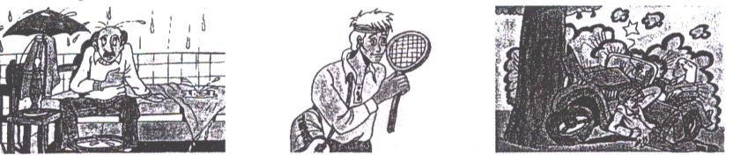

|  |  |  |
| --- | --- | --- |
| I…………….(move) into a better house if I get a job. | He…………(play) tennis. | They…………..(probably/buy) a new car. |

|  |  |  |
| --- | --- | --- |
| 4. …………………… | 5. ………………….. | 6. …………………… |

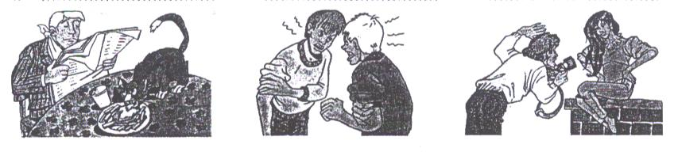

|  |  |  |
| --- | --- | --- |
| I think he…………….(be) angry when he sees that cat. | They………………(fight). | He…………………(take) a picture. |

**2. Fill in PRESENT CONTINOUS or BE GOING TO, then identify the speech situations.  *fixed arrangement – something already decided***

|  |  |  |
| --- | --- | --- |
| 1. ……………………….. | 2. ………………………… | 3. ………………………….. |

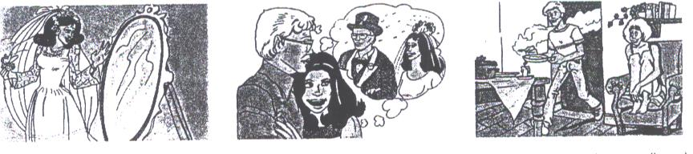

|  |  |  |
| --- | --- | --- |
| She………………(get married). | They……………(get married). | They……………….(have) dinner at home. |

|  |  |  |
| --- | --- | --- |
| 4. ……………………….. | 5. ………………………… | 6. ………………………….. |

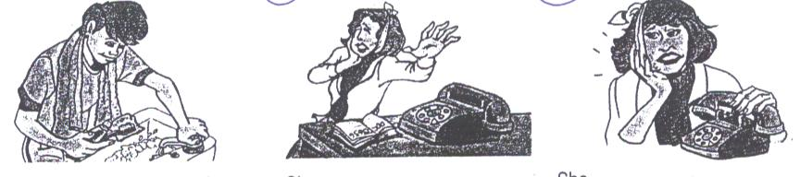

|  |  |  |
| --- | --- | --- |
| He's brushing his teeth. He …………..(have) an early night. | She …….…(telephone) the dentist. | She……………..(see) the dentist tomorrow. |

**3. Match the sentences with the pictures, then identify the speech situations.**

|  |  |  |
| --- | --- | --- |
| 1. I'll write to you every day. | 4. He's going to paint the house. | 7. Put on your coat or you'll catch cold. |
| 2. Look at that tree! It's going to fall down. | 5. I'll have two cheeseburgers for lunch. | 8. Finish your HW or I won't take you to the zoo. |
| 3. I love cooking. I'm going to be chef. | 6. Shall I do the washing-up? | 9. Robots will do the housework in the future. |

***intention, promise, evidence, prediction, offer, threat, warning, on-the-spot decision***

|  |  |  |
| --- | --- | --- |
| 1. ………………………… | 2. ………………………… | 3. ……………………… |

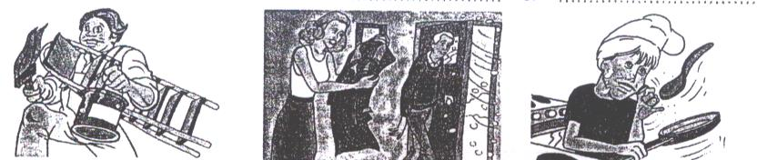

|  |  |  |
| --- | --- | --- |
| ­­­­­­­­­­­­­­­­­­­­­\_\_\_\_\_\_\_\_\_\_\_\_\_\_\_\_\_\_\_\_\_ | \_\_\_\_\_\_\_\_\_\_\_\_\_\_\_\_\_\_\_\_\_ | \_\_\_\_\_\_\_\_\_\_\_\_\_\_\_\_\_\_\_\_\_ |

|  |  |  |
| --- | --- | --- |
| 4. ………………………… | 5. ………………………… | 6. ……………………… |

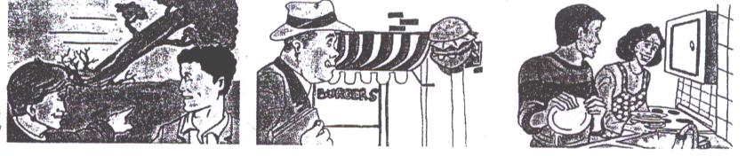

|  |  |  |
| --- | --- | --- |
| ­­­­­­­­­­­­­­­­­­­­­\_\_\_\_\_\_\_\_\_\_\_\_\_\_\_\_\_\_\_\_\_ | \_\_\_\_\_\_\_\_\_\_\_\_\_\_\_\_\_\_\_\_\_ | \_\_\_\_\_\_\_\_\_\_\_\_\_\_\_\_\_\_\_\_\_ |

|  |  |  |
| --- | --- | --- |
| 7. ………………………… | 8. ………………………… | 9. ……………………… |

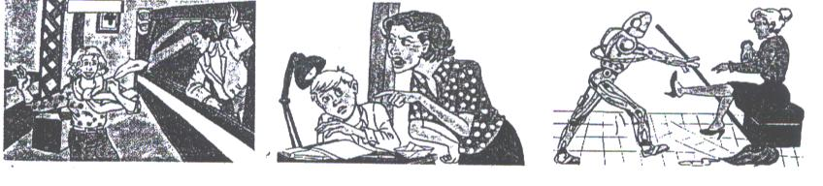

|  |  |  |
| --- | --- | --- |
| ­­­­­­­­­­­­­­­­­­­­­\_\_\_\_\_\_\_\_\_\_\_\_\_\_\_\_\_\_\_\_\_ | \_\_\_\_\_\_\_\_\_\_\_\_\_\_\_\_\_\_\_\_\_ | \_\_\_\_\_\_\_\_\_\_\_\_\_\_\_\_\_\_\_\_\_ |

**4. Put the verbs in brackets into PRESENT SIMPLE or FUTURE SIMPLE.**

1. We…………………(leave) as soon as he ……………………(arrive).
2. He says he……………..(telephone) us before he……………….(leave) the airport.
3. She ………………….(stay) at home until she …………………..(feel) better.
4. “When………………you ………………(visit) them?” “Probably next week.”
5. She…………………(call) us as soon as she……………….(reach) London.
6. Don’t go out until it …………….…. (stop) raining.
7. If he………………(give) you 5 pounds what …………you…………..(buy)?
8. He……………..(be) angry if she ……………….(come) home late.
9. Turn the lights off before you……………….(go) to bed.
10. When she ……………..(arrive) she………………(give) you the envelope.

**WORD FORMATION**

**Nouns formed from verbs**

|  |  |  |
| --- | --- | --- |
| **-ion** *eg. confuse - confusion*  **-tion** *eg. direct - direction*  **-ation** *eg. organise - organisation*  **-sion** *eg. suspend – suspension* | **-age** *eg. break - breakage*  **-ance** *eg. annoy - annoyance*  **-ence** *eg. prefer - preference*  **-ment** *eg. amuse - amusement* | **-y** *eg. injure – injury*  **-sis** *eg.* *analyse - analysis*  **-al** *eg. propose – proposal* |

**Nouns formed from adjectives**

|  |  |  |
| --- | --- | --- |
| **-ion** *eg. desperate – desperation*  **-iness** *eg. happy - happiness*  **-cy** *eg. fluent – fluency* | **-ance** *eg. tolerant - tolerance*  **-ence** *eg. obedient - obedience*  **-ment** *eg*. *content-contentment* | **-ity** *eg. popular - popularity*  **-ty** *eg. royal - royalty*  ***-y*** *eg. honest – honesty* |

**Adjectives formed from verbs Verbs formed from adjectives/nouns**

|  |  |
| --- | --- |
| **-able** *eg. bear - bearable*  **-ive** eg. *decide – decisive* | **-en** *eg. dark-darken, strong – strengthen,*  *fright – frighten, length - lengthen* |

**There are certain prefixes (syllables put at the beginning of words) and suffixes (syllables put at the end of words) which are used to form new words. However, there are no certain rules to follow to form one word from another.**

**Prefixes**

|  |  |
| --- | --- |
| **anti-** = against *eg. antinuclear*  **bi-** = two *eg. bilingual*  **co-** = with *eg. cooperation*  **de-** = acting against *eg. decomposition*  **ex-** = before, former *eg. ex-general*  **inter-** = between *eg.* *intermediate*  **mono-** = one *eg. monolingual*  **non-** = not *eg. non-stop*  **over-** = too much *eg. overeat*  **post-** = after *eg. postgraduate* | **pre-** = before *eg. prejudge*  **pro-** = in favour of *eg.* *pro-American*  **re-** = again *eg. rearrange*  **semi-** = half *eg. semicircle*  **sub-** = under *eg. subconscious*  **super-** = above *eg. supernatural*  **trans-** = across *eg. transatlantic*  **tri-** = three *eg. tricycle*  **under-** = not enough *eg. underestimate*  **uni-** = one *eg. unicycle* |

**There are certain prefixes which mean *not* or show an *opposite* state or process. These are:**

|  |  |
| --- | --- |
| **un-** *eg. unbelievable*  **im-** *eg. impossible*  **mal-** *eg. malfunction*  **in-** *eg. incompetent* | **ir-** (before r) *eg.* *irresistible*  **il-** (before I) *eg.* *illegal*  **dis-** *eg. disagree* |

**Suffixes**

|  |  |
| --- | --- |
| **-ee** (with passive meaning)  *eg. employee*  **-er** (with active meaning)  *eg. employer*  **-ful** a) = with *eg. careful*  b) : indicates quantity *eg. spoonful* | **-ish** a) = with the quality of  *eg.* *childish*  b) = rather  *eg. smallish*  **-less** without  *eg. careless*  **-proof** safe against  *eg. waterproof* |

**To describe *people* we add**

|  |  |
| --- | --- |
| **-ar, -er, -or** to the end of the **verbs** | ***eg.*** *lie - liar, rob - robber, create – creator* |
| **-ist, -ian** to the end of **nouns** or  **verbs** | ***eg.*** *type - typist, music - musician* |

***Do not forget to make any necessary spelling changes.***

***I. Make nouns from the following words.***

|  |  |  |
| --- | --- | --- |
| employ - | instruct | lonely |
| post | portray | reluctant |
| except | translate | excellent |
| expand | injure | intelligent |
| accept | refer | accurate |
| publish | apologize | excited |
| develop | examine | fragile |
| combine | pollute | regular |
| drive | judge | stupid |
| inspire | use | isolate |

***II. Fill in the right form of the words in brackets.***

The **1)** ...***length***... (long) of the journey was beginning to cause a lot of **2)** ............................. (frustrate) for everyone involved. Unfortunately, father got the blame, as he had been responsible for the **3)** ............................. (organise) of the trip. **4)** ............................. (impatient) had begun to set in when we realised we'd been given the wrong **5)** ................................ (direct) by a well-meaning pedestrian. What is more, father's **6)** .......................... (popular) was not **7)** ............................. (increase) by his **8)** ......................... (insist) that we stop every hour or so to observe the scenery. The trip to France, he'd said, would **9)** ............................. (broad) our horizons and provide us with both **10)** ........................ (amuse) and **11)** ...................... (educate). However, in **12)** ........................... (real), it turned out to be an **13)** .......................... (bear) waste of time and effort. It was then that we made the **14)** ................... (decide) never to listen to one of father's **15)** ..................(propose) again.

***III. Add the correct prefixes to the beginning of the words.***

**1** The ...***anti-***... **government** protesters marched to parliament.

**2** John ................. **slept** and was late for work.

**3** Many people who wanted tickets were disappointed because the organisers had ................. **estimated** the singer's popularity.

**4** He is taking a ................. **atlantic** flight from London to New York.

**5** When the ambulance came, the man was ................. **conscious** after being knocked down by a car.

**6** The ................. **president** of the United States was honoured at a ceremony, five years after he resigned.

**7** People who can only speak their own language are called ................. **lingual.**

**8** Superman is a comic strip character who has ................. **human** strength.

**9** There were violent scenes as ................. **government** and anti-government demonstrators fought outside parliament.

**10** ................. **racial** fighting between the two minorities had led to civil war in the country.

**11** John left his job because he was ................. **able** to deal with such a large amount of work.

**12** The two countries ................ **operated** to prevent the shipment of drugs from one to the other.

**13** That child looks very thin. I think he must be ................. **fed.**

**14** Don't ................. **feed** the dog or it'll get fat.

**15** The media gave her so much attention she became a ................. **star** overnight.

**16** He never goes out or talks to people; he's so ................. **social.**

**17** Tom knew the information was somewhere in his .............. **conscious,** but he couldn't remember it.

**18** I always find the day after Christmas an ................. **climax.**

**19** The man had to ................. **apply** the paint because the first coat wasn't sufficient.

**20** Ghandi achieved a lot through ................. **violent** action.

**21** The neighbouring tribes found it difficult to ................. **exist** peacefully.

**22** We caught the ................. **continental** train from Paris to Istanbul.

**23** As these programmes are ................. **changeable,** they can be used with any computer system.

**24** We weren't allowed onto the ferry because it had been ................. **booked.**

**IV. COMPLETE EACH SENTENCE USING THE CORRECT FORM OF THE WORD IN BRACKETS.**

1. IBM’s BlueGene is the most ………………………… supercomputer. (POWER)
2. Most library databases are ………………………..via the Internet. (ACCESS)
3. I’ll email my report to you as an ……………………….. . (ATTACH)
4. This book will show you how to ……………………. your small business. (COMPUTER)
5. An ……………………….. optical disc allows data to be deleted and new data to be recorded on it. (ERASE)
6. The growth of the Internet has increased the need for effective data ………………………… (SECURE).
7. The combination of ……………………….. and new textile materials has made it possible to create musical jackets and smart shirts that can read our heart rate. (ELECTRON)
8. Bluetooth is a ………………………..technology designed to connect computers, mobile phones and other devices, replacing direct cable links. (WIRE)
9. Aircraft flight ………………………………..is used to train pilots. (SIMULATE)

|  |  |
| --- | --- |
| NOUN | -ion, -ance, -ence, -ment, -ness, -y, -cy, -al, -ist, -ian, -ar/or/er, -ee… |
| ADJECTIVE | -able, -ive, -ous, -ful, -less, -proof, -ish, -ed/-ing… |
| VERB | -en, -ify, -ise… |
| ADVERB | -ly… |

|  |  |
| --- | --- |
| NEG. PREFIXES | un-, im-, in-, ir-, il-, dis-, mal- … |

**WORD FORMATION IN CONTEXT**

**USE THE WORD IN THE CAPITALS AT THE END OF EACH LINE TO FORM A WORD**

**THAT FITS IN THE SPACE IN THE SAME LINE.**

***1. Leaving a job***

|  |  |
| --- | --- |
| I recently left my job in an (1) ........................ agency  after a disagreement with my boss. She accepted my  (2) ............................ but warned me that because of the  (3) ………….............. situation, I might have to get used to  the idea of being (4) .............................. for a while. I thought that she was trying to make a point, but after I had made over  fifty (5) .............................. to other companies, I realised that she  was right. Although I am a (6) ............................. designer, I  didn't receive any offers of a job. After that I tried  working from home, but it was not very (7) ...................... Then  I became an (8) ........................... in a fast-food restaurant,  even though my (9) ....................... were extremely low.  I wish I had accepted early (10) .......................... from my old job.  That is what I disagreed with my boss about! | ADVERTISEMENT  RESIGN  ECONOMY  EMPLOY  APPLY  QUALIFICATION  PROFIT  EMPLOY  EARN  RETIRE |

***2. How a hobby can make you angry!***

|  |  |
| --- | --- |
| Recently I decided to take up (1) ………………….. as a hobby. I have  always taken snapshots, but I have never been very (2) ……………….  My snaps were either a complete (3) …………..……….. for  technical reasons, or were just not very (4) ………………….. First  I decided that to be (5) ……………………, I would have to buy new  equipment. Just then I had an (6) ………………….. piece of good  luck. A friend who works in a camera shop said she  could sell me a (7) ………………………camera. A customer had  left it at the shop to be repaired, but there had been  a (8) ……………………., and it was actually for sale.  I thought this was a rather (9) ………………….. explanation  and so I asked her some more questions. It turned out  that she had had a (10) ……………………. with the customer and he had thrown the camera at her in anger because she had  disliked his photos. | PHOTOGRAPH  SKILL  FAIL  IMAGINE  SUCCESS  EXPECT  VALUE  UNDERSTAND  BELIEF  AGREE |

***3. Father and son***

|  |  |
| --- | --- |
| My next-door neighbour has a very unusual (1) ..................... .  He has long hair with a (2) ..................... in the middle, and  usually wears an old pair of jeans and a (3) ..................... shirt.  His clothes are very (4) ..................... for working in a bank, but  that is what he does! Unless he (5) ..................... when he gets to  work and changes his clothes! His clothes are usually filthy  and I am sure he never washes them or takes them to  the (6) ..................... . When he wears a coat it is always  old and (7) ..................... , and even on very cold days it is  (8) ..................... all down the front. The funny thing is that his  son is very (9) ..................... , always wears the latest styles,  and never wears casual clothes, even on an (10) ................. occasion. | APPEAR  PART  STRIPE  SUIT  DRESS  CLEAN  WEAR  BUTTON  FASHION  FORMAL |

***4. A house in the country***

|  |  |
| --- | --- |
| When Ann decided to move house, it was mainly because  she was tired of the (1) ......... she lived in. It was crowded,  there was a (2) ............ of parking places, and  the view from her (3) ........... windows was of distant  factory chimneys. Luckily she arranged the (4) .............  of her house very easily, and with a small (5) .......... from  the bank, was able to buy a house in the country. It was an  old farm building, which had been (6) .......... and turned into  a modern house. After loading all her belongings into a van,  Ann managed to get them into the new house (7) .......... . DAMAGE  She (8) ............. most of the rooms with what she already FURNITURE  owned. Even her curtains were the right (9) ..........for the LONG  windows and she only had to buy a new (10) .............for COOK  the kitchen. It seemed too good to be true. Surely  something was bound to go wrong! | NEIGHBOUR  SHORT  STAIRS  SELL  LEND  BUILD  DAMAGE  FURNITURE  LONG  COOK |

***5. A letter of apology***

|  |  |
| --- | --- |
| I am writing to apologise for the (1) ................ of your Happy  Holiday Coach Tour to Aberdeen. (2) ................ our luxury  coach was involved in a (3) ................ in France a week ago,  and our driver has been (4) ................ obliged to remain there  for the moment. The coach was travelling on a road (5) ............  for heavy traffic, and the accident was (6) ................ . Luckily  none of the passengers suffered any (7) ................ , and we have complained to the authorities that the road needs (8) ................  Our new coach will be fitted with (9) ................ seat belts for  the safety and comfort of passengers. We will of course  return the (10) ................ you have made for your holiday as  soon as possible. | CANCEL  FORTUNE  COLLIDE  EXPECT  SUIT  AVOID  INJURE  WIDE  ADJUST  PAY |

***6. Supermarkets***

|  |  |
| --- | --- |
| Nowadays, a great (1) ............... of different food is available from large supermarkets. There are rarely any (2) ...............  of fresh food, and there is far less (3) ............... of our having  to rely on (4) ............... products. Does this mean that  supermarkets have become the most (5) ............... shops of  all time? Certainly they seem to have made some kinds of  food less (6) ............... and most people enjoy shopping in  them. There has been a (7) ............... in the number of  (8) ............... made against supermarkets in recent years.  The assistants are no longer (9) ............... , but smile and  try to be helpful. Above all, supermarkets have shown a  (10) ............... to listen to their customers, and to adapt to  customers' needs. | VARY  SHORT  LIKELY  FREEZE  SUCCESS  EXPENSE  REDUCE  COMPLAIN  POLITE  WILLING |

**MODAL VERBS**

**LOGICAL ASSUMPTIONS**

|  |  |
| --- | --- |
| MUST | I'm certain/sure that sth is true *He* ***must be*** *Tom’s son. He looks just like him.* |
| CAN'T, COULDN'T | I'm certain/sure that sth is NOT true  *That* ***can’t / couldn’t be*** *Sue over there. She’s in Paris on business.* |

**POSSIBILITY**

|  |  |
| --- | --- |
| CAN + pres. inf. | general possibility *The streets* ***can get*** *very slippery when it rains.* |
| COULD, MAY, MIGHT + pres. inf. | it's possible/likely (in a specific situation); perhaps  *If it gets colder tomorrow, it* ***could/may/might snow****.*  *NOTE:* ***In questions****, we use can, could or might but* ***not may***  *I can’t find him. Where* ***can/could/might*** *he have gone?* |
| COULD, MIGHT + perf. inf. | refers to the past – it was possible but it didn't happen  *He drove carelessly yesterday. He* ***might have had*** *an accident but luckily he didn’t.* |

**OBLIGATION – DUTY – NECESSITY**

|  |  |
| --- | --- |
| MUST | you are obliged to do sth, the speaker decides that sth is necessary  *I* ***must*** *complete this project by Monday.* |
| HAVE TO | it is necessary to do sth (sb else has decided)  *The manager told me that I* ***have to*** *complete this project by Monday.* |
| MUST↔HAVE TO  in questions | Must - do you insist that … ***Must*** *I do this HW now?*  Have to – is it necessary for me to do it… *Do I* ***have to*** *do this HW now?* |
| SHOULD, OUGHT TO | duty (less emphatic than must)  *Shop assistants* ***should/ought to*** *be polite to the customers.* |
| NEED | it is necessary to… ***Need*** *I call the doctor today?*  *(She* ***doesn’t need to = needn’t*** *go shopping this week.)* |

**ABSENCE OF NECESSITY**

|  |  |
| --- | --- |
| NEEDN’T, DON’T HAVE TO + pres. inf. | present/future – it isn’t necessary to do sth *You* ***needn’t/don’t have to/don’t need to*** *take a taxi. I’ll drive you to the airport.* |
| DIDN’T NEED TO,  DIDN’T HAVE TO | it wasn’t necessary to do sth  *He* ***didn’t need to/didn’t have to*** *stay in a hotel.* |
| NEEDN’T + perf. inf. | it wasn’t necessary to do sth, but it was done  *You* ***needn’t have asked*** *Tom to help you. You can do it by yourself.* |

**PROHIBITION**

|  |  |
| --- | --- |
| MUSTN’T, CAN’T | it is forbidden to do sth… *You mustn’t / can’t park your car here. (it’s against the law.)* |

**CRITICISM**

|  |  |
| --- | --- |
| COULD, SHOULD, MIGHT, OUGHT TO + perf. inf. | it would have been better if you had (past), but you didn’t…  *She* ***could/should/might/ought to have called*** *the police. (But she didn’t.)* |
| COULD, SHOULD, MIGHT, OUGHT TO + pres. inf. | it would be better if (present)…  *You* ***could/should/might/ought to tell*** *me if you’re going to be late.* |

**STUDY THE EXAMPLES AND THEN WRITE THE SECOND SENTENCE BY USING A MODAL VERB.**

|  |  |  |
| --- | --- | --- |
| I'm sure he **comes** from Italy. | **present infinitive** |  |
| Perhaps he **will cook** dinner. |  |  |
| It's possible that she **is having** a party tonight. | **pres. cont. inf.** |  |
| Perhaps she'**ll be having** a party tomorrow. |  |  |
| I’m sure he **didn’t receive** the message. |  |  |
| Perhaps they **have won** first prize. | **perfect infinitive** |  |
| It’s possible that she **had visited** a friend. |  |  |
| I’m certain she **was studying**. |  |  |
| Perhaps she **has been shopping**. | **perf. cont. inf.** |  |
| It’s likely that they **had been watching** TV. |  |  |

**I. Complete the sentences using *must, have* to, *may, might, could* or can't, as in the example.**

**1** Perhaps Tom will work late tonight. Tom *may/might work* late *tonight.*

**2** It's possible that Mary is trying to call us. Mary ..........................................................

**3** The students are obliged to finish the test in one hour. The students ........................

**4** It's possible that Mum is working in the garden. Mum ...............................................

**5** I'm sure Rachel is hungry. Rachel .............................................................................

**6** Perhaps Dad will take us out to dinner. Dad .............................................................

**7** I'm sure Lucy hasn't reached the station yet. Lucy ....................................................

**8** It is necessary for Grandma to take her medication every morning. Grandma ...........

**9** It's likely that they have gone to the supermarket. They ............................................

**10** I'm certain Bob didn't leave the party early. Bob ......................................................

**II. Fill in the gaps with must, mustn't or needn't/don't *have* to, as in the example.**

**1** A: You *...needn't/don't have to...* do the washing­ up. I'll do it.

B: Thanks, Mum.

**2** A: Paul ..................................... go to the dentist more often.

B: I know. His teeth are in terrible condition.

**3** A: If we want to see the beginning of the film, we ..................................... leave now.

B: Alright. I'm ready.

**4** A: You ....................................... speak with your mouth full.

B: I know. It's very rude.

**5** A: Shall I mow the lawn?

B: No, you .................................. . I did it earlier.

**6** A: ....................................... I walk the dog now?

B: Yes, it'll be dark in half an hour.

**7** A: John and I are going to the theatre on Friday night.

B: You .................................. get a baby-sitter. I'll take care of the children for you.

**8** A: You ............................ forget to post those letters.

B: I'll post them on my way to work.

**III. Tick the correct sentence.**

**1** a) You can't have called a taxi. I would have driven you to the station.

b) You needn't have called a taxi. I would have driven you to the station.

**2** a) Robert can't be very talented. He plays the piano, the violin and the flute.

b) Robert must be very talented. He plays the piano, the violin and the flute.

**3** a) If Jane sings well in the competition, she might win a prize.

b) If Jane sings well in the competition, she couldn't win a prize.

**4** a) You must go to the bank. I can lend you some money.

b) You don't need to go to the bank. I can lend you some money.

**5** a) Terry looks tired. He must have been studying all night.

b) Terry looks tired. He mustn’t have been studying all night.

**IV. Tick the correct item.**

***1*** *Dan can't be a teacher.*

**a)** I'm sure Dan isn't a teacher.

**b)** I think Dan isn't a teacher.

***2*** *Need I take the tablets every day?*

**a)** Is it a good idea to take the tablets every day?

**b)** Is it necessary to take the tablets every day?

***3*** *You needn't have bought me flowers.*

**a)** You bought me flowers.

**b)** You didn't buy me flowers.

***4*** *If it is hot tomorrow, we might go to the beach.*

**a)** We will definitely go to the beach tomorrow.

**b)** It is possible that we will go to the beach tomorrow.

