**LINKING WORDS AND PHRASES**

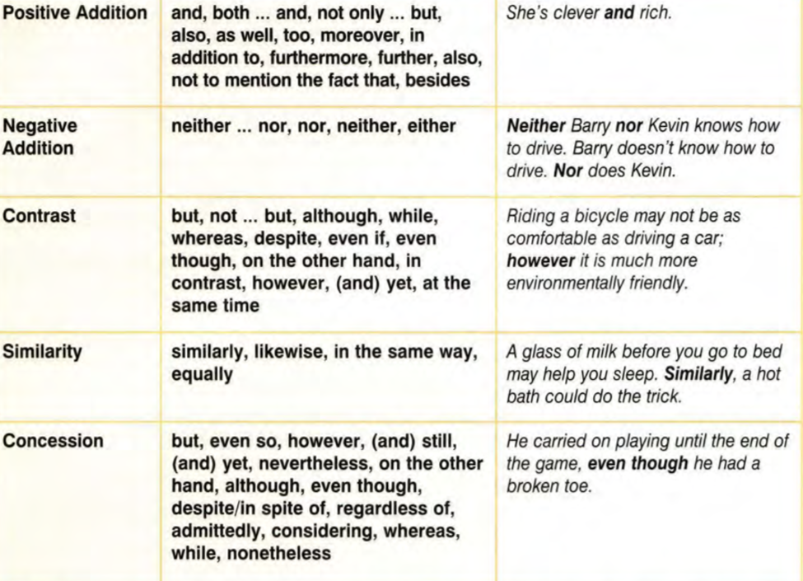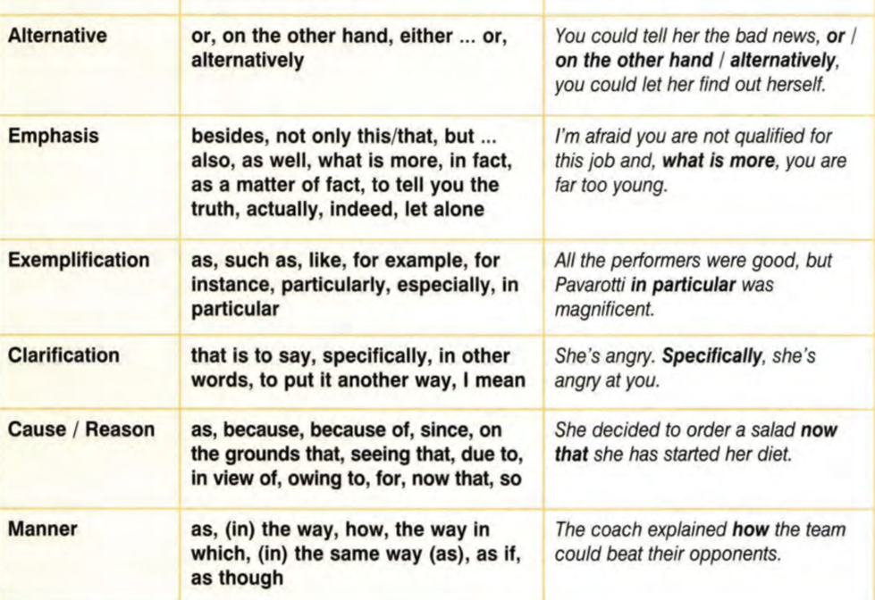

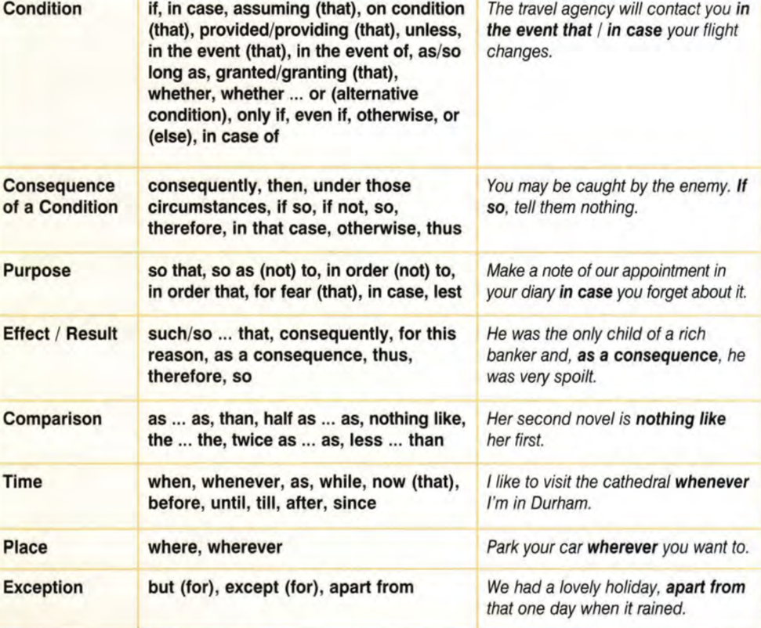

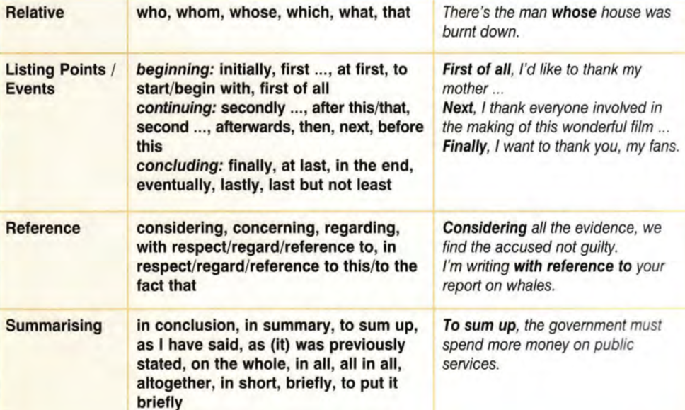

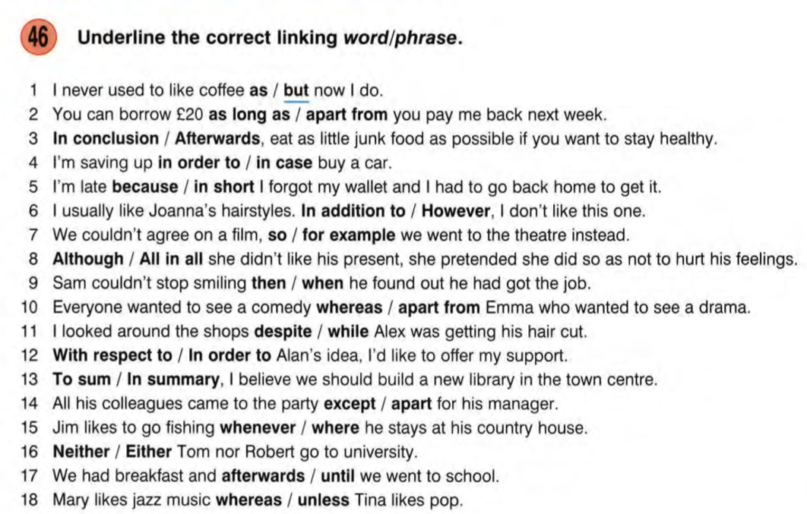

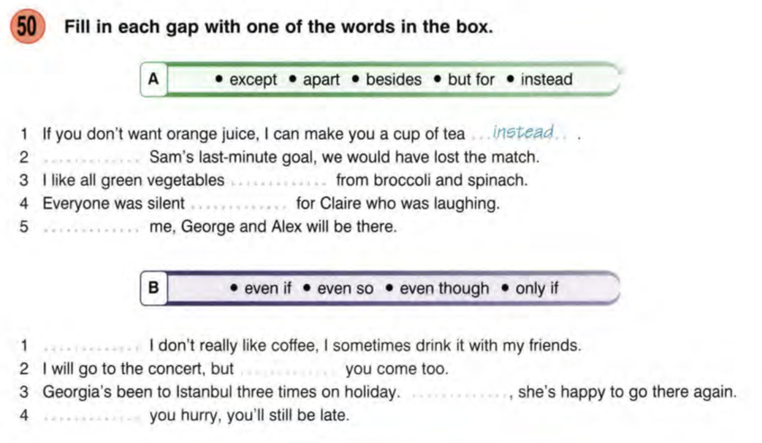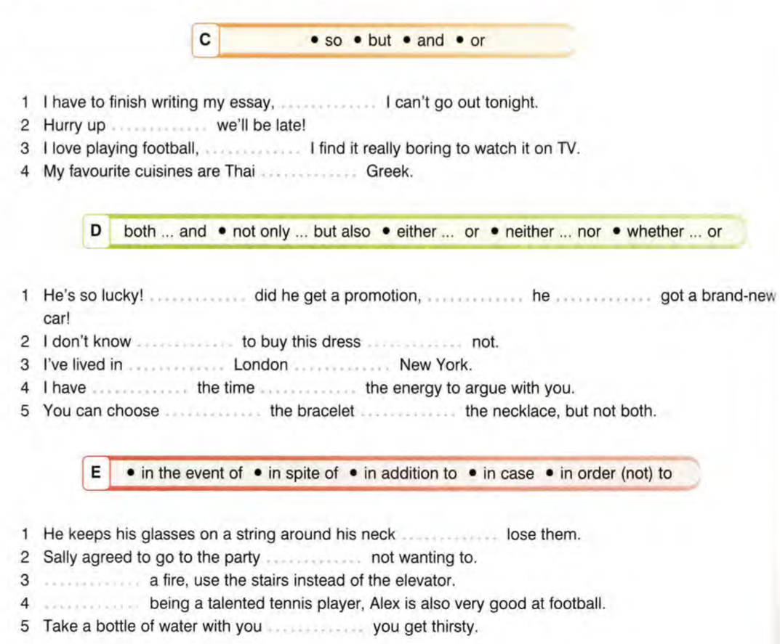



**Use your own ideas to meaningfully complete the sentences.**

1. He wanted to go on holiday **although** ___________________________________________________________
2. I’d always wanted to be a doctor. **However**, ______________________________________________________
3. The holiday way enjoyable **despite**______________________________________________________________
4. He lost his job **due to** _________________________________________________________________________
5. The prisoner was kept under tight security. **Nevertheless,** ___________________________________________
6. He wasn’t the best student. **Moreover,** __________________________________________________________
7. He is smart and clever, **although admittedly,** _____________________________________________________
8. I like all kinds of fruit, **particularly** _______________________________________________________________
9. He was the first to finish the race, **thus** __________________________________________________________
10. The plan was very good, **especially** ______________________________________________________________
11. He failed his driving test; **nonetheless,** ___________________________________________________________
12. He bought the car **despite** _____________________________________________________________________
13. He had no financial problems. **What is more** ______________________________________________________
14. Her niece was very rich, mostly **owing to** _________________________________________________________
15. He didn’t understand it **regardless of** ____________________________________________________________
16. She could never date him, **let alone** _____________________________________________________________
17. She has spent a lot of money on her wedding dress. **However**, _______________________________________
18. He’s a good friend of mine. **Moreover,**  __________________________________________________________
19. I am extremely disappointed in you! **As a matter of fact**, ____________________________________________
20. I demand a full refund. **Alternatively**, ____________________________________________________________
21. I missed my bus and was late for school. **Consequently**, _____________________________________________
22. She always arrives on time. **Furthermore**, ________________________________________________________
23. My sister is quite clever, **whereas** _______________________________________________________________
24. I’ll come home **in the event that** ________________________________________________________________
25. I’ll help you organise the party, **providing** ________________________________________________________
26. He’s a bright young man. **Similarly**, _____________________________________________________________